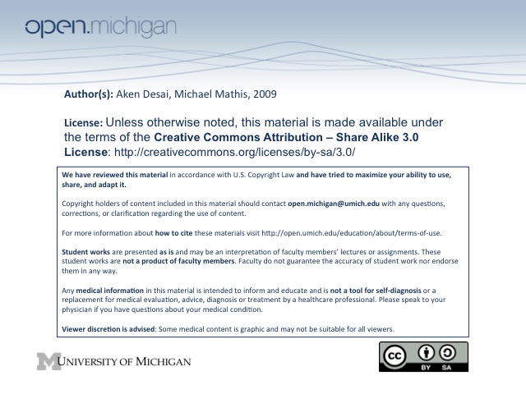
Hematopoiesis
Hematopoiesis
- Hematopoiesis – development of cells of blood system (platelets, WBCs, RBCs) & supporting structures
- Self-renewal – constantly replicating & differentiating, blood is constantly turning over
- Development – begins early embryogenesis, in first 8 weeks → begins liver/spleen, continues marrow
  - Primitive system – embryonic yolk sac develops RBCs
  - Definitive system – development begins in liver/spleen, continues in late fetus in bone marrow
    - Axial skeleton – primary site for hematopoiesis throughout life
    - Distal long bones – hematopoiesis gradually declines into adulthood
- Dynamic – hematopoiesis process adjusted during times of wound healing, blood loss, infection
Cell Biology
- Hematopoietic Stem Cell – have properties of self-renewal, quiescence, multipotency:
  - Self-renewal – stem cells constantly replicating & turning over
  - Quiescence – stem cells usually dormant, induced to become active
  - Multipotent – stem cells can differentiate into 10 different subclasses (platelets, WBCs, RBCs)
- Identification – numbers are low, can’t be detected through microscopy, ID relies on cell surface markers, specifically CD34, in addition to Thy-1la and c-Kit
- Origin – from aorto-gonadic mesonephric region (AGM) in the ventral aspect of the dorsal aorta → hemangioblast → hematopoietic stem cells
Stem Cell Differentiation
- Transcription Factors – balance of various TFs predisposes stem cells to differentiate in various ways
- Growth Factors – from bone marrow environment, interact with cells at different stages to promote cell growth
  - Early development – cells stay near cytokine-rich bony spicules, receive many growth factors
  - Late development – cells migrate into sinuses, become mature & ready for use
Stem Cell Lineages
- Hematopoietic Stem Cell (HSC) differentiates into…
  - Common Lymphoid Precursor (CLP) – makes B & T lymphocytes, NK cells
  - Common Myeloid Precursor (CMP) – makes various myeloid precursors:
    - Granulocyte precursor – gives rise to neutrophils, eosinophils, basophils
    - Monocyte precursor – can mature into macrophages
    - Erythroid/megakaryocyte precursors – mature into RBCs, platelets
- BFU/CFU – burst forming/colony forming units; more specific CMP stages before precursors above
- Experimental Determination – stem cell differentiation studied via mouse transplantation, cell cultures
Erythropoiesis
- Erythropoiesis – development of RBCs; process includes:
- Hemoglobin – major protein component of RBCs, requiring globins, protoporphyrin, & iron for synthesis
- Morphologic Development Stages – appearance of RBC in development related to hemoglobin synthesis
- Process: HSC→CMP→BFU→CFU→ Proerythroblast → basophilic → polychrom → ortho → retic → RBC
  - Proerythoblast – small amount of hemoglobin in RBC
  - Basophilic erythroblast – more condensed chromatin, more hemoglobin
  - Polychromatophilic erythroblast – maximum hemoglobin produced, nucleus condenses
  - Orthochromatophlic erythroblast – nucleus fully condensed
  - Reticulocyte – nucleus of RBC is extruded, some RNA remains
  - RBC –
- Turnover – differentiation process takes ~4 days, and lifespan is ~120 days
- GM-CSF – granulocyte-macrophage colony stimulating factor, cytokine for BFU/CFU diff
- Erythropoietin – also plays important role in erythropoiesis, from CFU onwards
Hemoglobin Formation
- ζ,ε – hemoglobin heterodimer present in early embryogenesis (1-2 months)
- α,γ – fetal hemoglobin present in later fetal development (2-10 months)
- α,β – adult hemoglobin (newborn onwards)
Megakaryopoiesis
- Megakaryopoiesis – generation of platelets → small, anuclear cells
- Endomitosis – nucleus divides, but cell doesn’t; leads to single polypoid nucleus, hi cytoplasmic volume
- Platelet formation – mature megakaryocyte sheds off platelets without nuclei
- Thrombopoietin (TPO), IL-11 – play important role in megakaryocyte development
Monopoiesis/Granulopoiesis
- CFU – colony forming unit stem cell common to both granulocytes/monocytes
- GM-CSF – important stimulating factor for CMF → CFU
- Granulopoiesis – leads to cells with prominent granules: PMNs, eosinophils, basophils
  - Granulocyte Colony Stimulating Factor (G-CSF) – primary cytokine at work
  - Basophils & eosinophils – have common precursor cell before undergoing final commitment
  - Mast cells – similar to basophils, derived from HSC developing in tissue
- Monopoiesis – CFU-GM develops to CFU-M → monocytes, not too much morphologic change
  - Macrophage Colony Stimulating Factor (M-CSF) – primary cytokine at work
Lymphopoesis
- Common Lymphocyte Progenitor (CLP) – precursor to lymphocytes
- Location – maturation takes place outside bone marrow:
  - T-lymphocytes – takes place in thymus
  - B-lymphocytes – takes place in bone marrow, then secondary lymph tissue (nodes, spleen)
- Heterogenous – although look similar, many different functions, surface markers, life spans, environs
- B-cell development – HSC→CLP→Pro/Pre-B → mature B-cell → activation, plasma cell
- T-cell development – HSC→CLP→ thymus, differentiate into αβ, γδ lineages
- Interleukins – IL-7 important early, later IL-1, IL-2, IL-4

