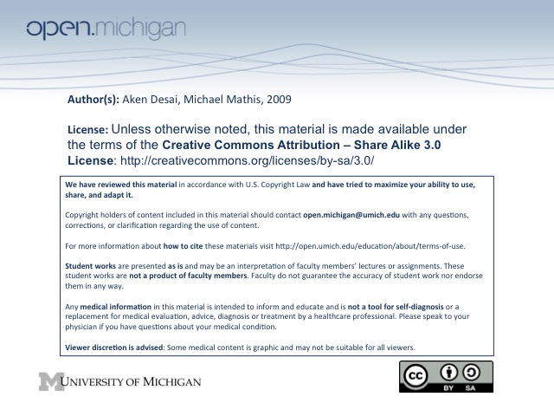
Red Blood Cells
Erythropoiesis Overview
- Chromatin – more condensed as RBC matures: basophilic erythroblast → poly- → ortho-chromatophilic
- Cell Nucleus – becomes extruded to form reticulocyte (has some remaining RNA), matures to RBC
- Reticulocytes – not normally seen in peripheral blood, if seen, may indicate early release of RBCs from marrow
- Cytoplasm – changes color from purple → red as more hemoglobin produced
Erythopoietin
- Erythropoietin (EPO) – produced in kidney in response to low hemoglobin & thus decreased O₂ supply
- Effect – causes erythroid marrow hyperplasia, stimulates RBC production
- Increased EPO – often a sign of a hemolytic process (sickle-cell, beta-thalassemia)
- Renal failure – causes low EPO → chronic anemia; normally Hct is negatively related to EPO, in RF Hct declines b/c of lower EPO
Hemoglobin Types
- Embryonic Hgb – ζ₂ε₂ tetramer, produced in yolk sac
- Hemoglobin F – has α₂γ₂ tetramer subunits, is fetal hemoglobin
- Hemoglobin A – has α₂β₂ tetramer subunits, is adult hemoglobin
- Hemoglobin A₂ – has α₂δ₂ tetramer subunits, a sparser adult hemoglobin
Hemoglobin Physiology
- Functions – binds O₂ in sigmoid fashion (binding cooperativity), binds CO₂ to release O₂, binds H⁺ efficiently at low pH
- Affinity – Δ’d by pH (dumps O₂ in acidic environment), 2,3 DPG (high altitude), and temperature (when something drops, O₂ affinity increases)
- Fetal Hemoglobin – binds less 2,3 DPG and thus has higher O₂ affinity
- Conformations – exists in “T” tense state and “R” relaxed state
  - “T” Tense State – nonaccepting, low O₂ affinity (deoxygenated)
  - “R” Relaxed State – accepting, high O₂ affinity (partially oxygenated) → binding cooperativity
Hemoglobin Variants
- High Affinity – favor “R” state, delivers less O₂ to tissues, decreased affinity for 2,3 DPG, increased erythrocytosis, higher Hgb
- Low Affinity – favor “T” state, delivers more O₂ to tissues; see cyanosis clinically, slate-gray color skin c/w cyanosis
- Unstable – increased susceptibility to oxidative stress, heme/globin complex is unstable → Heinz bodies
  - Heinz bodies – intracellular precipitates in RBCs that have weakened heme/globin binding
  - Hemolysis – occurs when Heinz bodies bind to RBC membrane → damages RBC, phagocytosis
- M Hemoglobins – abnormal heme environment favoring “T” state → right shifted curve, pseudocyanosis (brown-slate skin, no respiratory distress even though right shifted)
Heme Biosynthesis
- Location – in RBC → hemoglobin, but also in liver → “heme” enzymes (cytochrome P-450s, catalase)
- Process – several steps:
- Glycine + Succinyl CoA – makes aminolevulinate acid (ALA) in mitochondria; *rate-limiting* under negative feedback by heme
- ALA leaves mitochrondria, enters cytosol, eventually converted to coproporphyringen III
- Coproporphyringen III re-enters mitochondria, Fe incorporated into porphyrin ring by ferrochelatase
- Sideroblastic Anemia – X-linked lacks ALA synthase → can’t make ALA during heme biosynthesis → iron deposits around nucleus of erythroblasts (ringed sideroblasts)
- Porphyrias – patient lacks other heme biosynth enzymes → overproduction of heme precursors → increased excretion, phosensitivity, ab pain, neuro complications
RBC Cytoskeleton
- Spectrin & Ankryin – important proteins giving RBC biconcave shape
- Hereditary spherocytosis – central pallor lost, phosphoplipid bilayer leaky, cell swells due to Band 3 or Ankyrin mutation
- Hereditary elliptocytosis – spectrin abnormal, RBC becomes elliptically shaped
RBC Metabolic Pathways
- Na-K ATPase – sodium-potassium pump, inhibited by ouabain
- Glycolysis – generates 2 ATP, also NADH/NADPH, moth balls and fava beans can alter metabolism resulting in hemolysis
- Pentose-Phosphate shunt – uses G6P to make NADPH → synthesize glutathione (used by catalase)
RBC Degradation
- Lifespan – normally ~120 days, abnormal is <90 days
  - Short Lifespan – caused by spherocytosis, sickle cells, thalassemic RBCs
  - D_{x} – can see a compensation with increased reticulocytes
- Senescent/Abnormal RBCs – degraded by RES reticulo-endothelial system (spleen 1º)
- Degradation – hemoglobin binds to haptoglobin, complex is then transported to liver:
  - Globin Degradation – globin broken down into AAs
  - Heme Degradation – broken down into Fe + biliverdin, which is reduced to bilirubin
  - Fe Degradation – picked up by ferritin, can accumulate over time to make hemosiderin, iron overload results in hemosiderin deposits in other organs
- Hemoglobin Hemolysis – Hgb unbound to haptoglobin is oxidized to methemoglobin
  - Met-heme – binds to albumin or hemopexin → enters liver RES, heme catabolism
  - Hemopexin – measure of hemolysis (like haptoglobin), low levels = high hemolysis
Bilirubin Degradation
- Conjugated Bilirubin – esters added to bilirubin by bilirubin-UDP-glucuronyl transferase (BUGT)
  - Water soluble – conjugated form very water soluble, can then be excreted
  - Gilbert Syndrome, Crigler-Najjar Syndrome – BUGT mutated, hyperbilirubinemia
- Unconjugated Bilirubin – binds to albumin, less water soluble, elevated in jaundice
  - Jaundice – from increased bilirubin load on immature liver, T_{x} by UV light

