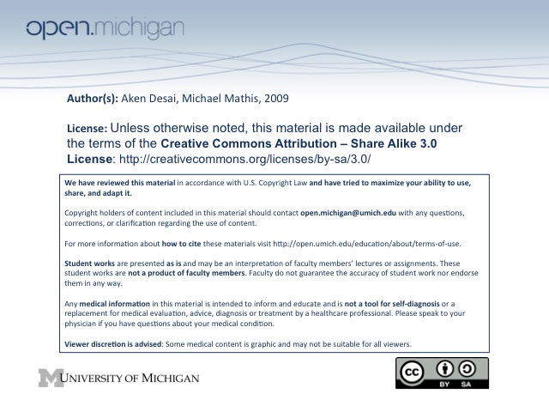
Anemia
Anemia
- Anemia – a decrease in RBC/hemoglobin mass, resulting in deficient O₂-carrying capacity of blood
- Symptom – anemia is considered a symptom of an underlying disease rather than a 1º disease itself
- Evaluation – includes H_{x}, CBC, peripheral blood smear:
  - Clinical/H_{x} – SOB, fatigue, angina, hypotension; cardiac compensation (inc HR, vasoconstrict)
  - CBC – complete blood count, summarizing RBCs, WBCs, platelets
  - Peripheral blood smear – examine morphology microscopically
CBC Variables
- Quantitiative – include RBC number, hemoglobin content, & hematocrit:
  - RBC Number –[RBCs] in blood; normally 4.0-5.0 *10¹²/liter
  - Hemoglobin Content – [hemoglobin] in blood; normally 13-15 g/dL
  - Hematocrit – % of blood occupied by RBCs; normally 40-45%
- Qualitative – includes properties of RBCs in blood:
  - Mean Corpuscular Volume (MCV) – ratio of Hct/RBC count → gives vol. of single RBC; 90 fl
  - Mean Corpuscular Hemoglobin (MCH) – ratio of Hgb/RBC count → gives Hgb vol. per RBC
  - Mean Corpuscular Hemoglobin Conc. (MCHC) – ratio of Hgb/Hct → gives [Hgb] per RBC
  - RBC Distribution Width (RDW) – variance in size of RBCs
Anemia Classification: Reticulocytes
- Reticulocytosis – if bone marrow is responding to anemia, will see reticulocytes
  - Reticulocyte – slightly larger than mature RBC, with some nuclear material remaining
  - Polychromasia – immature RBCs won’t be as red as normal; some variation in color (purplish)
  - Reticulocyte Index – amount of reticulocytes made during anemia, assess bone marrow response
    - Low Index – marrow not fxn properly; hypoproliferative or maturation abnormality
    - High Index – marrow functioning; cause is rather from blood loss, hemolysis, hematinic
Anemia Classification: RBC Size
- RBC Size – size of RBC will give clues to anemia cause:
  - Macrocytic anemia – large RBC > 100fl
    - Megaloblastic anemia – impaired DNA synth; due to folate/B12 deficiency, or R_{x} SE
    - Non-megaloblastic anemia – unrelated to DNA synth; bleeding/hemolysis, liver dz
  - Microcytic anemia – small RBC <80fl
    - Decreased Hemoglobin – defects in globin chain production, heme synthesis
    - Inherited – thalassemias (defective hemoglobin)
    - Acquired – iron deficiency, chronic disease, lead poisoning, medication SE
  - Normocytic anemia – normal RBC 80-100fl
    - Reticulocytes > 2% - acute hemorrhage, hemolysis
      - Acute Hemorrhage – GI/menstrual bleeding commonly w/ Fe deficiency as end result
      - Hemolytic anemia – decreased RBC longevity (membrane Hgb defect)
    - Reticulocytes < 2% - bone marrow failure, kidney disease (low EPO)
      - 1º – leukemia, lymphoma, myeloma, myelodysplastic syndromes
      - 2º – renal disease, chronic illness, medication SE, metastatic tumor affect EPO
Anemia of Chronic Disease
- Underlying inflammatory state – infection, rheumatoid disorders, malignancies
- Hepcidin – prevents iron absorption in duodenum and release from macrophages
- Other cytokines – lead to impaired proliferation of progenitor cells and blunted response to EPO
- Labs – low serum iron, normal/elevated serum ferritin, decrease EPO
Anemia & Location of Destruction
- Intravascular Hemolysis – destruction within transport system of blood; RBCs usually break apart → schistocytes
  - Mechanical destruction – heart valve, disrupted blood flow shearing RBCs
  - Vascular Damage – DIC, TTP, HUS
  - Immune-mediated – severe antibody reactions, PNH
  - RBC defects – sickle cell disease, PNH (paroxysmal nocturnal hemoglobinuria)
- Extravascular – destruction outside of transport system, caused by intrinsic property of blood → spherocytosis w/ elevated RDW:
  - Hemolytic anemia – IgG bound to RBC
  - Heinz body anemia – damaged RBCs from heme/globin precipitate
  - Hereditary spherocytosis – abnormal RBC membrane
- Labs
  - Extravascular – polychromatophilia, increase retic, erythroid hyperplasia, increased bilirubin, absent haptoglobin, nl-increased Hbg, variably increased LDH
  - Intravascular – polychromatophilia, increase retic, erythroid hyperplasia, increased bilirubin, reduced haptoglobin, increased Hbg, increased LDH

