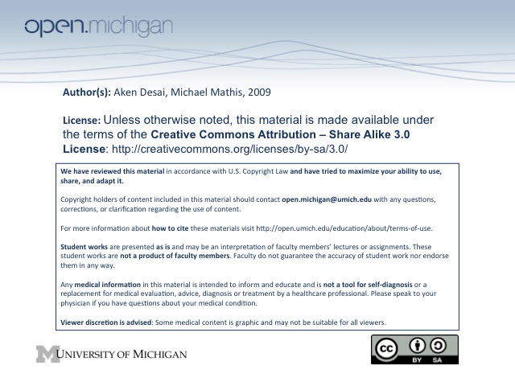
Nutritional Anemias
Nutritional Anemia
- Nutritional Anemia – anemia resulting from lack of essential substrate normally ingested
- Necessary nutrients – include iron, folate, vitamin B12/B6, niacin, Vit A/C/E, copper, AAs, cobalt
Iron Physiology
- Anemia Prevalence – most common type of nutritional anemia (think anemia T_{x} = iron supplements)
- Distribution – normal content is ~3-4gm, 70% in heme, 30% stored, <0.2% in plasma:
  - Hemes (70%) – hemoglobin & myoglobin carry most of body’s iron
  - Ferritin/hemosiderin (30%) – most of remaining non-heme, storage forms of iron
  - Transferrin (<0.2%) – iron in plasma, bound to transferrin protein
- Metabolism – absorbed in GI tract; used and re-used repetitively; 30% used in liver:
  - Non-heme proteins – liver makes cytochromes
  - Tissue heme proteins – liver makes myoglobin
- Absorption – US diet 10-15mg Fe/day, only about 1-2 mg absorbed; although more absorbed if needed
  - Heme iron – absorbed intact
  - Non-heme iron – gastric acid reduction of Fe3+ to Fe2+, presence of absorption inhibitors (grain, tea, egg yolks) or enhancers (Vit C) → must consider diet in causes of anemia
- Hepcidin – regulator of iron homeostasis, limits GI absorption/recycling
- Transport – carried in plasma by transferrin protein (can carry many Fe ions)
  - Total iron binding capacity –300 ug Fe/dl; increased during deficiency, pregnancy, estrogen
  - Decreased capacity – during inflammation, tumor, liver disease, nephrotic syndrome
  - Transferrin saturation – proportion of available iron-binding sites occupied by Fe atoms (serum FE/TIBC)*100%
  - Cell Import – transferrin binds to transferrin receptor; whole compound endocytosed, Fe dumped
- Storage – mainly stored in ferritin (less stable, more soluble, small capacity) and hemosiderin (opposite)
- Excretion – no physiologic mechanism; just lost when cells lost (bleeding, GI/renal epithelium slough)
Iron Deficiency Anemia
- S_{x} – can be asymptomatic early, or can have fatigue, weakness, DOE, pallor, light-headed
- S_{x} of underlying cause – GI problems, bleeding, psoriasis
- Exam Findings – glossitis (tongue swollen), angular cheilosis (cracked corners of mouth),
esophageal webs (dysphagia), koilonchyia (fingernails flatten), blue sclera,
gastric atrophy, pica (craving for ice chewing)
- D_{x} – conduct CBC (Hgb, Hct, MCV, RDW), measure serum iron/ferritin, transferrin saturation
  - RDW – increased during Fe deficiency; take on weird shapes
  - MCV – slowly decline as less Hgb made
  - Serum ferritin – low level is D_{x}, but normal level doesn’t rule out
- Iron Stores – 1st lose storage forms (ferritin/hemosiderin), next in transport forms (transferrin), last RBC
- Bone Marrow Aspirate – gold standard, D_{x} is absence of intracellular iron (no Prussian blue staining)
- Etiology – can be from increased iron requirements (physiologic/pathologic), or low supply
  - Physiologic stresses – growth, pregnancy, lactation (lost in breast milk)
  - Pathologic stresses – blood loss
  - Inadequate supply – low Fe in diet, impaired absorption, abnormal transferrin
- Treatment – treat underlying cause, give oral iron replacement (ferrous sulfate), or IV iron dextran
Megaloblastic Anemia
- Megaloblastic Anemia – anemia caused by a defect in DNA synthesis → larger RBCs
- Common Causes – lack of vitamin B12 or folic acid
- Peripheral Blood Smear – looks the same for vitamin B12 (cobalamin) and folic acid deficiencies:
  - RBCs – anemia, increased MCV (anisocytosis), increased RDW, poikilocytosis (variation in shape)
  - WBCs – PMNs hypersegmented, mild-to-moderate leukopenia
  - Platelets – mild-to-moderate thrombocytopenia
- Bone Marrow Aspirate – hematopoietic cell hyperplasia (all 3 cell lines)
- DD_{x} – congenital dyserythropoetic anemia, erythroleukemia, R_{x} SE (contraceptive), macrocytosis (liver dz)
- Clinical Manifestations – S_{x} of anemia (above), and effects of impaired DNA synthesis:
  - Epithelial tissues – glossitis (swollen, smooth tongue), angular cheilosis (cracked corner mouth)
  - Neural tissues – vitamin B12 deficiency only → periph. neuropathy, dorsal columns/cord degeneration, optic atrophy, psychiatric disorders
Megaloblastic Anemia: Vitamin B₁₂ Deficiency
- Function – Vitamin B₁₂ is essential cofactor for 2 enzymatic reactions:
  - Methyltransferase – convert homocysteine → methionine; form tetrahydrofolate → DNA synth
  - Adenosylcoblamain Mutase – converts methylmalonyl-CoA → succinyl CoA
- Source – produced only by vitamin B₁₂-producing microbes (bacteria, fungi); humans get from diet
  - Intrinsic factor – protein in stomach conjugating vitamin B₁₂, to absorb in GI tract
  - Intestinal bacteria – make vitamin B₁₂ too distally for absorption
- Content – average US diet 5-7 ug vitamin B₁₂/day, 2-5 mg total body content (1 mg stored liver)
- Mechanisms – include inadequate diet or inadequate absorption:
  - Inadequate diet – if strict vegetarian, or breast-fed infants of mothers w/ B₁₂ deficiency
  - Inadequate absorption – lack of gastric acid, intrinsic factor (pern. anemia), reduced receptors, pancreatic insufficiency, Zollinger-Ellison syndrome, nonfunctional TCII, NO inactivation of B12
- D_{x} – obtain serum B₁₂ level, also elevated homocysteine/methylmalonic acid (uncatalyzed reactants)
- Schilling Test – used to localize site of metabolic defect causing B12 deficiency:
  - Initial – patient given oral radiolabeled vitamin B12 and injection of normal B12
  - Stage I – record amount of radiolabeled B₁₂ excreted in 24 hour urine collection (normal = 92%)
  - Stage II – (if Stage I abnormal) patient given oral (intrinsic factor/pancreatic enzyme/etc) + radiolabeled B₁₂ → if normal, problem is with a lack of intrinsic factor/pancreatic enzyme/etc
  - Stage III – 7-10 days of Abx, if due to bacterial overgrowth, dose will be excreted in a 24 hour urine collection
  - Pancreatic insufficiency – patient is coadministered pancreatic extract w/ radiolabeled B12
- Intrinsic Factor / Parietal Cell Antibodies – occasionally the problem…
- Treatment – replenish B₁₂ (IV/oral), may need pancreatic extract, exogenous intrinsic factor…
- Folic Acid – don’t give, can exacerbate neuropsychiatric manifestations of B₁₂ deficiency
Megaloblastic Anemia: Folate Deficiency
- Folate – used in coenzyme tetrahydrofolate → methylated when homocys→Met; used for dUMP→dTMP
- Content – 5-10 mg in body, most stored in liver; children/pregnant require more in diet
- Source – obtained in diet → green leafy vegetables, yeast, legumes, fruits
- Absorption – in small intestine, no specific transport protein; binds nonspecifically
- Enterohepatic recirculation – re-uses/redistributes folate
- Intracellular – remains w/ cell throughout cell’s lifespan
- Mechanism – through inadequate intake, increased requirements, malabsorption, drugs, congenital
  - Inadequate intake – low folate levels in diet
  - Increased requirement – in children, pregnancy, lactation, hemolysis
  - Intestinal malabsorption – sprue, Crohn’s disease
  - Drugs – ethanol, barbiturates, sulfa drugs
- D_{x} – obtain serum folate level; more reliably RBC folate level, also homocysteine/methylmalonyl CoA
  - Homocysteine – should be elevated in folic acid deficiency (reaction not catalyzed)
  - Methylmalonic acid – should be normal in folic acid deficiency (not involved in this process)
- T_{x} – treat underlying problem, give folate supplements; prophylactic folate in pregnant women

