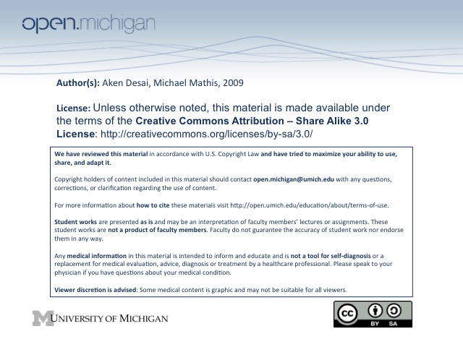
Peripheral Blood Smear Self-Review (Lab Final)
Blood Smear Technique
- Smear Concentration – smear blood across slide horizontally, so density is from high → low
- Examination – examine where not too packed, but not so sparse to create morphological distortion artifact
- WBC Differential – zig-zag through good field until 100 WBC’s counted; put into categories
  - “Left Shift” – means more premature WBCs in blood, due to active infection/appendicitis
- RBC Morphology – includes anisocytosis, poikilocytosis, polychromatophilia, hypochromia:
  - Anisocytosis – variation in size (1+ just detectable, 4+ macro/microcytes together)
  - Poikilocytosis – variation in shape (1+ occasional abnormal cell, 4+ 50% cells abnormal)
  - Polychromatophilia – retained RNA (1+ 1-2 blue cells per oil field, 4+ 50% cells blue) → retic’s
  - Hypochromia – increased central pallor (1+ just detectable, 4+ only faint RBC rim left)
- Platelet Estimation – 9-20 per oil field = 200,000-400,000/uL = normal
Normal Morphology
- RBC – should have pale orange-pink appearance with central pallor 1/3-1/2 diameter of cell
  - Too dense – RBC overlap, cells become thicker & don’t uniformly have central pallor
  - Too sparse – RBCs lack central pallor, too flattened out
- WBC – PMNs most common; myelocytes usually indicate infection, any “blast” form = definite infection
Neutrophil Maturation Series
- Myeloblast – precursor to granulocytes/monocytes:
  - Large ovoid eccentric nucleus, scant cytoplasm
  - Several clear nucleoli – unlike a lymphocyte (no nucleoli)
  - Reddish-purple granules – in scant cytoplasm
- Promyelocyte – myeloblast differentiates into this, precursor to granulocytes:
  - Larger cell size – more abundant cytosplasm than myeloblast; about 2x RBC diameter
  - Reddish-purple granules – indicate myeloid lineage
  - Several clear nucleoli – unlike lymphocytes
- Myelocyte – promyelocyte differentiates into this, precursor to granulocytes:
  - More condensed nucleus – only occupies 50% of cell size; eccentric
  - Blue “azure” granules – in cytoplasm, appears smoother
- Metamyelocyte – myelocyte differentiates into this, precursor to granulocytes:
  - Indented oval nucleus – resembles kidney bean, 50% of cell size
  - Absent nucleoli – chromatin is now very clumped
  - Pink cytoplasm – neutrophilic granules completely color cytoplasm
- Myeloid Band form – precursor to granulocytes:
  - C-shaped nucleus – eventually will begin to lobulate, but no indentations yet
  - Pink cytoplasm – characteristic of granulocyte
- Granulocytes – final stage of neutrophil maturation
  - Polylobular nucleus – with many identations, 2-5 lobes
- Vs. lymphocytes – lymphocytes have much darker nucleus, no nucleoli; most closely resemble myeloblast
- Vs. basophilic normoblast – (RBC precursor) like promyelocyte, but no granules & smaller overall size
Granulocytes
- Monocyte – larger cell size, lighter horseshoe/kidney nucleus, cytoplasm usually light w/ some vacuoles
- Eosinophil – has bright red cytoplasm due to acidophilic granules; 2-3 nuclear lobes
- Basophil – has dark cytoplasm due to basophilic granules (5-HT, histamine,leukotrienes), 2-3 nuc. lobes
- Neutrophil – pink to purple granules in cytoplasm; most common; 2-5 nuclear lobes, Barr body nuc. notch
Lymphocytes
- Small lymphocyte – look like myeloblast, but no nucleoli, darker nucleus
- Large lymphocyte – look like a promyelocyte, but no nucleoli; very scant granules in cytoplasm
- Atypical lymphocyte – weird elongated dense nuclei; often seen in viral infection (mononucleosis)
Neutrophil Abnormalities
- Hypersegmentation – more than 5 lobes in PMN is abnormal, D_{x} of megaloblastic anemia (B₁₂, folate)
- Leukemoid Reaction – WBC response to infection, >30,000; also can be leukemia
  - Vacuolization – cytoplasmic vacuoles seen in PMNs
  - Left-shift – PMN precursors (myelocytes, etc) can be seen in blood
- Pelger Huet Anomaly – bi-lobed nucleus; benign inherited disorder; can mimic leukemia/myelodysplasia
- Dohle Body – aggregates of RER seen in PMN cytoplasm during infection; looks like a bluish platelet
Platelets
- Platelet – small faint doo-hickies; red/purple granules
- Abnormalities – can be too large (macrothrombocyte) or no granules (agranular), also gray:
- Gray platelet syndrome – congenital disorder; decreased granules, larger than normal size
RBC Abnormalities
- Leukoerytrhoblastic RBCs – see RBC precursors (erythroblasts w/ nuclei); hemolytic anemia
  - Howell Jolly bodies – dark granules similar to basophilic stippling; can occur in left-shift here
- Macrocytes – very large RBCs
- Elliptocytosis – RBCs elliptically shaped
- Spherocytosis – RBCs don’t have central pallor; spherical shape
- Basophilic Stippling – pathologic precipitation of ribosomes in RBC; dark granules
  - Disordered heme synthesis – such as in lead intoxication, thalassemia, etc can cause
- Schistocytes – fragmented RBCs, look like bites taken out of them; often mechanical shearing defects
- Hemoglobin C Disease – show target cells and “box car” cells with condensed hemoglobin (pill shape)
- Sickle Cell – crescent-shaped RBCs
- Tear Drop Cells – RBCs look like tear drops, D_{x} thalssemia
- Target Cells – excess of RBC membrane causes bulging in the center of central pallor → target sign
  - Thalassemia – D_{x} by target cells
- Rouleaux Formation – stacking of RBCs due to protein coat → hypergammaglobulinemia
- RBC Agglutination – RBC antibodies bind, RBCs cluster and meld together

