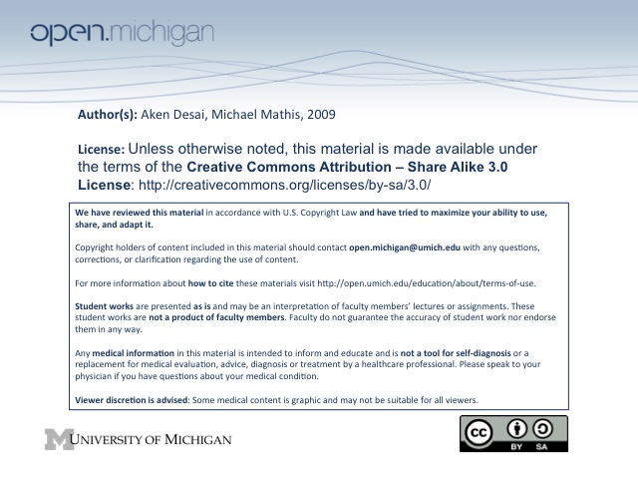
Coagulation Self-Review
Normal Circulation
- Vascular space – blood sequestered in fluid phase balanced by procoagulant & anticoagulant components
- Platelets – in inactive form, resemble disc-shaped structures, no tissue factor (TF)
- Tissue Factor – contained in monocytes, fibroblasts, and injured endothelium, not platelets
Coagulation: Initiation
- Injury: endothelial lining disrupted, blood exposed to subendothelial cells and TF-bearing fibroblasts
- Platelet adhesion: von Willebrand Factor (VWF) tethers platelet to site of injury, connecting
glycoprotein 1b/FIX receptor of platelet to collagen of subendothelium
- Tissue factor complex: Exposed TF binds to plasma FVII, activates to FVIIa
- FX Activation: TF/FVIIa complex activates FX → FXa (free FXa in blood deactivated by antithrombin)
- FV Activation: TF/FVIIa/FXa complex activates FV → FVa, FVa/FXa complex forms prothrombinase
FIX Activation: TF/FVIIa also activates FIX → FIXa, which moves onto platelet surface
(FIXa isn’t rapidly degraded by antithrombin the way FXa, FVa/FXa are)
- Thrombin Activation – FVa/FXa complex activates prothrobin (FII) → thrombin (FIIa)

Deactivation – Tissue Factor Prothrombin Inhibitor (TFPI) can bind to complexes in 3 & 4, deactivate
Coagulation: Amplification
- Platelet Activation – Thrombin (FIIa) activates platelets through protease activated receptors (PARS)
- FV expression & activation – activated platelets express more FV on surface, thrombin activates to FVa
FVIII activation – thrombin also activates FVIII → FVIIIa on non-PARS sites on platelets
FXI activation – thrombin also activates FXI → FXIa on platelet surface
- Fibrin formation – thrombin also activates circulating fibrinogen → fibrin, but doesn’t stop bleeding yet
Coagulation: Propagation (QUIZ: Absent in Hemophilia!)
- Tenase formation – activated FIXa (initiation #5) binds to activated FVIIIa on platelet surface
- FX activation – tenase activates FX → FXa on platelet surface (compare initiation #4, endo surface)
- Prothrombinase formation – FVa & FXa complex on platelet surface (compare initiation #6, endo)
- Thrombin burst – prothrombinase activates thrombin (FII → FIIa); thrombin burst
Coagulation: Clot Formation
- Fibrin clot formation – thrombin burst activates circulating fibrinogen → fibrin, and now forms clot
Recombinant FVII
- rFVIIa – a recombinant FVII synthesized; bypasses need for FVIII & FIX for clotting
  - QUIZ: Direct activation of FV & FX → leads to thrombin burst directly
- Formation – several steps:
  - FVII – on chromosome 13, synthesized in liver, once activated becomes FVIIa, same as rFVIIa
  - Plasmid vector – FVII plasmid isolated, introduced to baby hamster kidney (BHK) cells
  - rFVIIa formation – forms in BHK cells, secreted into media BHK cells growing on
- Usage – high dose rFVIIa can induce hemostasis (clotting) in hemophiliacs
- TF independent – rFVIIa doesn’t work on non-activated platelets, only activated ones near injury
- TF dependent – rFVIIa can also complex with TF, activates FX → FXa, complexes FVa → thrombin

