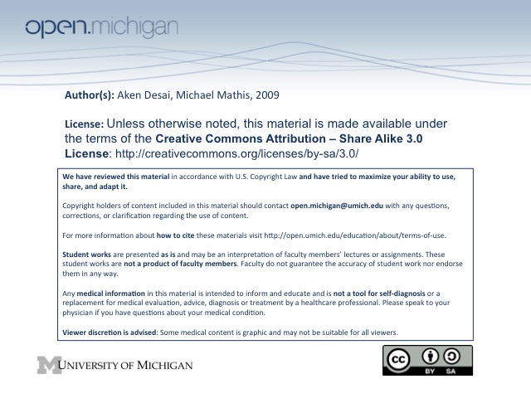
Hemostasis
Hemostatic System
- Hemostasis – blood maintained in fluid phase thru balance of procoagulant & anticoagulant components
- Hemostatic Plug – injury needs to be rapidly recognized and occluded, and clots needs to be amenable to remodeling during healing to allow normal blood flow in recovery (prevent ischemia distal to injury)
- Hemostatic System – has cellular components, adhesion molecules, pro/anticoagulants, fibrinolytic:
  - Cellular components – include platelets and endothelial cells, monocytes/macrophages:
    - Platelets – hemodynamic barrier at injury site, locus for coagulation reactions, SM contraction (ATP, 5-HT; stop bleed)
    - Endothelial cells – contribute to normal anticoagulant state of vessel
      - Antithrombin III – bound to cell surface, prevents coagulation
      - Tissue plasminogen activator – released into blood, breaking up clots
      - Thrombomodulin – activates protein C, anticoagulation
      - NO, prostacyclins (PGI₂) – also inhibit coagulation
  - Adhesion molecules – such as von Willebrand Factor, fibronectin; allow platelets to attach
  - Procoagulants – signal clotting cascade, including zymogens (V) & co-factors (Va) leading to fibrin clot
  - Natural Anticoagulants – reduce the amount of thrombin produced or directly inhibit thrombin action
  - Fibrinolytic system – factors controlling clot remodeling
Vascular Injury
- Von Willebrand Factor – giant multimeric protein binding to subendothelium during injury, stored in platelet granules and in plasma
- GpIb Receptor – VWF binds to Glycoprotein GpIb receptor in subendothelium, uncoils & exposes
multiple binding sites for platelet adhesion
- Platelet receptors – have a GpIb receptor binding VWF, also have a GpIIbIIIa receptor for aggregation
- Platelet Activation – binding to subendothelial causes partial activation and once exposed to tissue factor (TF) on surface of endothelial cells, fblasts, monocytes…
- Thrombin – generated by expsorure to TF; activates platelets by binding to…
- PAR1/PAR4 – protease activated receptors → thrombin binds & activates platelets → morphologic change
- Activated platelets – undergo morphological change, release alpha & dense granules into local milieu
- Tenase & prothrombinase – help activate thrombin release from platelet = “thrombin burst”
- Recruitment – attract more platelets to forming plug
Platelet Aggregation, Amplification, Clot
- GpIIbIIIa – on platelet, binds fibrin, which then binds GpIIbIIIa of circulating platelets → aggregation
- Extrinsic System – involve TF and Factor VII (think subendothelium initiation) → initiates
- Intrinsic System – involve Factors XI, IX, VIII (think platelet activation) → amplifies, doesn’t initiate
- Contact System – uses other cofactors, involved more in modulating inflammatory response
- Clotting Cofactors – several factors:
  - Factor VIII – forms tenase, activates Factor X → prothrombinase
  - Factor V – aids prothrombinase in activating Factor II (prothrobin) → thrombin
  - Thrombin Feedback – thrombin catalyzes XI → XIa of intrinsic pathway → amplification
Fibrin Assembly
- Activation – thrombin clips fpA & fpB from fibrinogen → forms protofibrils
- Fibrin Formation – protofibrils can complex vertically & horizontally to form fibrin
- Covalent crosslinks – form between protofibrils, make fibrin strong & resistant to plasmin breakdown
  - Factor XIII – catalyzes formation of crosslinks between protofibrils
Anticoagulation
- Thrombomodulin – on endothelial surface; binds thrombin & inhibits thru antithrombin III
  - Antithrombin III – binds thrombomodulin-thrombin complex; inhibits Factor Xa → no clot
- Protein C – activated by a thrombin-thrombomodulin complex → PCa inactivates Factor Va & VIIIa
- Protein S – can bind to Protein C to act as a cofactor; binding to C4b BP inactivates Protein S
Fibrinolysis
- u/t-PA – tissue plasminogen activator, activates plasminogen → plasmin, breaks down fibrin into D-dimers
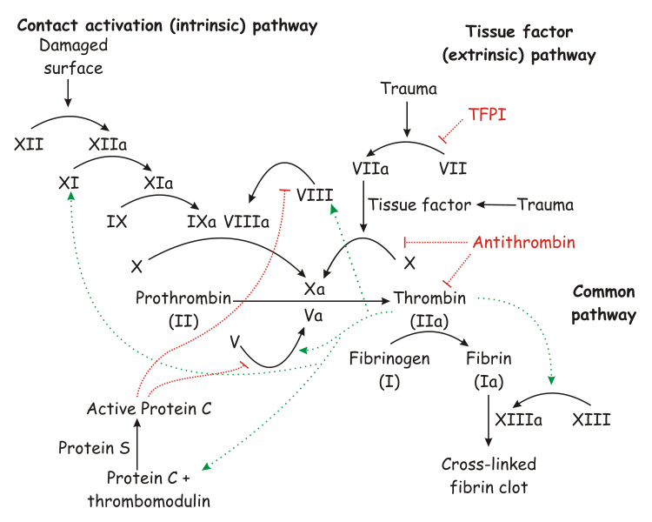
  - D-dimers – indicates the presence of a complete clot formation, good lab test to indicate that clotting has occurred and plasmin has acted to degrade fibrin cross-links
- TPA inhibitor – stops TPAs action on plasminogen, keeps clot
- Alpha-2-antiplasmin/TAFI – inhibits action of plasmin, keeps clot

