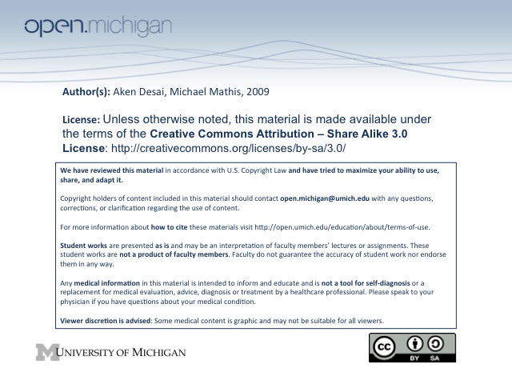
Bleeding Disorders
Bleeding Exam
- Severity/Timline – is patient having mild bleeding, or profuse? How long has this been a problem?
- Location – bleeding can be mucocutaneous (nosebleeds), joints/muscles, or surgical/trauma sites
  - Hemophilias/Clotting Factor Deficiency – bleeding into muscles/joints (hemarthrosis)
  - Platelet, VWF, Vessel Disorders – usually mucocutaneous bleeding (nose, gums, periods)
  - Single Organ/System – could be a neoplasm, ulcer, vascular abnormality
- Gingival bleeding – in addition to platelet disorders, can be vitamin C deficiency or gingivitis
Bruising Exam
- Ecchymoses – a bruise noted on exam; should note:
  - Site – knees/elbows are common sites for bruising, back/abdomen are uncommon sites
  - Spontaneous vs. Traumatic – key defining characteristic
  - Severity – how large? Is it palpable? How frequently do they occur?
  - Coloring – different bruise colors mean different D_{x}:
    - Purple/blue – most likely a true physiologic ecchymosis
    - Red – could be Cushing syndrome, excess steroids., senile purpura, UV exposure
    - Jet black – warfarin-induced skin necrosis
- Rashes – include petechiae & purpuras:
  - Petechiae – common sign of thrombocytopenia
  - Purpura – larger/thicker, a sign of vasculitis
Bleeding Sites
- Fibrinolytic Tissues – certain tissues have high fibrinolysis (urinary tract, endometrium, mucosal, GI)
- Hemoptysis/Hematemesis/Melena – rarely the presenting sign of patient w/ 1º bleeding disorder
- Menorrhagia – heavy or prolonged menstrual bleeding; often from 1º bleeding dz; need medical T_{x}
- Obstetric bleeding – if transfusions, iron T_{x}, or hysterectomy necessary post-partum, could be 1º bleed dz
Bleeding Patterns
- Spontaneous/Provoked – pay attention to bleeding during tooth extraction, surgery, trauma, childbirth
- Age of first bleed – earlier onset = inherited hemostatic disorder; later = inherited bleeding disorder
- Bleeding Patterns – variety of bleeding disorders related to different bleeding patterns
  - Mucocutaneous – disorder of platelets, VWF
  - Joint/Muscle – related to severe hemophilias or clotting factor deficiencies
  - Injury-related – usually a mild-moderate hemophilia, or mild clotting factor deficiency
  - Umbilical Stump – usually disorder of fibrinogen
  - Impaired Wound Healing – usually Factor XIII deficiency
- Bleeding Timing – acute = platelet/VWF defects, delayed = coagulation factor def (thrombin)
Bleeding History
- Hospital Visits for bleeding – ask patient if this ever was necessary
- Significant Bleeding S_{x} – ask if transfusions were necessary, H_{x} or anemia/iron deficiency
- Medication H_{x} – anticoagulants (warfarin, heparin), OTCs (aspirin), herbs (gingko, St. John’s wort)
- Nutritional H_{x} – are there deficiencies of vitamin K? vitamin C? general malnutrition?
- Family H_{x} – spontaneous bleeding, excessive surgical bleeding, anemia/Fe deficiency, inheritance
- Common Acquired Disorders – liver disease, renal failure, vitamin K deficiency, leukemia
Physical/Lab Exam
- Oral Mucosa – look for wet purpura, petechiae
- Skin – look for ecchymoses, petechiae, telangiectasias, bleeding around venipuncture sites
- MSK – look for joint deformities, limited mobility
- Labs – include CBC, Ferritin, and many platelet function studies:
  - CBC – Hbg, Hct, MCV, platelet count, smear (morphology, bone marrow dz)
  - Ferritin – look for Fe deficiency anemias
  - Platelet function tests – in addition to blood smear & platelet count, many tests (below):
Platelet Function Tests
- Bleeding time – normal less than 9 minutes; measures 1º hemostasis (VWF, platelet)
- Platelet aggregation – assess response to thrombin, ADP, epinephrine, collagen
  - GpIIaIIIb defect – platelets won’t clot in response to anything really
- Prothrombin Time (PT) – isolate plasma w/ some platelets, add thromboplastin (TF source) → clot time
  - Pathways Measured – measures process of extrinsic system (VII) → thrombin → fibrin
  - Not measured – nothing to do with contact factors (XI, XII)
- Activated Partial Thromboplastin Time (aPTT) – isolate plasma w/ platelets, phospholipid, activator and calcium added
  - Pathways Measured – measures contact factors & intrinsic pathway
  - Not measured – initial steps of extrinsic pathways
- Thrombin Clotting Time (TCT) – isolate plasma w/ platelets, thrombin added
  - Use – tests whether fibrinogen is intact & fibrin clot being formed
  - Pathways Measured – fibrinogen → fibrin clot
  - Not Measured – anything upstream of thrombin in clotting cascade
  - Heparin, FDPs – can artificially prolong clotting time
  - Warfarin – does not affect clotting time
- D-dimers & Fibrin Degradation Products – assess for presence of fibrin-lysed clot = d-dimer & FDP
  - Use – positive test indicates that clotting system has proceeded to complete & is fully intact
  - Pathway Measured – fibrinolysis, furthest downstream = cross-linked clot → FDP & d-dimers
  - DVT/Pulmonary Embolus – can be detected through this test, as excess FDP in blood
Lab Value Interpretations – Unexpected Values, Factor XIII, Empiric
- Unexpected Value – first and foremost, repeat test → many can be screwed up
- Factor XIII Deficiency – patient will present w/ obvious bleeding disorder, but normal tests (prob w/ heal)
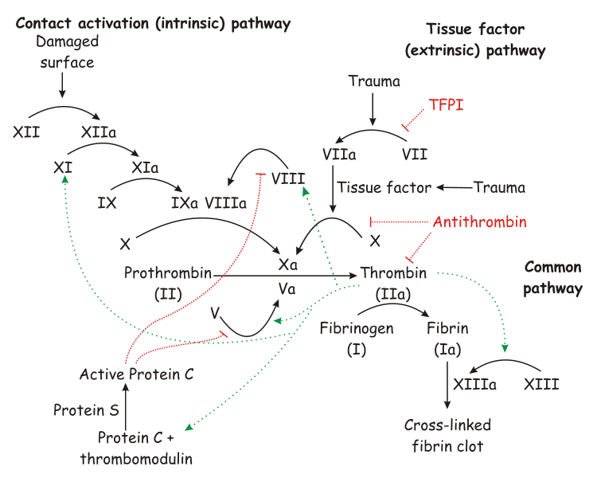
- Empiric Treatment – consider if patient obviously bleeding badly despite negative labs

