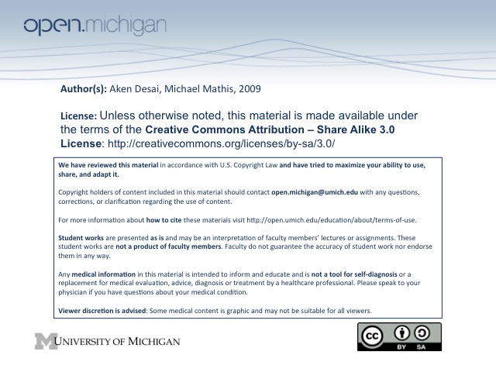
Congenital Coagulation Factor Deficiencies
Hemophilia A – Factor 8 deficiency, sex-linked
Hemophilia B – Factor 9 deficiency, sex-linked
Hemophilia C – Factor 11 deficiency
SQ vs. IM Injections – SQ injections okay in hemophilia, IM injections are not!
Hemophilia A
- Hemophilia A – a Factor VIII deficiency, sex-linked disorder, gene mutation
  - Prevalence – 1/5000 male births, 30% are de novo mutation, 70% family H_{x}
  - Sex-Linked – on X chromosome → sons of hemophilic M are okay, daughters obligate carriers
→ sons of hemophilic F 50% hemophilic, daughters 50% carriers
- Clinical Exam – excessive bleeding after a circumcision, deep cut, dental extraction; muscle/joint bleeding
- Lab D_{x} – usually has prolonged aPTT test (VIII = intrinsic), but normal PT (extrinsic unaffected) & TCT
  - Factor VIII Activity – after obtaining prolonged aPTT, pinpoint w/ specific assay (not 9, 11, 12)
  - Factor VIII Deficiency cutoff – below 50% of normal range
- Male Severity – range from asymptomatic – severe:
  - AS_{x}, VIII > 20% - asymptomatic usually, until a major surgery or trauma
  - Mild, VIII 5-10% - unlikely to spontaneously hemorrhage, but risk during trauma/surgery
  - Moderate, VIII 1-5% - common soft-tissue bleeding
  - Severe, VIII <1% - spontaneous muscle/joint hemorrhages
- Female Severity – F carriers have 50% Factor VIII usually, but Lyonization can bring down to low as 25%
Hemarthrosis
- Acute Hemarthrosis – hemorrhaging into joint space, common in severe hemophilia
  - Warning signs – earliest S_{x} tingling sensation & warmth in joint space; severe pain hours later
  - Cartilage destruction – blood proteases penetrate synovial space, cause destruction
- Chronic Hemophilic Arthropathy – vicious cycle of rebleeding, leading to joint space destruction leading to synovial thickening and adhesion, hemosiderin deposits causing inflammation, fibrovascular proliferation, subchondral cyst formation, bone collapse and ankylosis
- Invasive procedure precautions – IV infusion of factor if doing ABGs, LP, bronch; immunizations don’t require infusion but should be given subQ
Hemophilia B
- Hemophilia B – a Factor IX deficiency, sex-linked disorder, gene mutation
  - Prevalence – 1/30,000 male births, 30% are de novo mutation, 70% family H_{x}
  - Sex-linked – same deal as Hemophilia A above…
- Clinical Exam – hard to D_{x} before 6 mo, due to naturally low factor IX (Vit K depdendent) in neonates
- Lab D_{x} – same as Hemophlia A, but for Factor IX
- Severity – same as Hemophilia A
Hemophilia C
- Hemophilia C – a Factor XI deficiency, not-sex-linked, gene mutation
  - Prevalence – most common in Ashkenazi Jews
  - Not sex-linked – inherited in autosomal recessive fashion
- Clinical Exam – more variable, milder S_{x} usually after major surgery/trauma; no spontaneous joint/muscle bleeds
- Lab D_{x} – same as Hemophlia A, but for Factor XI
Factor VII Deficiency
- Prevalence – rare autosomal recessive disorder; from liver disease or vitamin K deficiency
- Clinical Exam – similar to Hemophilia A, but milder
- Lab D_{x} – has a normal aPTT & TCT but a prolonged PT
Common Pathway Factor Deficiencies
- Common Pathway Factors – include Factor II (thrombin), Factor V & X (prothrombinase)
- Prevalence – all are rare autosomal recessive disorders
- Clinical Exam – involve soft tissue bleeding and hemarthroses
- Lab D_{x} – has a prolonged PT and aPTT, but normal TCT
Congenital Fibrinogen Defects
- Hereditary Afibrinogenemia – no clottable (functional fibrin) or no antigenic (fibrin protein)
- Hereditary Hypofibrinogenemia – low clottable (functional fibrin) and low antigenic (fibrin protein)
- Hereditary Dysfibrinogenemia – low clottable (fxn’l fibrin), but normal antigen (protein); cirrhosis
- Clinical Exam – has hemophilia presentation but less hemarthroses
  - Clottable fibrin – when falls below 50 mg/dL, bleeding more likely to manifest
  - Thrombotic events – some dysfibrogenemias do paradoxically present with thrombotic events
- Lab D_{x} – has prolonged everything, since final step in clotting pathway
Factor XIII Deficiency
- Factor XIII – used in creating covalent crosslinks between fibrins in clot; deficiency = premature lysis
- Prevalence – rare autosomal recessive disorder
- Clinical Exam – umbilical stump bleeding, intra-cranial hemorrhage, and soft tissue bleeds
- Lab D_{x} – has normal everything, since clot forms fine, just lysed too early
  - Urea clot solubility test – shows rapid clot dissolution due to lack of crosslinks
  - Threshold – clot solubility test only detects factor XIII levels <4-10%, this is okay, since only 4-
10% needed for normal life
Von Willebrand’s Disease
- Von Willebrand Factor – used for anchoring platelets to site of vascular injury; deficiency = VWD
  - Subunits – has many subunits
    - Factor VIII binding region – allows for transport of Factor VIII in blood
    - Gp1b receptor binding region – binds to platelet receptors & subendothelium
  - Thrombotic Thrombocytopenic Purpura (TTP) – VWF plays important role here
  - Factor VIII Carrier – serves as intravascular carrier protein for factor VIII to prevent cleavage
- Prevalence – most common congenital bleeding disorder
- Clinical Exam – shows mucocutaneous bleeding (epistaxis, mucosal bleed, menorrhagia, dental bleed), postpartum hemorrhage, rare spontaneous hemarthrosis (only in type 3 when factor 8 level < 5%)
- Lab D_{x} – no one definitive test, instead assess bleeding time, Factor VIII activity, VWF antigen/activity
  - Factor VIII activity – measured same as Hemophilia A
  - VWF antigen assay – just an ELISA test for VWF antigen…
  - Ristocetin Cofactor Assay – measures VWF activity, atbx exposes Gp1b receptor on VWF from patient plasma → agglutinates normal platelets (not from patient) and compared to standard curvers
  - Ristocetin-Induced Platelet Aggregation Assay – similar test, except w/ patient’s own platelets, and low level of ristocetin → assesses if Gp1b receptor is abnormally sensitive (will agglutinate)
    - Assesses for Type 2B VWF deficiency!
Von Willebrand’s Disease Types
- Type I vWD – most common, all multimers present but quantity reduced
  - Factor VIII Activity, Ristocetin cofactor activity, vWF antigen – all reduced
- Type II vWD – qualitative defect in vWF, loss of specific multimers; several types:
  - Type 2A – most common, mutation in A domain, impaired assembly & secretion of vWF; large and intermediate multimers reduced
  - Type 2B – assessed by enhanced RIPA (above), spontaneous platelet binding → thrombocytopenia; caused by point mutation in A1 domain to result in increased and spontaneous binding to GpIb; mulitmer analysis shows loss of highest molecular weight multimers
  - Type 2N – mimics hemophilia A, autosomal recessive, almost normal vWF but can’t protect Factor VIII → reduced; mutation in factor VIII binding domain
  - Type 2M – has decreased vWF binding to platelets, due to unprocessed vWF, decreased activity and normal multimer distribution
- Type III – almost all vWF & Factor VII depleted, autosomal recessive, Sx include both platelet type immediate bleeding and hemophilic type delayed bleeding
Treatment for Coagulation Factor Deficiencies
- Fresh Frozen Plasma – can partially replace missing coagulant in emergency, get up to about 15%, can’t be routinely used because of large volume required
- Cryoprecipitate – contains Factors 8, 13, vWF → T_{x} these deficiencies; not used in Western world anymore because specific factors now readily available
- DDAVP – synthetic vasopressin, induces Factor VIII & vWF release from storage sites → T_{x} these def’s but doesn’t work for IIb and III
- Factor Concentrate – for Factors 8, 9, 13, vWF

