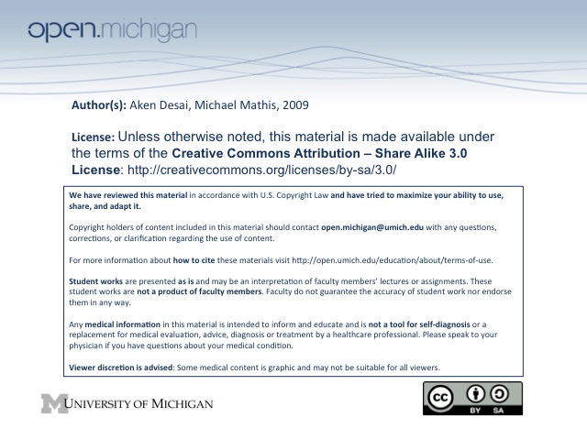
Intro to Radiation Oncology
Radiation Oncology – the use of radiation in the treatment of cancer
Radiation Basics
- EM Spectrum – radio (low freq) → (micro, light, x) → therapy rays (high freq) → cosmic (very high freq)
- Photons – include gamma rays, x-rays; deep penetration, (hi energy = hi penetration)
- Electrons – interact directly with tissues; skin dose high (T_{x} skin cancer, or tissue close to surface)
- Protons & Carbon Nuclei – deepest penetration, can kill healthy & hypoxic cells; but $$$$
  - Deep tumors – treated with photons, since these penetrate deep without causing skin damage
Teletherapy
- Cobalt Machine – antiquated, but uses radioactive cobalt to exposure patient to radiation (not used anymore)
- Linear Accelerator – electrons accelerated & made very energetic, direct @ metal target to make x-rays
Brachytherapy
- Brachytherapy – treatment of cancer via placement of radioactive sources next to tumor
- Inverse square rule – intensity is the inverse square of the distance (2x distance, 4x loss of intensity)
- Pros – allow for much more radiation given to tumor compared to normal tissue
- Cons – making for a uniform dose is difficult
- Permanent/Temporary – radioactive sources can be permanent or temporary (minutes to days)
- Methods – plastic tubes with beads, seeds, high dose rate with probe
Radiation-Cell Interaction
- Direct – electrons can damage DNA & cell membrane directly (30% of damage)
- Indirect – electrons can create free radicals (hydroxyl, superoxide, peroxide) which then damage cell (70% of damage)
  - Radiation duration – free radicals exist for microseconds → milliseconds after radiation
  - Biological effects – occur over hours/days/years after radioactive exposure
- Cellular Responses to Radiation – include a number of outcomes:
  - Irreversible block – cell never changes/grows = “senescence”
  - Apoptosis – programmed cell death, 1-2 days after; less common
  - Mitotic Death – tumor cells attempt to undergo mitosis, and death at this stage
  - Colony formation – cells which survive can go on to form colonies about 3 days after exposure
Radiation Effects on DNA
- Single Strand Breaks – well-repaired by cell, since template of other strand exists
- Double Strand Breaks – less well-repaired, no template to work off
- Single dose curve – acute bolus of radiation more effective at killing cells → more double strand breaks
- Repeated fraction curve – chronic low radiation doses less effective → DNA repair machinery works on
single strand breaks to fix before other breaks occur
- Fluorodeoxyuridine – inhibits sublethal damage repair and allows for repeated fraction dosing
Cell Death Mechanisms
- Mitotic Cell Death – damaged cells okay until they try to divide, then die → may take a while to do this
- Apoptosis – DNA damage activates cell death pathway; lymphocytes & spermatocytes sensitive
  - Lymphomas & seminomas can be destroyed via apoptosis after radiation T_{x}
- Cell Membrane Signals – cell membrane has many life/death signals, which radiation T_{x} can target
Radiation Effects in Cells
- Genetics – some cells inherently more sensitive to radiation than others
- Oxygen status – cells with more oxygen will have more damaging free radicals after radiation → hypoxic cells are resistant to radiation
- Cell Cycle – cells in M phase more sensitive to radiation than cells in S phase
- Chemical Modifiers – certain drugs in cells can act as radiation protector/sensitizer
- Radiation Physics – effects of radiation also dependent on physics:
  - Kind of radiation – carbon nuclei & protons much more damaging than electrons, photons…
  - Speed of dose – acute boluses much more damaging than slow fractions
  - Amount and total time of dosing
  - Area of radiation – obviously determines extent of damage
Radiation Effects at Tumor/Organ Level
- 4 R’s of Radiation Biology – Repopulation, reoxygenation, redistribution, repair
  - Repopulation – tumor cells can grow back during a course of radiation
  - Reoxygenation – tumor O₂ increases as cells die (less competition) → more & more effective
  - Redistribution – cell cycle distribution changes → become more aligned
  - Repair – cells can repair damage between fractions
- Hyperfractionation – if normal cells repair damage better than tumor cells, can fractionate radiation,
counting on a speedy normal cell recovery but a lagging tumor cell recovery
- Accelerated Fractionation – more frequent doses of same radiation amount; thus more total radiation;
reduce the treatment time in order to keep overall treatment radiation the same and prevent tumor growth during treatment
- Chemical Modifiers – include radiation sensitizers & protectors:
  - Sensitizers – for tumor cells, hypoxic cell sensitizers, chemotherapeutic agents, molecularly targeted therapies
  - Radiation protectors – for normal cells, scavenge free radicals, prevent cytokine damage (anti-inflammatory)
Normal Tissues
- Parallel organs – damage to small fraction has no toxicity like in lung and liver
- Serial organ – damage to small fraction produces toxicity like esophagus and spinal cord
- Therapeutic Index – want to maximize this in order to give effective radiation therapy:
  - Single-dose radiation – small therapeutic index (about 1.2)
  - Fractionated radiation – much larger therapeutic index (e.g. 1.2^30 = 36)
  - Chemical Modifiers – also aim at raising therapeutic index
Radiation Fractionation
- Single Large Dose – used when small part of organ can afford to be damaged; similar to ablation
- Repeated Fractionated Doses – used when organ cannot afford to be damaged, need normal cells to heal
Radiation Failure
- Tumor Size – cant give enough radiation to kill every tumor stem cell without intolerable damage
- Tumor physiology – hypoxic tumor cells resistant to radiation; tumor cells may be better at recovering
Radiation Success
- Not due to initial damage, only due to prolonged recovery of tumor cells
- Normal cells migrate back into irradiated field
- Cancer cells not as good at repairing DNA damage
- Tumor is more dependent on new vasculature which may be more sensitive to radiation

2nd Hour of Lecture – The concepts sheet doesn’t list anything from the 2nd hour, so no notes.

