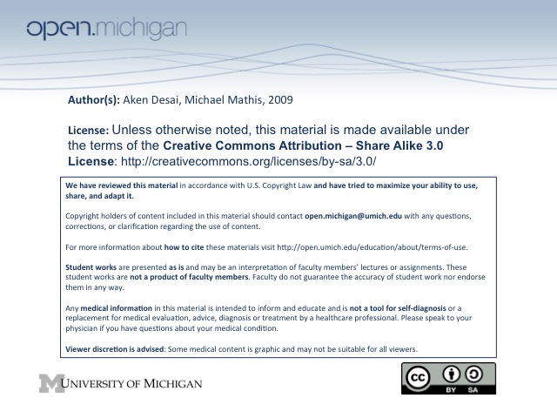
Acquired Bleeding Disorders
Coagulation Initiation – Extrinsic Pathway
- Tissue Factor – exposed on damaged endothelium, and on activated macrophages at site of injury
- Factor VII – binds to TF, complexes & becomes activated to Factor VIIa
- Factor X – binds to Factor VIIa/TF complex, becomes activated to Factor Xa
- Factor II (prothrombin) – proteolytically cleaved by Factor Xa → Factor IIa (thrombin)
- Thrombin – helps lead to clotting, but extrinsic pathway isn’t enough… needs intrinsic feedback
Coagulation Amplification (Feedback) – Intrinsic Pathway
- Thrombin – converts Factor XI → XIa
- Factor XIa – converts Factor IX → IXa
- Factor IXa – feedback onto Factor X → Xa, helps reinforce clotting cascade
Coagulation Propagation (Cofactor Catalysis)
- Tenase – tenase requires Factor VIIIa, but once activated will catalyze Factor X → Xa
- Prothrombinase – requires Factor Va, and will catalyze Factor II (prothrombin) → IIa (thrombin)
- Thrombin Feedback – thrombin will feedback on Factor VIII (→tenase) and Factor V (→ prothromb)
Contact System – Pre-Intrinsic Pathway
- Contact System – occurs before intrinsic pathway, but any defect doesn’t result in clinical bleeding
- Factor XII – PK coverts to Factor XIIa
- Factor XIIa – activates Factor XI → intrinsic pathway
Coagulation Pathway Inhibitors
- Tissue Factor Pathway Inhibitor (TFPI) – inhibits action of Factor VIIa (TF-binding), stops extrinsic
- Antithrombin – inhibits action of Factor Xa & Thrombin → stops common pathway using thrombin
  - Weak interaction – physiologic antithrombin has a very weak inhibition, fails to totally stop path
  - Heparin – changes conformation of antithombin → makes for a strong antithombin action
- Protein C – combines with cofactor Protein S, proteolytically degrades Factor VIII & V, stops intrinsic
  - Protein S – cofactor which needs to be in free form (not bound to C4b) to work
  - Bound Protein S – unable to complex with protein C, and intrinsic pathway continues
Clot Formation – Fibrin Assembly
- Thrombin – acts to cleave fpA & fpB off fibrinogen → forms insoluble fibrin monomer (protofibril)
- Fibrin monomers – assemble into a fibrin polymer (clot)
- Factor XIIIa – acts on fibrin polymer to crosslink monomers → clot stronger
Clot Degradation – Plasmin Assembly
- Plasminogen – activated to plasmin
- Plasmin – proteolytically cleaves fibrin polymer → clot lysis and D-dimer release
- D-dimer – released via plasmin, can be assayed to verify entirely intact clotting system, embolus presence
Coagulation Pathway Assays
- aPTT – uses the contact system to initiate intrinsic clotting pathway in test tube
- PT – uses extrinsic clotting pathway
Acquired Bleeding Disorders
DIC
- Disseminated Intravascular Coagulation (DIC) – simultaneous thrombin & plasmin activity
- Process – underlying disorder activates coagulation → systemic coagulation:
  - Widespread fibrin deposition – from systemic coagulation, leads to subacute thrombosis
  - Consumption of platelets & clotting factors – more commonly leads to acute hemorrhage
- Blood Smear – will show schistocytes (from RBCs shearing through fibrin) and platelet absence
- Etiology – can be acute DIC and subacute DIC:
  - Acute DIC – triggered by infection (sepsis), obstetric complications, trauma
  - Subacute DIC – usually a malignancy, obstetric (retained dead fetus), vascular thrombotic dz
- Clinical Exam – present with paradoxical acute hemorrhage and subacute thrombosis
- D_{x} – CBC shows lowered platelets, prolonged PT/aPTT; confirmed by elevated D-dimer/FDP’s
- T_{x} – must treat underlying condition, then worry about restoring normal blood status:
  - T_{x} underlying condition – antibiotics, surgery, chemotherapy, embolization; dz-specific T_{x}
  - APML – give all trans-retinoic acid
  - Replacement therapy – give platelets, fresh frozen plasma (FFP), cryoprecipitate
  - Heparin – may be useful in acrocyanosis, thrombophlebitis, etc
Microangiopathic Hemolytic Anemia
- Blood smear – schistocytes and microcytes (spherocytes), accompanied by thrombocytopenia
- Intravascular hemolysis – caused by red cells traversing small blood vessels with fibrin deposition or platelet aggregates or in areas of high turbulence
- Fragmentation – fragments are targeted for destruction in RES (spleen)
- DDx – DIC, TTP, HUS, malignant HTN, aortic stenosis, HELLP syndrome/eclampsia, HIT, severe GN
Thrombotic Thrombocytopenic Purpura
- Classic pentad – MHA (see above), thrombocytopenia, renal involvment, neuro signs, fever
- Pathogenesis – autoantibodies inhibit ADAMTS13 (metalloprotease vWF cleaver in platelet-rich thrombi) → large amounts of platlets accumulate at clot (congenital deficiency = Upshaw-Schulman syndrome)
- Labs – hemolysis, thrombocytopenia, abnormal renal tests
- Treatment – plasma exchange +/- immunosuppression
Vitamin K Deficiency
- Vitamin K – functions to carboxylate a number of coagulation enzymes & inhibitors to active form
- Vitamin K deficient – coagulation enzymes that have been produced are no longer active
- Etiology – includes nutritional depletion, antibiotic SE, and warfarin effect:
  - Nutritional depletion – alchoholics, long-term TPN nutrition → no more vitamin K
  - Antibiotic administration – can interfere with bacteria making vitamin K in gut
  - Warfarin – inhibits epoxide reductase (which recycles vitamin K)
Liver Disease
- Liver – function to synthesize and clear both procoagulants and inhibitors
- Factor VIII – usually increased (due to lack of clearance)
- Factor V – will be reduced; distinguishes from vitamin K deficiency
- Fibrinogen – very last enzyme to fall; signal of severe liver disease
- Liver disease sequelae – portal HTN, varices, gastritis, hemorrhoids → bleeding
Massive Transfusion
- Massive Transfusion – transfusion of more than 1.5x patient blood volume in 1 day
- Acquired coagulopathy – from dilution of plasma & platelets with excess anticoagulant → hemorrhage
  - Anticoagulant – about 10% of a transfusion is anticoagulant → can build up easily in blood
- Prevention – administer 1 unit FFP & calcium chloride for every 4-6 units of PRBC’s (packed RBCs)
Prolonged aPTT, normal PT
- Factor VIII inhibition – antibody meadiated; will affect intrinsic pathway only
- Etiologies – can be elderly, post-partum, CT disorder, or B cell malignancy
- Clinical – see ecchymoses, hematomas; favorable prognosis
- T_{x} – give immunosuppressive T_{x}, also give clotting factors during bleeding as “bypassing agents” (activated prothrombin complex concentrates, recombinant factor VIIa)

