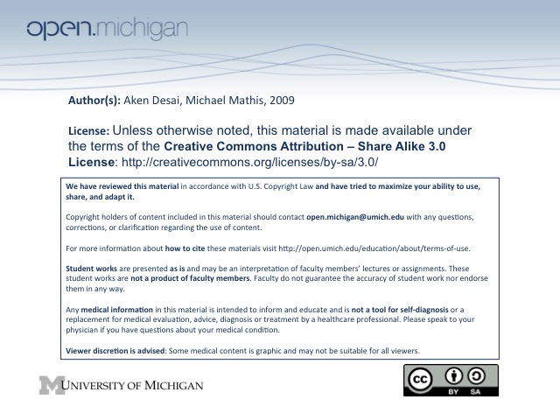
Platelet Disorders
Thrombocytopenia of Decreased Platelet Production
- Bone Marrow Disease – include 1º failure, invasion, or injury:
  - 1º bone marrow failure – bone marrow idiopathically stops producing blood cells
  - Bone marrow invasion – from metastatic cancer, myelofibrosis, or cancer in situ
  - Bone marrow injury – reaction to drugs, radiation, chemicals, alcohol
- Nutritional Disorders – leading to lack of compounds necessary to build platelets
- Megaloblastic Anemia – Fe deficiency affects platelet production…
- Hereditary Disorder – involve decreasing megakaryocytes or producing bad megakaryocytes
Immune Thrombocytopenias
- Autoimmune thrombocytopenia – antibodies produced against platelets:
  - Acute – more common in children, preceded by viral infection; generally self-limited
  - Chronic – commonly seen in women 20-40y, a chronic disorder, have normal bone marrow
    - T_{x} – give immunosuppressives, reduce platelet removal by macrophages
  - Secondary – associated with disordered lymphoid function (e.g. SLE, lymphoma, leukemia)
- Post-transfusion Purpura – patient’s serum contains antibodies to platelet antigens of donor blood
  - Pla¹ – most common antigen on a platelet which can have antibody response
  - Innocent bystander mechanism – often patient’s own platelets also destroyed in Ig response
- Neonatal Isoimmune Thrombocytopenia – maternal antibodies to neonate platelets transferred in utero
  - Mother – is Pla¹ negative, and has been previously sensitized to Pla¹ → develops Ig’s
  - Neonate – is Pla¹ positive, and mother’s transferred serum mounts immune response
Drug-Induced Immune Thrombocytopenia
- Common Drugs – include sulfa drugs, penicillin, gold salts, dilantin, lasix
- Mechanism – several different mechanisms drugs cause immune reaction:
  - (Comp. “Hapten Mech”) – drug binds to platelet, Ig recognizes, platelet bystander destroyed
  - (Protein/Drug Complex) – drug binds to platelet surface sturcture → “complex” → Ig attacks
  - (Comp. “In Vivo Sensitization”) – drug binds to platelet surface antigen → “neo-antigen” → Ig
- Treatment – REMOVE DRUG!!!
- Thrombosis problem – Ig response invokes complement system on platelets, pro-thrombotic contents
lysed into blood
Heparin-Induced Thrombocytopenia
- Mild – direct chemical interaction between heparin & platelet surface; premature clearance, rarely <100K
- Severe – life-threatening; several stages:
- Heparin & platelet factor IV combine (Hep-PF₄)
- IgG antibody binds to Hep-PF₄ to form immune complex
- F_{c} region of antibody binds to platelet, and platelet activates
- Large quantities of PF₄ released into plasma
- PF₄ will bind to more heparin, or heparin-like proteins (heparans) on endothelium
- Immune response damages endothelium → limb ischemia, myocardial infarction, stroke
Non-Immune Thrombocytopenias
- Dissmeinated Intravascular Coagulation – coagulation uses up all available platelets
- Thrombotic Thrombocytopenic Purpura (TTP) – disorder of vWF proteolysis
  - Mechanism – lack of ADAMTS 13, → cleaves long vWF; without = massive platelet plugging
  - No Fibrin – vWF platelet plugs don’t have fibrin (no clot cascade); fibrin = DIC
  - Findings – include a classic pentad:
    - Microagniopathic hemolytic anemia – shows schistocytes on blood smear
    - Thombocytopenia – platelets reduced
    - Neurologic dysfunction – confusion
    - Renal Failure – can’t filter RBC’s? Hemolytic uremic syndrome…
    - Fever – also present
  - Prevalence – rare (1/250,000 each year, young adult females; 90% fatal no T_{x}, <20% fatal w/ plasmpheresis
- Splenic Sequestration – splenic enlargement will cause spleen to hold up to 90% of platelets, rather than 20%
Thrombocytosis
- Primary Thrombocytosis – series of mutations leading to excess (often malformed) platelets; rare
- Secondary Thrombocytosis – in response to inflammation, hemorrhage, post-splenectomy, Fe def.
  - Inflammation – body produces blood cells to fight infection
  - Hemorrhage – makes sense for body to produce excess clotting factors to stop bleeding
  - Post-splenectomy – no buffer for platelet storage
  - Iron deficiency – can result in an increase in platelet count
Thrombocytopenia Ranges
- 100,000 – slight risk of bleeding
- 20,000-70,000 – increased risk of bleeding with trauma/surgery
- <20,000 – increased risk of spontaneous hemorrhage
- <10,000 – increased risk of spontaneous intracranial hemorrhage
Platelet Function Tests
- Peripheral Smear – Are platelets visible? Size? Granules?
- Platelet Count – how many platelets are in the blood?
- Bleeding Time – highly variable; normal < 9 minutes
- Platelet Aggregation/Secretion Studies – assess platelet responses to various chemicals
Congenital Qualitative Platelet Disorder
- Qualitiative Platelet Disorder – dysfunctional platelets; usually normal count, variable bleeding
- Congenital Platelet Disorders – involve defects in adhesion, aggregation, activation, and secretion:
  - Adhesion Disorders – vWF & GpIb interaction defective:
    - Von Willebrand’s Disease – AD; vWF dysfunctional, can’t bind GpIb
    - Bernard Soulier syndrome – AR; GpIb dysfunctional; can’t have vWF bind
    - Lab Results – aggregation normal, just can’t adhere; flat ristocetin test; otherwise norm
  - Aggregation Disorders – defects in fibrinogen & IIb/IIIa receptor
    - Afibrinogenemia – fibrinogen not available for binding platelet IIb/IIIa receptor
    - Glanzmann’s thrombocytopenia – platelets lack IIb/IIIa receptor
    - Lab Results – adhesion normal (ristocetin normal), but flat aggregation tests (ADP, Epi)
  - Activation/Secretion Disorders – platelets can’t activate to speculated form
    - Storage Pool Deficiency – deficiency of dense/alpha granules activating platelet
    - Stimulus-Response Pathway Defect – defect in pathway leading to granule secretion
    - Primary Secretion Defects – defect in ability of platelet to secrete granule after signal
Platelet Aggregation Pathway
- Stimulus binds to receptor
- Receptor causes PLA2 to produce arachidonic acid
- Arachidonic acid cascade produces thromboxanes
- Thromboxanes cause release of fibrinogen granules
- Fibrinogen binds two platelets together at IIbIIa receptor
Acquired Qualitiative Platelet Disorder
- Uremia – causes abnormalities in vessel wall & platelet prostaglandin pathways → T_{x} dialysis
- Myeloproliferative Disorders – loss of first and second wave of aggregation → arterial and venous thrombosis
- Myelodysplasia, Leukemia – usually produces bad platelets
- Dysproteinemias – increased plasma viscocity → interferes with fibrin polymerization, can’t clot
- Cardiopulmonary bypass – tubing can partially activate platelets
- Anti-platelet antibodies – can bind & block receptors important for adhesion & aggregation; generally have better platelet function than other disorders here
- Liver Disease – bad protein synthesis → coagulopathy; creates bad platelets
- Drugs – can bind to platelet receptors, interfere with action

