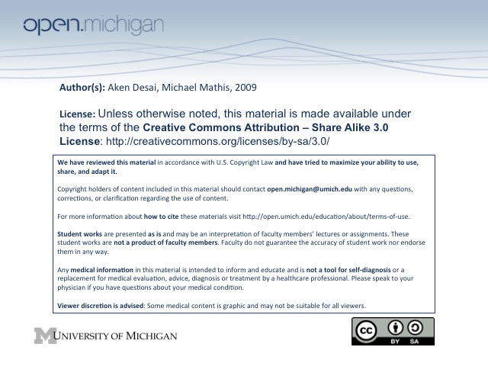
Thrombosis
- Virchow’s Triad – includes stasis, injury, hypercoagulability:
  - Venous Stasis – slowed rate of blood flow; through immobility or compression
  - Vascular Injury – involves damage to vasculature favoring deposition of platelets/fibrin
  - Hypercoagulability – blood components are in favor of thrombosis to begin with
- Related disorders – thrombophlebitis, compartment syndrome, DVT
- Venous Thrombosis Risk Factors – >40, obese, H_{x}, stasis, surgery, parturition (clot to stop childbirth
hemorrhage), estrogen, medical disorders, genetic thrombophilia
- Genetic Thrombophilia – indicated by thrombosis <50 yo, recurrent thromboses, Fam H_{x}, and
thrombosis @ unusual site (portal/renal vein, mesenteric, CNS venous sinus)
Congenital Anticoagulant Deficiencies
- Protein C Deficiency – vitamin K dependent protein, inactivates Va, VIIIa
  - Prevalence – present in 1 in 200-500 individuals, 2-9% of individuals w/ venous thrombosis
  - Vs. Acquired – many diseases lead to acquired Protein C deficiency, so be wary of D_{x} congen.
  - Warfarin (Coumadin) – will lower protein C levels, so can’t D_{x} when on these drugs
    - Warfarin hypercoagulability – warfarin dec. protein C faster than coagulants initially!
- Protein S Deficiency – acts as a cofactor for Protein C
  - Free Active Form – only 40% circulates in this form, rest is bound by C4b
  - Vs. Acquired – same as Protein C… many diseases lead to this, may not be congenital
  - Oral contraceptives, pregnancy – will lower protein S levels, so can’t D_{x} at these times
- Antithrombin III Deficiency – binds natural heparin-like molecules to activate & anti-coagulate
  - Action – binds & inhibits thrombin & Xa, along with IXa, XIa, XIIa
  - Severity – much more severe than protein C/S deficiencies; causes very early thromboses (teen)
  - aPTT test – heparin won’t prolong, since ATIII isn’t really there! Often how D_{x} is made…
  - Reduced ATIII – can be lowered by chronic heparin therapy, or acute thrombosis
Pro-Coagulant Thrombophilia
- Factor V Leiden – mutation in Factor V leading to resistance to protein C → hypercoagulability
  - Protein C Resistance – protein C can no longer deactivate mutated factor V
  - Prevalence – only Caucasians
  - Thrombosis – 7x increase in risk
  - Oral contraceptives – will magnify thrombosis risk
- Prothrombin 20210 Mutation – excessive prothrombin synthesis
  - Thrombosis – also increased risk
  - Prevalence – also only in Caucasians (some SE Asians too, likely result of trade routes)
- Fibrinolysis Abnormality – decreased levels of plasminogen or elevated plasminogen inhibitor (PAI-1)
- Hyperhomocysteinemia – associated with premature atherosclerosis, venous thromboembolism
  - Oxidative damage – elevated levels of homocysteine lead to vascular damage → thrombosis
  - CAD – greater risk of CAD due to accelerated atherosclerosis
  - Methylene Tetrahydrofolate Reductase – elevated MTHFR leads to elevated homocysteine
- Dysfibrinogens – fibrinogens polymerize too easily, or which lack cleavage sites → thombosis
- Excessive Clotting Factor – most commonly too much Factor VIII → hypercoagulability
Arterial/Venous Thrombosis
- Arterial Thrombosis – atherosclerotic plaques, a “white thrombus”
  - Elevated – lipoproteins, factor VII, homocysteine, platelets, GpIIbIIIa gain-of-function
- Venous Thrombosis – a “red thrombus”
Lipoprotein (a)
- Lp(a) – modified LDL, serum levels are genetically determined
- Structure – homologous to plasminogen → interfere w/ fibrinolysis and interacts with macrophages to promote foam cell formation and deposition of cholesterol
- ICAM-1 – enhanced expression leading to recruitment and binding of monocytes to vessel wall
- Levels – associated w/ cerebrovascular disease in men

