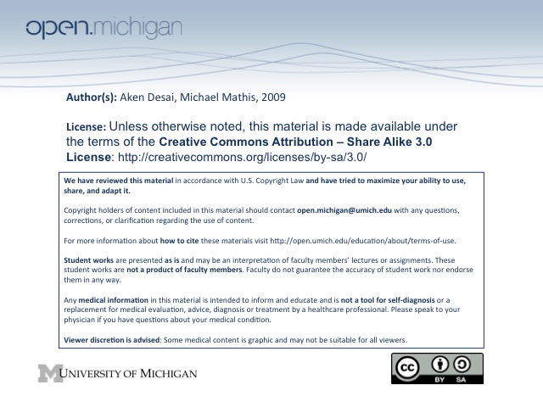
Pediatric Hematology
QUIZ: Embryonic Hematopoiesis – in yolk sac 1st trimester, liver 2nd trimester, bone marrow 3rd trimester
QUIZ: Hemoglobin Types – @ birth, 50% of RBC have Hgb F
QUIZ: Neonate Hemoglobin – neonate is polycythemic (high Hgb) at birth, and decreases to trough 14 weeks
QUIZ: Premature Neonate Platelets – count will be lower than normal, but despite this, under 150K = always bad
QUIZ: Erythroblastosis Fetalis – hemolytic anemia of Rh⁺ infant caused by Rh⁻ mother producing antibodies
Embryonic Hematopoiesis
- Yolk Sac – hematopoiesis site during first trimester; begins 15-20 days, ends 12 weeks
- Liver – hematopoiesis site during second trimester; stem cells from yolk sac migrate here; ends at birth
- Bone Marrow Space – 1º hematopoiesis site during third trimester and beyond; space formed by 3 mos, cellular by 20 wks, primary site by 24 wks
Hemoglobin Synthesis
- Chromosomal distribution – 11 has genes for beta chain, 16 has genes for alpha chain
- Gower 1 & 2 – earliest types of hemoglobin 1st trimester, use ζ₂ε₂ and α₂ε₂ subunits
- Fetal – another hemoglobin type, made in liver, uses α₂γ₂ subunits
- A₁ – earlier main adult hemoglobin type, made in marrow, uses α₂β₂ subunits
- A₂ – final supplementary adult hemoglobin type, made in marrow, uses α₂δ₂ subunits
Hemoglobin Values in Newborns
- Neonate – has high (17-18) hemoglobin concentration (from both fetal & adult hemoglobin made)
- 2 Months – has low (10-12) hemoglobin concentration (from fetal hemoglobin stopping) → physiologic anemia
- Child 1-12y – has slightly low (12-13) hemoglobin conc.
- Adult – has normal (14-16) hemoglobin conc.
- Retic count – decreases from 28 wks onward
Newborn RBCs
- Rigidity – neonate “eggshell” RBCs are more rigid and less permeable than adult RBCs
- Stability – neonate RBCs are less stable, w/ more unstable methemoglobin, & more denaturation-prone
- O₂ Affinity – neonate RBCs have greater O₂ affinity (fetal Hgb)
- Well water – has high nitrite/nitrate concentrations, oxidizes Hgb → methemoglobin; don’t give to babies
- Clamping strategy – because 1/3rd of blood volume in placenta at time of birth, OB/GYN holds newborn at level of womb for 2 minutes then clamps; clamp early and child is anemic, clamp late and child is polycythemic
Neonate Platelets
- Premature Neonates – have low platelet counts (220,000 – 350,000)
- Normal Neonates – have high platelet counts (250,000 – 380,000)
- Normal Adult/Child – normal platelet counts (250,000 – 350,000)
- Always abnormal – despite low premie platelet counts, a count less than 150,000 = always abnormal
- Neonate Platelet Function – equivalent to adults
Newborn WBC
- Neonate – have a very high PMN count, helps protect against infections during birth
- Infant-Preschool – PMN count dips down, and high lymphocyte count, helps develop immunity
- School-age-Adult – lymphocyte count dips back to normal level, PMN count picks back up to normal
Newborn Coagulation Factors
- Clotting Factors – diminished synthesis & high clearance during birth, but…
  - Vitamin K Dependent Factors – Factors 2, 7, 9, 10 all diminished at birth → vitamin K supp.
  - PT, aPTT – both elevated (lack of clotting) at birth
  - Factor VIII – should be normal at birth, so if low → Hemophilia A
  - Factor IX – vit K dependent, so cannot diagnose Hemophilia B at birth
- Anti-clotting Factors (Protein C/S) – even more diminished than clotting factors, thus thrombosis risk
Newborn Diseases – infections of newborn (rubella, CMV, toxo, syphillis, malaria) can lead to hemolytic anemia & thrombocytopenia
Newborn Iron – normal @ full-term (takes iron from mother, even if mom low), but low in premies (get iron late); thus if <36 wks at birth, iron supplementation is necessary
Erythroblastosis Fetalis
- Erythroblastosis Fetalis – left-shift of RBCs (nucleated RBCs) in neonates, from hemolytic anemia
- Pathogenesis – most commonly from Rh antigen on RBCs → mother produces antibodies → hemolysis
  - Transfer – only need about 1 mL of fetal RBC to be transferred to elicit maternal immunity
  - ABO incompatible – if mother & child also ABO incompatible → risk reduced of EF!, since this immune response quicker than Rh response, but is primarily an IgM response, which can’t cross placenta (IgG only = Rh response)
  - Obstetric Procedures – C-section, amniocenesis, etc have risk of blood transfer → increase risk for next child
- Compensation – infant forced to increase erythropoiesis (leads to left-shift RBCs) so they are only mildly anemic at birth
- S_{x} – include jaundice, pallor, hepatosplenomegaly, hydrops:
  - Jaundice – seen quickly after birth, from hyperbilirubinemia due to hemoglobin breakdown
  - Pallor – due to anemia of hemolysis
  - Hepatosplenomegaly (HSM) – due to liver overdrive to produce compensatory RBCs
  - Hydrops – CHF due to heart recognizing anemia & pumping way too fast
- Lab D_{x} – low hemoglobin, high retics/nucleated RBCs, hyperbilirubinemia
- T_{x} – force an early delivery, before CHF hydrops; can also give intrauterine transfusions
  - Exchange transfusion – at birth, put catheter into fetal blood line & replace with compatible
RBCs which won’t lyse from transferred maternal antibodies if Hgb < 12 or Bilirubin >20
  - Maternal plasmapheresis – get rid of maternal antibodies produced…
- Prevention – can use Rhogam → antibodies against Rh, given to mother so that this “fake” immune
response can prevent the development of a real immune response

