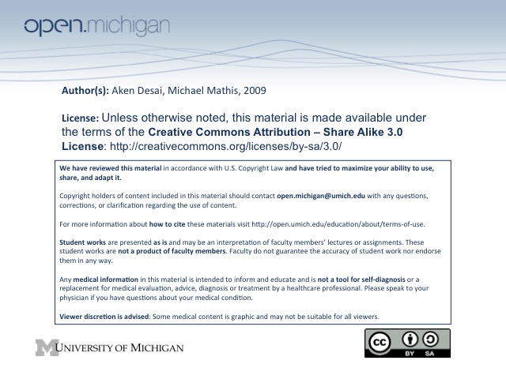
Blood Transfusion Complications
Transfusion Reactions
- Hemolytic Reactions – include acute and delayed reactions; ABO/Rh incompatibility
- Febrile non-hemolytic reaction – mild inflammatory response elicited from cytokines / leukocyte Ig’s
- Allergic (urticarial) & anaphylactic reactions – allergic reactions to/from donor blood
- Bacterial contamination – nonsterile equipment; donor skin/blood bacteria; platelet x-fusion (room temp)
- Transfusion-related acute lung injury – due to platelet activation/HLA reaction, causes pulm. edema
- Transfusion-associated circulatory overload – simulates CHF
- Post-transfusion purpura – clots?
- Graft vs. Host Disease – transfused T-cells are engrafted, attack host
Hemolytic Transfusion Reactions
- Acute Hemolytic TR – usually ABO incompatibility; presentation <24 hrs, has intravascular hemolysis
- Delayed Hemolytic TR – usually Rh incompatibility; presentation >24hrs, has extravascular hemolysis
- HTR Presentation – different for intravascular/extravascular
  - Intravascular (acute) – fevers/chills, pain @ infusion site, hemoglobinemia/-uria, dyspnea, vomiting, shock
    - Complications – leads to DIC, renal failure, ARDS, death
    - Mortality – about 10%
  - Extravascular (delayed) – fevers/chills, leukocytosis, anemia
    - Complications – leads to DIC, renal failure, sickle cell crisis (can be severe)
    - Mortality - rare
- HTR D_{x} – Can be detected through free serum hemoglobin, positive DAT
  - Positive DAT – RBCs coated with antibodies, thus bad transfusion
  - New RBC antibody – new Ig developed against antigen
  - Misidentification – most common cause of a HTR!
  - Bleeding + Hemoglobinuria in Anesthetized Patient – means a transfusion reaction
Febrile Non-Hemolytic Transfusion Reaction
- Mechanism – two main mechanisms:
  - Leukocyte antibodies in recipient – host reacts to leukocytes of blood transfusion; doesn’t happen often b/c WBCs filtered out
  - Cytokine release – when blood is stored, some cytokines (IL-1, IL-6, CD40L) are released into blood bag
- Presentation – patient has fevers/chills during transfusion
- Incidence – about 1:250 transfusions
Allergic Transfusion Reaction
- Mechanism – antibody to allergens/plasma proteins in donor blood; or passive transfer of donor IgE’s
- Presentation – looks like allergic reaction → hives, flushing, dyspnea, vomiting
- Incidence – about 1-3% of transfusions
Anaphylactic Transfusion Reaction
- Mechanism – generally when recipient has no IgA, and transfusion elicits anti-IgA response of recipient
  - Haptoglobin – also can happen if recipient has no haptoglobin → anti-haptoglobin response (Japan)
- Presentation – patient has anaphylactic reaction: bronchospasm, hypotension, stridor, shock
- Preventation – make sure to transfuse IgA-deficient plasma, and wash RBCs/platelets
Bacterial Contamination
- Platelet Transfusion – since stored at room temperature, higher risk for bacterial contamination
- Organisms – platelet transfusions have wide variety (Gram – rods, Gram + cocci), RBC = pseudomonas, Yersinia
- Sources – from nonsterile blood donation, or bacteria on donor skin/blood
- Presentation – has fevers/chills, rigors, hypotension, shock, DIC → looks like HTR or sepsis
- D_{x} – do a Gram stain, cell culture
- Treatment – initial broad spectrum abx until culture results come back
Transfusion-Related Acute Lung Injury (TRALI)
- Mechanism – several key mechanisms:
  - Donor antibodies to HLA/HNA antigens – can cause TRALI by releasing vasoactive substances
  - Platelet problems in storage – producing platelet activating factor-like lipid, or CD40L release
- Presentation – non-cardiogenic pulmonary edema
- Mortality – 10-20%
- DD_{x} – includes HTR, allergic reaction, fluid overload, acute lung injury
- Prevention – use plasma components from male donors; (use female donors for concentrates…)
  - Pregnant women – likely to have HLA/HNA antibodies, since passive transfer from neonate
  - Mother-to-child blood donation – not good, this is precisely what mom produced Ig’s against
  - Antibody screening
Transfusion-Associated Graft vs. Host Disease
- Mechanism – transfused T-cells are engrafted & launch immune response against host
- Presentation – patient has rash, fever, diarrhea, liver dysfunction, cytopenia
- Incidence – very rare, but very lethal
- Risk Groups – patients with severe cellular immunodeficiency:
  - Congenital immunodeficiencies – SCID, etc
  - Intrauterine transfusion – fetus doesn’t yet have a developed immune system
  - Bone marrow transplantation – patient is very immunosuppressed
  - Acquired Immunodeficiency – hodgkin’s, high dose chemotherapy, NHL
- Homogenous populations/families – also risk, when donor recognizes host as foreign, but not vice-versa
- DD_{x} – viral infection, drug reaction
- T_{x} – attempt to gamma irradiate T-cells, but difficult
Transfusion-Associated Circulatory Overload
- Mechanism/Presentation – presents same way CHF presents → dyspnea, hypoxemia, pulmonary edema
- Risk Groups – patients with heart disease, renal failure
- Mortality – will double underlying disease mortality
- DD_{x} – includes HTR, allergic, TRALI, cardiac/pulmonary disease
- Prevention – slower infusions
Other Transfusion Adverse Effects – iron overload, alloimmunization, non-immune hemolysis, hypotension, pain
Tranfusion-Transmitted Diseases
Hepatitis B
- Jaundice – presents 2-3 months after transfusion
- Carrier – of patients receiving Hep B through transfusion 5-10% become carriers
- Active – of 5-10% carriers, about 25% of carriers have active hepatitis B → cirrhosis, hepatocellular carcinoma
Hepatitis C
- S_{x} – patients receiving Hep C through transfusion usually nonicteric (not jaundiced), no acute infection
- Complications – although usually no infection, high risk chronic hepatitis (70%)
  - Cirrhosis – of those w/ hepatitis, 10-20% later develop cirrhosis
- Prevalence – about 0.5% of 1st-time blood donors are HCV+
- Screening – now that screenings in place, HCV transfusion less; but still 10% prevalent based on past
HIV – incidence now way down, since screenings put in place; older recipients progress much more rapidly than younger recipients
CMV
- Cytomegalovirus – an enveloped DNA herpes virus
- Prevalence – quite high in donor populations
- S_{x} – usually asymptomatic in immunocompetent patients, latent in monocytes
- Risk Groups – those who are immnunocompromised – fetus, premies, bone marrow x-plant, HIV
- Prevention – can either screen for CMV+ individuals, or just remove CMV from blood by filtering out monocytes
Parvovirus
- Parvovirus – a non-lipid enveloped DNA virus
- Clinical S_{x} – can be associated w/ erythema infectiosum (5th disease), arthritis, RBC bone marrow prob
  - Bone marrow shutdown – if patient w/ accelerated hematopoiesis → RBC aplasia, hydrops
  - Non-immune hydrops – if transferred in utero, leads to immune cell destruction → fatal
- Prevalence – about 1:1000-1:5000, found in plasma/factor concentrates (still not filtered out yet)
- Seroconversion rate – about 80%, thus will spread easily
West Nile Virus
- West Nile Virus – USA used to have blood x-fusion risk higher than background risk
- No chronic carrier state – those w/ antibodies don’t still carry disease
- Latent Period – 3-15 day latent period, before acute viral symptoms in 1:150 individuals
- Prevalence – about 1:10,000 blood donors, transfusion risk 1:1,000,000 b/c screened for w/ DNA testing
Chagas Disease
- Chagas Disease – tropical parasite disease, rare but usually in Hispanic population
- Prevalence – very low, but in high foreigner areas more prevalent 1:5000 Los Angeles
- Infection – 60% of seropositive blood (antibody +) is PCR positive (disease present)
- Transmission – 7 cases in US & Canada; prevent through screening, leukocyte reduction
CJD
- Creutzfeldt-Jakob Disease – mad cow prion disease
- Transmission – in UK, a variant CJD (vCJD) transmitted to 3 recipients; USA, no transmittance
Other Transfusion-Transmitted Diseases – Human T-lymphotropic virus, Hep G, Epstein-Barr, Malaria, Babesiosis, Leishmania
Transfusion Ethics
- Informed Consent – explain possible risks/benefits, alternatives, consequences of no T_{x}
- Emergency – need to make a judgment; don’t delay in life-threatening situations

