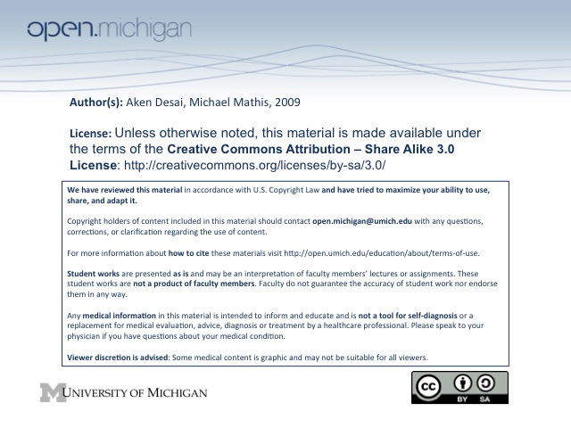
Myeloid Cell Disorders
Myeloid Cell Maturation
- GM-CSF – granulocyte-m-phage col. stim. factor; myeloid stem cell → (myeloblast)/(immature monocyte)
- G-CSF – granulocyte colony stimulating factor; stimulates myeloblasts → N. promyelocyte
- Use as drugs – both GM and GCSF are in use as drugs to cause differentiation in neutropenias
WBC
- WBC Measurement – uses automated counter, reflects circulating pool of myeloid/lymphoid cells
- Relative/Absolute Amounts – each WBC type indicated by relative (%) and absolute (% * WBC)
- Infant WBC – usually very high WBC (fighting infections), high PMN compared to lymphocytes
- Child WBC – also somewhat high WBC (developing immunity), high lymphocytes compared to PMNs
- Adult WBC – has a lower WBC (mature immune system), high PMN compared to lymphocytes
- Disease States – can also affect WBC:
  - Bacterial infection – huge increase in WBC, high PMN % and left-shift (band cells)
  - Steroid therapy – actually increases WBC, due to high PMN % (marginating effect)
  - Splenectomy – also increases WBC, due to putting more into active circulation, less sequestered
  - Viral infection – actually decreases WBC, due to suppressive effect of virus on bone marrow
  - Chemotherapy – has huge decrease in WBC, although monocyte increase after recovery
Neutrophil Maturation
- Proliferation – involves myeloblast → N. promyelocyte → N. myelocyte in bone marrow (6-7 days, 25%)
- Maturation – longest, involves N. myelocyte → N. metamyelocyte → N. band → PMN in marrow (6-7 days, 65%)
- Intravascular/Tissues – about 10% of neutrophils finish development here, N. band → PMN
Neutrophilia
- Neutrophilia – an abnormally high PMN count (>7700), often involving a left-shift (more bands/precursors)
- Types – either an acute shift or a chronic stimulation:
  - Acute shift – a sudden shift of PMNs from marginating → circulating pool, (not a total WBC ↑)
    - Causes – include steroids, exercise, epinephrine, hypoxia, seizures, stress
  - Chronic stimulation – excess cytokines stimulating proliferative pool; a real WBC ↑
    - Causes – include infection, pregnancy, chemo recovery
    - Disorders – causes are Down’s syndrome, myeloproliferative dz., marrow metastases
Neutropenia
- Neutropenia – an abnormally low PMN count (<1500), with risk of infection
  - 500-1000 – infection from exposure
  - <500 – infection from host organisms
  - AfAm – lower normal n’phil counts (1000-1200)
- Types – include decreased production, increased destruction, or shift to marginating pool
  - Acute shift – a sudden shift of PMNs from circulating → marginating pool (not a real WBC ↓)
    - Infection – a severe infection (penetrates to tissues), endotoxin release will cause
    - Medical procedures – artificial circulations, such as hemodialysis, cardiopulm. bypass
  - Decreased production – fewer PMNs produced in bone marrow
    - Immunosuppression – some medications, chemotherapy, antibiotics will cause
  - Increased destruction – more PMNs destroyed in peripheral circulation
    - Autoimmune diseases – such as RA, SLE will cause
- Management – any time patient has fever + neutropenia (F+N), good reason to hospitalize
  - Medications – many medications have neutropenia as a known SE; look through these
  - Bone marrow – look for malignancies in bone marrow which indicate myeloproliferative disorder
  - Cyclic neutropenia – inherited disorder (auto dom) where every 3 weeks patient has neutropenia (fever, mouth ulcers); treat w/ G-CSF, usually improves after puberty
  - Congenital neutropenia – PMN maturation arrest; freq. infections, mouth sores, leukemia risk
    - T_{x} – give artificial G-CSF, bone marrow transplant (BMT)
Neutrophil Function
- Response Process – when tissue is damaged, chemotactic factors released which induce PMN response:
- Rolling & attachment – PMNs stick to endothelial cell wall due to chemotactic interactions
- Adhesion – integrins allow for tight adhesion of PMN to vessel wall
- Diapedesis – margination of PMN across endothelial cell wall
- Phagocytosis – PMN phagocytosis offending organism, contains within lysosomal vesicle
- Granule release – granules, along with peroxide & superoxide released to kill organism
- PMN disorders – can involve a disruption in function at any step of response process above:
- Sialyl Lewis^{X} – PMNs lack protein needed for rolling/attachment
- LAD-1 – a leukocytic adhesion protein (integrin) defect (Type 1), PMNs can’t adhere
- --
- --
- Chediak-Higashi Syndrome (CHS)– defect in granule formation (too large); associated w/ oculocutaneous albinsim, neuropathy, frequent infxn; treat w/ bone marrow x-plant
Chronic Granulomatrous Disease – defect in peroxide/superoxide formation
    - Catalase (–): CGD can kill Cat (–) bacteria (strep B), since they produce own peroxide
    - Catalase (+): CGD can’t kill Cat (+) bacteria (E. coli), since they break down peroxide
Myeloperoxidase Deficiency – more common, defect in hyperchlorous acid (HOCl), usually
clinically silent, although bacterial killing takes longer than norm
Monocytes/Macrophages
- RES – the reticuloendothelial system is the monocyte/macrophage system
- Maturation – again involves proliferation, maturation (shorter), and intravascular/tissue (longer)
- Function – can phagocytose foreign particles after nphils arrive at site and release cytokines to attract them
  - Destruction – can destroy phagocytosed particles (innate immunity)
  - T-cell presentation – APCs can also present phagocytosed particles to T-cells (adaptive)
- Defects – defects of PMNs also affect monocytes (LAD, CHS, CGD)
- Monocytopenia – low monocyte count, can occur with steroids or stress
- Monocytophilia – high monocyte count, can occur with tumor, infection, CGD, marrow recovery and a number of infections (malaria, TB, RMSF, leshmaniasis, brucellosis, mononucleosis)
Eosinophils
- Maturation – also have a faster maturation than PMNs
- Function – bright red granules with IgE on surface (unlike PMNs); key role in killing parasites
- Eosinophila – elevated eosinophils (<400), “NAACP” conditions:
  - Neoplasm – hodgkin’s disease, lymphoma, other tumor
  - Allergies – induced by environment, drugs
  - Asthma – has elevated eosinophils too
  - Collagen vascular disease – includes vasculitis
  - Parasite – infection of parasite
- Idiopathic Hypereosinophilia – too high eosinophil count → organ dysfxn; T_{x} immunosuppress, antihist
Basophils & Mast Cells
- Maturation – basophil like PMN, mast cell very quick
- Function – largely unknown, possible defense against parasites
- Low Basophil count – from steroids, hypersensitivity
- High Basophil count – from allergies, infection, endocrinopathies, myeloproliferative dz (CML)¸ systemic mastocytosis (symptoms due to excess histamine release)

