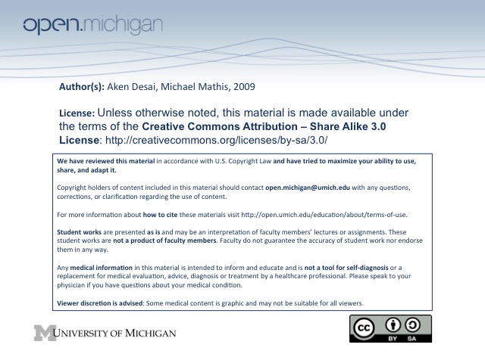
Acute Leukemia
Acute Myeloid Leukemia – Presentation (Leukostasis, Infiltration, DIC), Labs
- AML – acquired genetic defect of unregulated myeloid growth w/ limited or no differentiation
- Presentation – shows symptoms of bone marrow failure:
  - Leukostasis – increased viscosity of blood with pulmonary/cerebral effects (SOB at rest)
  - Extramedullary disease – myeloblastomas
  - Infiltration – leukemic infiltration of skin, gingiva, liver, spleen, lymph nodes, CNS
  - DIC – from increased viscosity & platelet dysfunction
- Lab D_{x} – patient will have hyperuricemia, hypokalemia, and spurious hypoxemia
AML
- Etiology – can be a part of a syndrome, or reactive from an insult:
  - Radiation, toxins (benzene) – can induce an AML state
  - Treatment-related – alkylating agents (cyclophosphamide), topoisomerase II inhibitors
  - Congenital DNA Repair Disorders – Fanconi’s syndrome, Bloom’s syndrome
  - Myeloproliferative & Myelodysplastic Disorders, Aplastic Anemia – can progress to AML
  - Treatment related – alkylating agents (5-7 yrs later), topoisomerase II inhibitors (1-2 years later)
- AML Prognosis – include age, blast karyotype, MDR phenotype, patient H_{x}, molecular indicators
  - Age – although common in children, increased incidence & severity w/ age
  - Performance Status – if patient feels bad, disease prognosis is bad
  - Karyotype – certain karyotypes good, others bad prognosis:
    - t(15;17) – karyotype with good prognosis; associated w/ acute promyelocytic leukemia
    - t(8;21), inv(16) – other karyotypes with good prognosis (better remission)
    - 5del, 7del, Phl chromosome – poor prognosis
    - Core binding factors (CBFα and -β) – TFs for blood cell production, lost in t(15;17)
  - Multi-Drug Resistant (MDR) Phenotype – have toxin pumps → can’t treat as easily!
- AML Molecular Prognosis – mutations in FLT3 receptor can make for bad prognosis
  - FLT3 Activation – mutations in areas of gene will activate receptor
  - Function – receptor binds ligand and signals cell growth → high WBC
  - Prognosis – associated with a worse outcome, and remains negative prognostic factor following HSCT
  - Karyotype – associated with normal karyotypes
- Nucleophosmin1 – mutation results in better prognosis
  - Mutation – frameshift mutation results in nuclear export signal so protein goes to cytoplasm
  - Prognosis – in younger patients with normal cytogenetics, NPM1 mutation predicts favorable prognosis
AML Treatment
- Induction – induce a complete remission of AML through combination chemotherapy
  - Leukemic blast clearance – remove all leukemic blasts by morphologic review
  - Anthracycline + Ara-Cytarbine – wipe out marrow (aplasia), an induction chemotherapeutic
  - G-CSF Priming – give simultaneously w/ Ara-C, induce cell division (Ara-C only kills dividing)
    - Bad idea – “priming” hasn’t proven to be helpful except young pts w/ normal karyotype
  - MDR Modulation – stop MDR pump from working, but more toxicity elsewhere (bad idea)
  - Intense Ara-C – higher doses better in children, who can tolerate more
- Post-Remission Therapy – weigh issues; maintain remission & replenish blood cells:
  - More chemotherapy – maintain remission, make sure few remaining leukemic cells don’t resurge
  - Bone marrow transplant – need to replenish blood cells eventually, treatment of choice in peds
  - Age – young patients easier to get into remission, can take more chemo
AML Biologically Targeted T_{x}
- Acute Promyelocytic Leukemia – occurs in younger patients, associated with biologically targeted T_{x}:
  - Histology – leukocytes cells are hypergranular with isthmus-shaped nuclei, Auer rods
  - Genetics – involves t(15;17) fusion protein
  - Treatment – fusion protein can respond to large doses of retinoic acid combined w/ chemo
    - SEs – capillary leak syndrome (wt gain, hypoxia, pleuropericardial effusions, lung infiltrates, fever); onset day 2 to week 3, hyperluekocytosis, rapidly fatal; treat w/ dexamethasone
  - Prognosis – targeting with RA makes for good prognosis
  - Relapse – treat with Arsenic trioxide → also moderately successful (same types of SEs as ATRA)
- CD33 – cell surface protein on AML blast cells, spans membrane
  - CD33 Antibody gemtuzumab – antibody against CD33 protein can help target AML blasts
  - Toxicity – infusion-related rxn, myelosuppression, hepatotoxic, hepatic veno-occulusive dz
  - Remission – helps get disease in remission, although not curative T_{x\}
  - High risk mutations – didn’t help with high-risk patients
- FLT3 – protein with gain-of-function mutation which induces blast proliferation → bad AML prognosis
- Lestaurtinib – an oral FLT3 inhibitor, can be synergistic with chemotherapy T_{x}
  - Sensitivity – some patients are sensitive to FLT3 inhibitor → remission; some aren’t → no remit
ALL
- Acute Lymphoid Leukemia – much less common in adults; more common in children
- Prognosis – determined by age, cytogenetics, immunophenotype:
  - Age – children 2-9 yo have best prognosis, because like to have t(12;21)
  - Cytogenetics – t(12;21) = good prognosis
  - Philadelphia Chromosome – can be present in adults w/ ALL (not just CML), poor prognosis
  - Immunophenotype – those affecting T cell lineage = better prognosis (than B cell lineage)
- Treatment – give an extended induction & post-remission treatment
  - Induction – give anthracycline plus steroids, vincristine 2-3 years
  - Post-Remission – chemotherapy is prolonged compared to AML; eventually allogenic transplant
  - CNS prophylaxis – ALL likes to lie dormant in CNS, need to prevent relapse here
- Outcomes – 80-90% can go into remission, but survival poor → 30% adults, 70% children; HSCT is recommended in adults w/ high risk features or relapse

