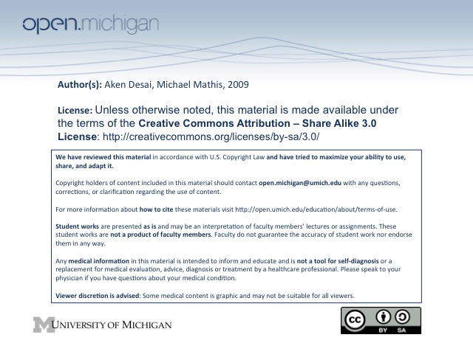
Lymphoma Pathology
Lymphoma
- Lymphoma – a malignant neoplasm of cell derived from lymphocytes/lymphocyte precursors
- Sites – where lymphocytes typically reside (lymph nodes, spleen, etc.), but can be basically anywhere
  - BALT – bronchus-associated lymphoid tissues
  - MALT/GALT – mucosa/gut-associated lymphoid tissues (mostly same thing)
  - Other key sites – skin, thymus, bone marrow, blood
- vs. ALL – in ALL, lymphocytes/blasts are in the circulation; in lymphoma, they are in a palpable mass (with exceptions)
- B-cells – more common lymphoma problem in US than T-cells (this lecture focuses on B-cells only)
Lymphoma Node Anatomy
- Lymph Node Anatomy – contain cortex, which has lymph node follicles within, comprised of:
  - Germinal center – B-cell rich area of lymph node (antigen-stimulated differentiation occurs)
  - Mantle zone – Cuff of dark cells around germinal center
  - Marginal zone – thinner layer around mantle zone, seen best in spleen
- Pre-follicular B-cells – are naïve recirculating B-cells, located in mantle zone or blood; haven’t diff’d
- Follicular B-cells – cells from mantle zone can travel deep into germinal center → differentiate to stim.
  - Somatic gene mutation – takes place inside germinal center; can be used to identify follicular
- Post-follicular B-cells – already differentiated memory B-cells, located in marginal zone or in elsewhere
Lymphoma Classification
- Pre-follicular B-cell Lymphomas – include CLL/SLL & mantle cell lymphomas:
  - Chronic Lymphocytic Leukemia/Small Lymphocytic Leukemia (CLL/SLL) – since pre-follicular B-cell lymphomas are in the circulation often, they are a leukemia in this sense
    - Monoclonal – CLL/SLL presents as excess lymphocytes in blood of same size/shape
    - Caveat – morphologically, CLL/SLL appears pre-follicular, but molecular studies indicate some are actually post-follicular. Pre-follicular subtypes have more aggressive course
  - Mantle Cell Lymphoma – cells of mantle zone become neoplastic & invade outside of boundary; more aggressive than CLL/SLL; irregularly contoured cells
- Follicular B-cell Lymphoma – include follicular, large cell, and Burkitt’s lymphoma
  - Follicular lymphoma – presents as many invading follicles within a lymph node
    - Small “cleaved” cells – if this cell type present in follicle, less aggressive course
    - Large “round” cells – more of this cell type present in follicle, prognosis worse but responds to therapy well because dividing faster
  - Large cell lymphoma – follicle only contains large “round” cells, can expand out of germ. ctr.
    - Prognosis – lymphoma is highly aggressive, but this means T_{x} can at least work better
    - Treatment – aims at killing dividing cells, so works better on aggressive proliferating
  - Burkitt’s Lymphoma – incredibly aggressive, increased number of mitotic figures, often EBV association
    - Genetic Defect – most commonly t(8;14)
- Post-Follicular B-cell Lymphoma – include marginal zone lymphoma (MALT) & lymphoplasmacytic
  - Marginal Zone lymphoma – pale marginal zone is abnormally expanded
    - Spleen, GI Tract “MALT” – common sites of marginal zone lymphomas
    - H. pylori – infection by this bug can induce MALT lymphoma
  - Lymphoplasmacytic lymphoma – induces syndrome of Waldenstrom’s macroglobulinemia
    - Plasma-cell prone – since post-follicular B-cells have differentiated already, some are predisposed to activate into plasma cells → lymphoplasmacytic
    - IgM secretion – main initial Ig secreted vs. no IgM in plasmocytoma
    - Waldenstrom’s macroglobulinemia – thickened blood due to high Ig secretion
- Classification Scheme – lymphoma subtypes are based upon analogy to normal cell types in lymph node
  - Morphology – some basic lymphomas can be identified based on morphology alone
  - Surface marker studies – most lymphomas are complex & require cytometry/immunostain to ID
    - “Pan-B” – CD19, CD20, CD22, CD79a
    - “Pant-T” – CD2, CD3, CD4, CD7
    - CD5 – normally found on T-cells but pathognomic of B cell lymphomas
    - CD10, Bcl-6 – marker of germinal center differentiation
    - Cyclin-D1 – mantle cell lymphoma, some plasma cell myelomas, some hairly cell leukemias
    - Specific patterns – each lymphoma has specific immunophenotypes that can be used to identify
  - Molecular genetics – some lymphomas are defined by chromosomal abnormalities
Clinical D_{x} of Non-Hodgkin’s Lymphomas
- Non-aggressive, but incurable – CLL/SLL, follicular lymphoma, marginal zone, lymphoplasmacytic
- Aggressive, incurable – Mantle cell lymphoma
- Aggressive, potential cure – Large cell lymphoma
- Highly aggressive (potential cure) – Burkitt’s lymphoma
Hodgkin’s Disease
- Hodgkin’s Disease – a clinically & histologically distinct type of lymphoma:
  - Contiguous spread – tends to spread contiguously from one lymph node to the next
  - Mediastinal mass – common presentation of Hodgkin’s disease
  - Inflammatory reaction – histology can show non-neoplastic inflammatory reaction to tumor cell
- Reed-Sternberg cell/Hodgkin Cell – neoplastic cell type in disease, often surrounded by inflammation
  - Histology – can be bi-lobed nucleus, w/ 2 clear nuclei & 2 dark nucleoli → “Owl’s eye”
  - What is it? – a B-cell, but very distinctive shape & properties
- Prognosis – very responsive to therapy, often curable
- Subtypes – classical (nodular sclerosis, mixed cellularity, lymphocyte depletion) & lymphocyte predomint.
  - Classical Hodgkin’s Disease -
    - Nodular sclerosis – most common; lymph nodes have sclerotic nodules
    - Mixed cellularity – another type
    - Lymphocyte depletion – very rare
  - Lymphocyte predominant Hodgkin’s Disease:
    - Totally different disease – lymphocyte predominant different from classical!
    - Behavior – acts like a low-grade, slowly progressive non-Hodgkin’s lymphoma

