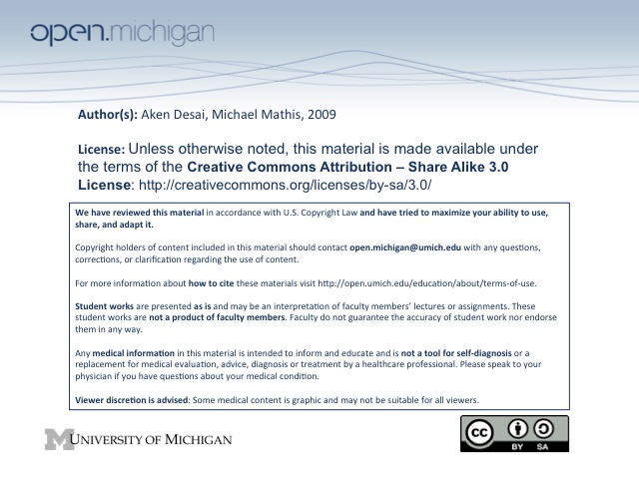
Lymphoma
Lymphoma
- Lymphatic System – network of vessels carrying lymph (w/ immune cells) from tissues → blood
- Palpable Lymph Nodes – based on features, can evince at normal, reactive, or malignant D_{x}:
  - Size – smaller is more normal; (opp. malignant)
  - Shape – soft, flat, & fixed is normal; firm, spherical & movable is more malignant
  - Tenderness – non-tender is normal; (opp. malignant)
  - Stability – non-growing is normal; (opp. malignant)
- S_{x} – can be asymptomatic, or notice lymph node changes & B-symptom (constitutional) changes:
  - Asymptomatic – find lymphoma incidentally
  - Lymph node changes – usually painless enlargement in neck/axilla/groin
  - B-Symptoms – unexplained fever, drenching night sweats, 10% weight loss over 3 months
  - Other constitutional changes – fatigue and pain based on location and size of mass
- D_{x} – can be made through lymph node biopsy, or if still unsure, a bone marrow biopsy
Lymphoma: Hodgkin’s vs. Non-Hodgkin’s
- Hodgkin’s Lymphoma – has 3-4 main subtypes, 3 treated the same and have same prognosis
  - Prevalence – more rare; about 3 times less common than NHL
  - Demographic – generally younger(20-29) patients, but also late peak after 60 yo
  - Spread – predictable spread through contiguous lymph nodes
- Non-Hodgkin’s Lymphoma – many subtypes with varying behavior/prognosis/T_{x}
  - Prevalence – 3 times more common than Hodgkin’s Disease
  - Demographic – incidence increases with age
  - Spread – more random spread
  - Sites – can involve Waldeyer’s ring, CNS, skin, GI tract/mesenteric
Lymphoma Staging Prognosis
- Staging – lymphomas (like any cancer) staged I-IV
  - History & Physical – assess for tumor size, nodal spread, metastases
  - Labs – can find cytopenias, organ dysfunction
  - CT/PET Scans – image lymph nodes
  - Bone Marrow biopsy – also assess for lymphoma
- Diaphragm – if lymph nodes on one side of diaphragm involved → stages I/II; if both → stages III/IV; if patient has B symptoms then add B to stage; E = extralymphatic, S = splenic
Hodgkin’s Disease Treatment
- Limited (Early) Stage HD – stages IA, IB, IIA; treated by:
  - Chemotherapy + Radiation Therapy – most common treatment
    - ABVD – adriamycin, bleomycin, vinblastive, dacarbazine → general chemo treatment
  - Radiation Therapy Alone – older method; irradiate lymph nodes affected & adjacent ones
  - Chemothearpy Alone – debated for use among young; limits SEs of radiation (particularly effects later in life)
  - Prognosis – good; 80-90% prevention of 5-year relapse
- Advanced Stage HD – stages IIB & up; treated by:
  - Chemotherapy – plays larger role, use longer treatment course
  - Prognosis – okay; about 2/3 cured (prevent 5-year relapse)
- Salvaging Failed Treatments – a number of options:
  - Chemotherapy – if radiation therapy was only given previously, chemotherapy = 60% success
  - High-dose chemotherapy + Autologous stem cell transplant – if previous chemo failed; 60%
  - Post-transplant salvage – very poor
- Late Risks – some of the complications of T_{x} now more concerning than HD itself:
  - 2º cancer, heart/lung damage – common risks post-treatment
  - Reduce/eliminate radiation – proposed solution to reduce risks
Non-Hodgkin’s Lymphoma
- Indolent, but incurable – Follicular lymphoma, CLL/SLL, marginal zone, lymphoplasmacytic
- Aggressive, incurable – Mantle cell lymphoma
- Aggressive, curable – Diffuse large cell lymphoma
- Highly aggressive, curable – Burkitt’s lymphoma, lymphoblastic
- (Italics = most common NHLs); 85% of NHL are B-cell
Indolent NHLs
- Follicular lymphoma – most common indolent lymphoma; many invading follicles in lymph node
- Marginal zone lymphoma (MALT) – pale marginal zone of MALT is abnormally expanded
- Lymphoplasmacytic lymphoma – memory B cells tend to activate into plasma cells → macroglobulinemia
Indolent NHL Prognosis & Treatment
- Prognosis – difficult treatment, but very slow progression
  - FLIPI – Follicular Lymphoma International Prognostic Indicator → predicts prognosis
- Treatment Options – observation, radiation, chemo, antibody, transplantation:
  - Watch & wait – maintain good QOL while observing progression of disease; treat when symptoms/complictation emerge; no difference in survival whether treated immediately or observed; 2-3 years to treatment
    - Pros – avoids treatment toxicity, spontaneous regressions occur, new treatments or new standards may become available
    - Cons – requires periodic monitoring
  - Radiation therapy – good for early stage; knocks out lymph nodes, but remission w/ adv. stage
  - Chemotherapy – ABVD?
  - Antibody therapy – such as Rituximab, monoclonal Igs against surface markers (CD20)
    - CD20 surface marker – present in Pre-B cell → Activated B-cell, not plasm
    - Given with chem – higher response rates and longer remissions than chemo alone
  - Radioactive antibodies – bind to lymphoma, also irradiate nearby lymphoma cells
    - Zevalin, Bexxar – both radioactive antibody treatments for indolent lymphomas
    - Regimen – a single cycle treatment, lasts 1 week, two infusions
    - Response – great overall survival, also many without relapse
  - Transplantation – replace bone marrow
Aggressive Curable NHLs
- Diffuse Large B-cell Lymphoma – most common type of lymphoma
- Prognosis – also scaled by various risk factors into a prognostic index
  - Elderly – worse prognosis, if chemo fails, many elderly can’t withstand bone marrow x-plant
  - CNS inolvement risk – bone marrow, sinuses, testes pose higher risk of CNS involvement
- Treatment – should be initiated as soon as possible after diagnosis:
  - Chemotherapy – central role, “CHOP” chemotherapeutic combination of drugs, 6-8 cycles
  - Rituximab – also part of standard T_{x} for B-cell lymphomas
  - Low stage disease – fewer cycles
  - Salvage – less than 20% of those who do not achieve CR with initial therapy are cured but best option is autologous HSCT
Aggressive Incurable NHL
- Mantle cell lymphoma – pre-follicular cells of mantle zone become neoplastic & invade outside boundary
- Prognosis – bleak; median survival of 3-4 years
- Treatment – initially give chemotherapy, but relapse & resistance high:
  - Chemotherapy – give “CHOP” chemotherapeutic combination of drugs
  - Remission – short remission time; relapse rate high → often resistant to salvage regimens
Highly Aggressive Curable NHL
- Burkitt’s lymphoma – as well as lymphoblastic lymphoma, both aggressive follicular lymphomas
- Prognosis – due to rapid division, can be easily targeted and very responsive to chemo
- Treatment – give chemotherapy, also need to prophylax for CNS involvement
  - Chemotherapy – standard treatment
  - CNS involvement – has a high risk for this, need CNS prophylaxis (intrathecal chemo and cranial radiation)
New Treatments
- Stem Cell Transplants – ways to make these safer, ways to prevent graft vs. host disease
- Vaccines – also an new idea
- New Drugs – including proteasome inhibitors, histone deactylase inhibitors

