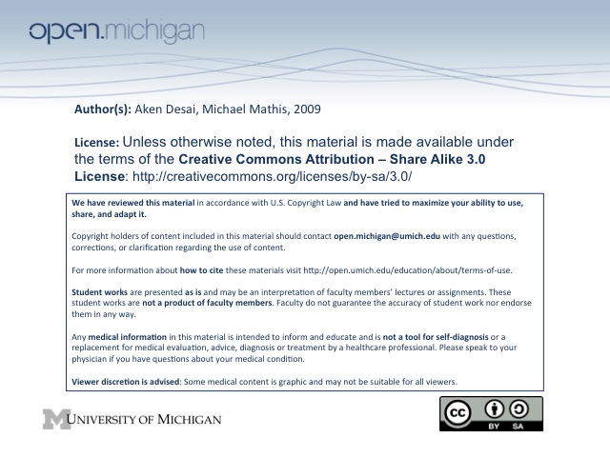

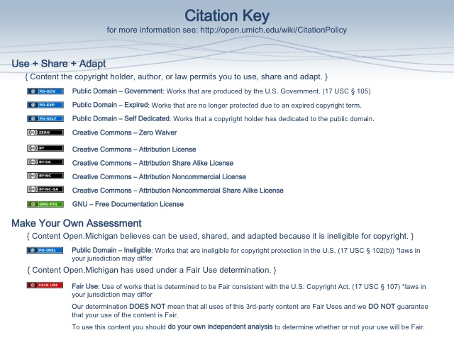
Cancer Pharmacology
Cancer Pharmacology Principles
- Behavior Modification – change the behavior of malignant cells to become non-malignant
  - Retinoic Acid – will induce differentiation of leukemic cells in acute promyelocytic leukemia
- Indirect Cell Killing – create an environment in the host which will lead to the killing of cancer cells:
  - Bevacizumab – antibody binds VEGF (vascular endothelial growth factor), T_{x} colon cancer
    - Halted angiogenesis – in colorectal cancer, tumor needs neovascularization to grow
    - VEGF receptor – endothelial cell → binds VEGF, but can’t if VEGF complexed w/ Ig
  - Rituximab – antibody that binds to CD20 on B-cell lymphomas, induces immune response to kill
- Direct Cell Killing – drugs which directly kill tumors:
  - DNA damage – drugs can induce DNA damage in tumor cells → apoptosis
  - Antimetabolites – drugs which prevent tumor cell from growing & functioning
  - Chromosome inhibitors – drugs which inhibit the structure/function of tumor chromosomes
  - Survival inhibitors – drugs which inhibit the survival signaling pathways of tumor cells
Cancer Selectivity Strategies
- Therapeutic Index – goal of cancer T_{x} to widen, so just as valid to protect host cells as to attack cancer
  - Host Protection – can help patient recover from lesions caused by cancer/drug SEs:
    - Antiemetics – keep patient from feeling nausea during chemotherapy → more chemo
    - Chemical lesions – ifosfamide causes bladder lesions → protect with MESNA
    - Genetic lesions – develop bone marrow factors which is more resistant to chemo
    - Replenish blood cells – help induce post-chemo recovery with HSC growth factors
- Host Toxicities – anti-cancer T_{x} has a variety of common host toxicities
  - Myelosuppression – loss of WBC, platelets, & RBCs in trying to attack blood cell tumor
  - GI Toxicity – methotrexate: nausea, vomiting, diarrhea, stomach ulcers
  - Alopecia – hair loss
  - Nephrotoxicity – cis-platinum
  - Cardiotoxicity – anthracyclines (-rubicin): irreversible cardiomyopathy
  - Neurotoxicity – oxaliplatin (sensory neuropathy), vinca alkaloids (peripheral neuropathy)
  - Hemorrhagic Cystitis – Ifosfamide → accumulates in bladder, causes lesions → bleeding
  - Bilary sclerosis – irinotecan (not sure actually, but bile excretion after UGT → SN-38)
Tumor-Specific Delivery
- Antibody-Mediated Delivery – toxins/radioisotopes conjugated to antibodies against tumor (CD20)
- Regional Drug Delivery – tumors have greater affinities for different regions of body:
  - Tumor-selective blood supply – liver, brain, head/neck → inject drug directly here
  - Regional advantage – if drug in higher concentrations of tumor region
- Survival Pathway Inhibition – block biochemical pathways which tumor uses to survive & proliferate
  - EGFR – epidermal growth factor receptor, upregulated in many tumors → block this!
- Exploiting Cell Cycle Checkpoint Deficiencies – cancer cells have uninhibited cell cycle checkpoints…
  - ATM/ATR – Apical protein kinases which signal cell replication if everything is A-OK
    - Normally – if DNA damage occurs, ATM/ATR tells cell to halt replication until fixed
    - Cancer – this checkpoint is lost, replication continues despite DNA damage
Anti-Cancer Therapy Cell Responses
- Apoptosis – best T_{x} response → cancer cell will rapidly lyse
- Mitotic Catastrophe – next best → excessive chromosomal disruption in tumor cell, loss of proliferation
- Senescence-Like – prolonged cell cycle arrest without gross DNA damage; proliferation stops temp/perm
- Resistance – tumor becomes resistant, either by slow proliferation, or developing other metabolic means
  - Be skeptical – if drug company shows cells with inhibited proliferation for only a few days, doesn’t necessarily mean that this “anti-cancer” drug actually has any significant clinical outcome
Anti-Cancer Therapy In Vivo Experimentation
- Transplantable – include xenografts & allografts
  - Xenograft – transfer a tumor from an immunologically different host (human tumor → lab rat)
    - Most common – easiest, common because interested in treating humor tumors
  - Allograft – transfer a tumor from an immunologically similar host (lab rat tumor → another rat)
    - Immunodeficient mouse – induce an immunodeficiency in mouse to cause tumor, can then transfer to immunocompetent mouse & assess responses
  - Ectopic/Orthotopic – grafts can be placed in easy spot, or at spot of transplant tissue origin
    - Ectotopic – easier, but maybe not as accurate
    - Orthotopic – more difficult, but will more accurately similar tumor environment
- Spontaneous – induce a transgenic oncogene in lab rat to cause real disease → attempt to treat this
- Maximum Tolerated Dose – much higher in mice, one shortcoming
- Dose Limiting Toxicity – what toxicity occurs first, limiting the dose (e.g. liver damage)
Anti-Cancer Therapy Clinical Trials
- (Phase 0) – see if drug does in fact work on its target in humans, rather than just lab rats
- Phase I – identify sensitive organs, establish max tolerated dose (escalation), patients w/ no options
- Phase II – apply doses & schedules of Phase I to a focused population of target patients
- Phase III – compare new T_{x} vs. standard, conduct large scale RCTs, assess for weird rare reactions
Cancer Cell Drug Resistance
- Metabolic – decreased prodrug activation, increased drug degradation
- Uptake/Transport – decreased drug uptake, increased drug efflux
- Altered Target – target molecule undergoes change/mutation to be resistant to drug
- Increased Target – increased abundance of target, drug is outnumbered
- Increased Repair – repair processes in cancer cells upregulated, fix DNA damage
Drug Resistance Development
- Classical – change in cell confers a specific resistance to a single drug
- Multiple Drug Resistance (MDR) – change in cell brings about resistance to many drugs
  - P-glycoprotein – pumps drugs out, can confer a non-specific resistance to many lipophilic drugs
  - Wide variety of other MRPs – many MDR proteins on various chromosomes, not small problem
Log Cell Growth & Log Cell Kill
- Mouse Experiment – inject different amounts of cancer cell into mice, see how long it took to be fatal
  - Log Cell Growth – because cells grow on a logarithmic scale, each log factor increase of tumor would equate to a linear decrease in survival time.
  - Introducing chemotherapy – chemotherapy was shown to extend mouse life by the same amount, no matter what level of tumor burden was present.
  - Log Cell Kill – because of above observation, realized that chemotherapy kills the same % of tumor cells each time, not the same number
- Formal Log Cell Kill – 1 log cell kill = 90% cells killed (reduce by factor of 10); 2 log = 99%, 3 = 99.9%
- Treatment Resistance – after one round of log cell killing, next round wouldn’t be as effective (resistant)
  - Goldie-Coldman Hypothesis – once a tumor gets large enough, chance of MDR high
  - Alternating Drug Schedules – give different drug for each round of log cell kill, avoid resistance
- Gompertzian Growth – theory that tumor cells actually grow faster at lower numbers
- Norton-Simon Hypothesis – tumor killing is also proportional to growth rate
  - Outcome – T_{x} of tumor in early phases will extend life the same amount as T_{x} in late phases
  - Early treatment – only beneficial if T_{x} wipes out tumor entirely → need to be aggressive early!
  - Sequential Therapy – proved that “AAABBB” T_{x} better than “ABABAB” T_{x} for tumors
Drug Combination Therapy
- Combination Therapy Principles:
  - Effectiveness – each drug by itself should have some effectiveness in treating tumor
  - Diversity – drugs used in combination should act thru different mechs (less resistance chance)
  - Non-overlapping Toxicity – drugs should not have the same toxicities → bad SE!
- Adjuvant Therapy – therapy given after main treatment, to eliminate any residual disease
  - Tumor Example – surgery followed by chemotherapy, to eliminate hidden tumor cells
  - Benefits – can help cure patients who were not completely treated by initial therapy
  - Risks – can subject cured patients to unnecessary injury → must weigh this against benefit
- Neoadjuvant Therapy – therapy given before main treatment, to reduce chance of residual disease
  - Tumor Example – chemo before surgery → shrink tumor to size that can be surgically removed
- Radiosensitization – chemotherapy to make tumor cells more sensitive to radiation
DNA Damaging Agents
- Alkylators – include mechlorethamine & cyclophophamide, act to form crosslinks with DNA:
  - Mechlorethamine – “nitrogen mustard”, highly reactive, give IV
  - Cyclophosphamide – prodrug activated into a mustard, give orally
    - Unusual toxicity – can cause hemorrhagic cystitis → give early in day to avoid urine
accumulation, give lots of fluids to avoid concentration
    - Ifosfamide – similar to cyclophosphamide, but can give MESNA to neutralize urine
  - Mechanism – drugs will crosslink with DNA to inhibit function
  - Resistance Mech – increased DNA repair, alkylator scavengers, and decreased uptake
  - Dose-limiting Toxicity – usually bone marrow suppression, 2-3 wks to reach low point
- Non-Alkylators – include cis-platinum
  - Cis-platinum – although not true alkylating agent, has many similar properties
    - Unusual toxicity – severe nausea & vomiting, ototoxicity
  - Mechanism – drugs will crosslink with DNA to inhibit function
  - Dose-limiting Toxicity – causes renal toxicity (& renal excretion)
- Carboplatin – dose-limiting toxicity is myelosuppression (bone marrow suppression)
- Oxaliplatin – dose-limiting toxicity is sensory neuropathy, has lifetime cumulative dose limit
Antimetabolites
- Methotrexate – is a folate analog, binds tightly to dihydrofolate reductase
  - Mechanism – binding dihydrofolate reductase prevents folate reduction (recycled), and thus
prevents dUMP → dTMP methylation; DNA damage
  - Unusual Toxicity – can cause GI mucositis
  - Dose-Limiting Toxicity – usually myelosuppression, or GI mucositis
  - Drug-drug interaction – be careful when giving w/ neprhotoxic agents (renal excretion)
- Fluorouracil – 5-FU becomes ribosylated & altered to FdUMP, inhibits thymidylate synthase
  - Mechanism – FdUMP tries to be converted to FdTMP by thymidylate synthase, but F stops,
forms an irreversible complex
  - Leucovorin – given with 5-FU, acts as a reduced folate cofactor for thymidylate synthase,
increases formation of FdUMP-thymidylate synthase complex
  - Resistance – decreased DNA synthesis, increased thymidylate synthase
  - Metabolism – 5-FU is rapidly metabolized, needs to be protected in prodrug form to be effective
  - Toxicity – various depending on administration, has intra-individual variations in metabolism
    - Dihydroxypyrimidine dehydrogenase (DPD) → metabolizes 5-FU, various levels in pts.
- Cytosine Arabinsoide (Ara-C) – cytosine analog, converted Ara-CTP → put into DNA, stops elongation
  - Dose-Limiting Toxicity – is myelosuppression
- Gemcitabine – cytosine analog, converted dFd-CTP → put into DNA, stops elongation
  - Radiation Sensitizer – will make GI tumor cells more susceptible to radiation
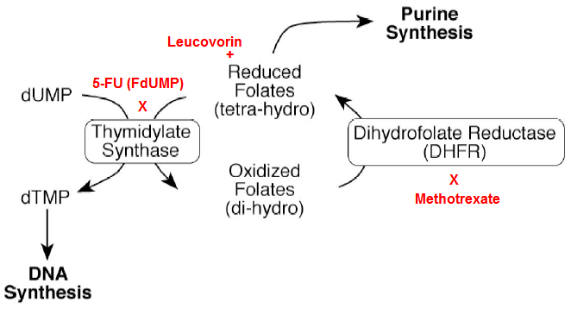
  - Dose-Limiting Toxicity – is myelosuppression, also causes flu-like symptoms
- SKIPPED: Thiopurines – guanine analog, converted to thioguanine → put into DNA
  - Intra-individual variations – TMPT metabolizes thiopurines
  - Dose-Limiting Toxicity – is myelosuppression
  - Hyperuricemia – from tumor lysis syndrome
    - Allopurinol – prophylaxis against hyperuricemia
Chromosome Structure/Function Inhibitors
- Microtubule Antagonisists – include vinca alkaloids and taxanes
  - Vinca alkaloids – include Vincristine, Vinblastine, Vinorelbin
    - Mechanism – bind free tubulin dimers → form aggregates, can’t form microtubules
    - Toxicity – have a peripheral neuropathy, also myelosuppression
    - Resistance – MDR
  - Taxanes – include Paclitaxel, Taxotere
    - Mechanism – bind to assembled microtubles → microtubules can’t depolymerize
    - Toxicity – induce a neutropenia
- Topoisomerase II Inhibitors – include anthracyclines (-rubicins)
  - Anthracyclines – include any “-rubicin”
    - Mechanism – inhibit topoisomerase II (breaks both strands) → contorted DNA
    - Toxicity – limited by myelosuppression and cardiac arrhythmias
    - Unusual toxicity – irreversible cardiomyopathy → need lifetime dose limit
- Topoisomerase I Inhibitors – include
  - Camptothecins – include Topetecan, Irinotecan
    - Mechanism – inhibit topoisomerase I (breaks one strand) → contorted DNA
    - Toxicity – can cause myelosuppression
    - Excretion – different:
      - Topetecan – excreted renal
      - Irinotecan – a prodrug converted to active form (SN-38), bile excretion
SKIPPED: Intra-Individual Variability
- Morphometric – variability based on body size & composition
- Pathophysiological – based on renal/hepatic function
- Demographic – based on age/gender
- Genetics – based on drug metabolism & transporter function
  - Thiopurine S-methyltransferase (TPMT) – metabolizes thiopurines used to screw up DNA
  - UDP-Glucuronosyltransferase (UGT) – metabolizes ironotecan to SN-38 → bile excretion
  - Dihydropyrimidine Dehydrogenase (DPD) – metabolizes 5-FU
- Overcoming Variability Problems – accomplished through a number of ways
  - Phenotyping – assess for phenotypes which have low/high metabolism
  - Genotyping – assess for genotypes…

