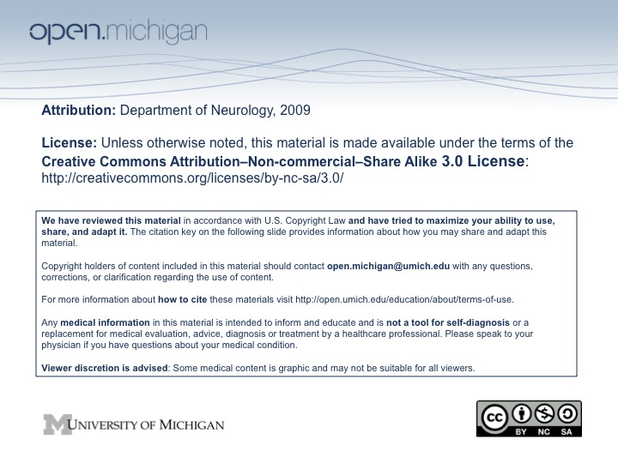
Spinal Cord I Lecture Outline and Objectives

CNS/Head and Neck Sequence

TOPIC: THE SPINAL CORD AND SPINAL NERVES, Part I

FACULTY: Department of Neurology/Division of Anatomical Sciences

LECTURE: Monday, March 9, 2009

READING: John H. Martin, Neuroanatomy, Text and Atlas, 3rd edition
pp. 32-34, 55-68, 85-86, 107-120, 229-242 and 425-435.

OBJECTIVES:

From reading and lecture, you should be able to:

Define the central nervous system and peripheral nervous system

Define a segment of the spinal cord

Describe the four functional components of a thoracic spinal nerve

Distinguish between the receptive field of one dorsal root ganglion cell and a dermatome, and describe the peripheral overlap of adjacent dermatomes

Name the nuclei of the spinal cord gray matter and the function of each nucleus; identify nuclei that form continuous cell columns through the length of the cord; describe the basis for defining a discontinuous cell column as an entity

Name the white matter funiculi

Describe each of four basic reflexes (flexion, crossed extension, muscle stretch, autogenic inhibition,) in terms of the:
- receptor and afferent fiber type
- termination of afferents in the cord:
ipsilateral vs. contralateral
interneurons, if any (excitatory or inhibitory)
- location of motor neurons in the spinal cord
- muscle or muscle group activated (or inhibited)

Describe the elements of a somatic spinal reflex arc

Predict the type of neurological deficit that would result from occlusion of the anterior spinal artery vs. a posterior spinal artery.

SAMPLE TEST QUESTIONS:

Which of the following nuclei (cell columns) is found in the thoracic region of the spinal cord?

A. dorsolateral ventral horn cell column
B. accessory nucleus
C. parasympathetic cell column
D. intermediolateral cell column

Ans. D

A painful stimulus on one side of the body results in which of the following responses?

A. contraction of the contralateral extensor muscles
B. contraction of the contralateral flexor muscles
C. contraction of the ipsilateral extensor muscles
D. relaxation of the contralateral extensor muscles
E. relaxation of the ipsilateral flexor muscles

Ans. A

LECTURE OUTLINE:

Central Nervous System (CNS)
Brain:
Forebrain: telencephalon and diencephalon
Brain Stem: midbrain, pons and medulla
Cerebellum

Spinal Cord
Cervical
Thoracic
Lumbar
Sacral
Coccygeal

Peripheral Nervous System (PNS)
12 pairs of cranial nerves
31 pairs of spinal nerves
8 cervical
12 thoracic
5 lumbar
5 sacral
1 coccygeal

Spinal Cord Segmental Organization

Segment: that part of the spinal cord that gives rise to one pair of spinal nerves
Gray matter and white matter
Central gray matter divided into dorsal, lateral and ventral horns
Surrounding white matter divided by the gray into dorsal, lateral and ventral funiculi

Spinal nerves are:
Formed by dorsal and ventral roots
And give off:
Dorsal and ventral primary rami
Gray and white rami communicantes

Receptive fields and motor units
A receptive field is the area of skin innervated by one dorsal root ganglion (DRG) neuron
A motor unit is the total number of skeletal muscle fibers innervated by one ventral horn cell (VHC) = alpha motor neuron

Dermatomes
A dermatome is the area of skin innervated by one segment of the spinal cord (or, by one pair of dorsal root ganglia)
Adjacent dermatomes overlap

Functional components of a spinal nerve:
General somatic afferents = sensory fibers from somatic pseudounipolar cell bodies in dorsal root ganglion (DRG)
General somatic efferents = axons from VHCs (alpha motor neurons) that innervate skeletal muscles
General visceral afferents = sensory fibers of visceral pseudounipolar cell bodies in DRG
General visceral efferents
Preganglionic autonomic neuron cell bodies in lateral horn of spinal cord segments T1 – L2 (sympathetic) and S2 – S4 (parasympathetic)
Postganglionic neurons (sympathetic neurons in paravertebral or prevertebral ganglia; parasympathetic neurons in terminal ganglia); innervate smooth muscle, cardiac muscle and glands

Longitudinal organization of spinal cord Gray Matter
Cell groups of spinal cord gray are described with two different terminologies, as: Nuclear Groups and Rexed’s laminae (I through X)
Nuclear groups of the spinal cord are longitudinal columns of cells.
Individual cell columns are defined by the morphology of the cells their functions and connections

Posteromarginal Nucleus (pain and temperature)
Substantia Gelatinosa (pain and temperature)
Nucleus Proprius (fine touch and proprioception)
Nucleus Dorsalis (proprioception)
Secondary Visceral Gray (visceral sensations)
Intermediolateral Cell Column (visceral motor connect to postganglionic neurons that innervate smooth muscle, cardiac muscle and glands)
Ventral Horn Cells = alpha motor neurons (motor to skeletal muscle)

Some cell columns are continuous throughout the spinal cord
Substantia Gelatinosa – receive pain and temperature inputs
Medial column of ventral horn cells – innervate axial muscles
Some cell columns are discontinuous and exist only in one part of the cord Phrenic nucleus
Accessory nucleus
Nucleus dorsalis
Some discontinuous columns are found in more than one region of the cord
Lateral columns of ventral horn cells (cervical an lumbar enlargements) innervate limb muscles
Intermediolateral cell column and secondary visceral gray
sympathetic T1-L2
parasympathetic S2-S4
Reflexes
Elements of a polysynaptic reflex arc
Receptor
Afferent (sensory) neuron fiber
Interneuron in spinal cord dorsal horn
Efferent (motor) neuron and axon
Effector

Somatic spinal reflex arc
Sensory receptors in skin, skeletal muscle or tendon
Somatic afferent nerve fiber is the peripheral branch of dorsal root ganglion neuron (pseudounipolar neuron)
Somatic afferent fiber (usually) synapses with interneuron in the dorsal horn gray matter; interneuron projects to ventral horn
Ventral horn cell (alpha motor neuron) receives input from interneuron and projects through the ventral root and spinal nerve to activate skeletal muscle

Flexion Reflex
Contraction of a group of flexor muscles (and inhibition of their antagonists) in response to noxious stimulus
Receptor: free nerve endings
Slowly conducting afferent fibers (lightly myelinated or unmyelinated)
Interneurons (polysynaptic)
Diffuse
Spreads to adjacent segments of spinal cord
Many muscles are recruited

Crossed Extension Reflex
In the lower extremity occurs with the flexion reflex (upper extremity not necessary, i.e., you won't fall down)
Contraction of extensor muscles on the opposite side of the body (and inhibition of antagonists)

Muscle Stretch Reflex
Contraction of one muscle (or part of a muscle) in response to stretch (lengthening of the muscle) and inhibition of antagonists
Rapidly conducting afferent fibers (heavily myelinated)
Monosynaptic connections directly to VHCs = alpha motor neurons
Discrete
Response limited to the muscle (or part) that was stretched and the antagonist muscle
Tonically active in extensor muscles of the trunk and legs (antigravity muscles), but may be elicited from any skeletal muscle

Receptor: the Muscle Spindle
Small connective tissue capsule containing intrafusal muscle fibers
Capsule is attached to connective tissue septae that are continuous with the tendons; thus capsule is connected to bones “in parallel” with the extrafusal skeletal muscle fibers
Stretching the central region of the intrafusal fiber stimulates the afferent fiber that encircles the central region
Central region may be stretched passively (stretch on the whole muscle) or actively (by contraction of the intrafusal muscle fibers)
Intrafusal muscle fibers are innervated by gamma motor neurons; gamma motor neurons are controlled by descending pathways from the brain that set the tension in the muscle spindle; thus, the brain sets the sensitivity of the muscle spindle to stretch.

Autogenic Inhibition: Reflex relaxation of muscle in response to tension on its tendon
Receptor: the Golgi Tendon Organ;
attached between tendon and muscle fibers
Inhibition of the muscle area to which the tendon organ is attached; accomplished by inhibitory interneuron action on ventral horn cells (alpha motor neurons) to the muscle

Alpha motor neurons (VHCs) integrate reflex inputs from skin, muscles and joints, as well as descending pathways from the brain

Visceral spinal reflex arc (thoracic cord)
Receptors in the viscera of the thorax and abdomen
Visceral afferent fibers pass through the white ramus to the spinal nerve; cell body is a visceral DRG cell; synapses on interneuron
Interneuron in the secondary visceral gray of dorsal horn projects to intermediolateral cell column in lateral horn
Preganglionic sympathetic neuron in lateral horn projects through ventral root , spinal nerve, and white ramus to synapse in paravertebral (or prevertebral) ganglion
Postganglionic neurons send axons to viscera, or to skin via the gray ramus and spinal nerve

Blood Supply to the Spinal Cord

Segmental arteries contribute via
Dorsal and Ventral (Posterior and Anterior) Medullary arteries
Anastomoses of medullary arteries creates
Anterior Spinal Artery, single artery
Ventral Median Fissure
Posterior Spinal Artery, two
Dorsal and Ventral (Posterior and Anterior) Radicular arteries

Ventral (Anterior) Spinal Artery Supplies:
Ventral Horn
Ventral Funiculus
Intermediate Zone
Lateral Funiculus

Dorsal (Posterior) Spinal Artery Supplies
Dorsal Horn
Dorsal Funiculus

