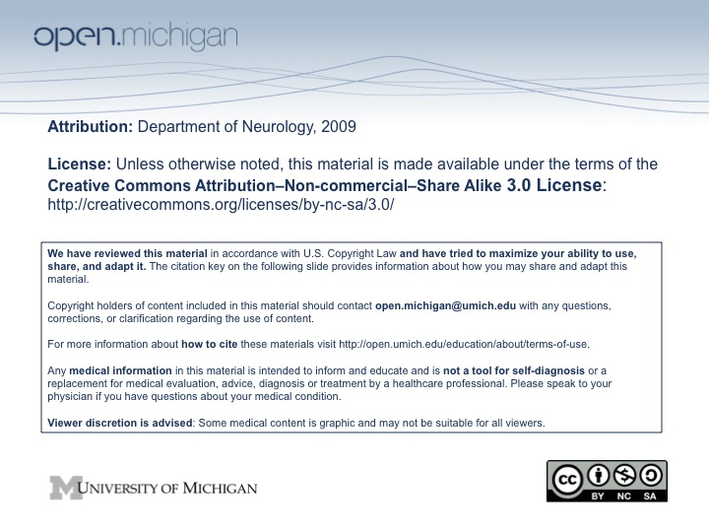
Hypothalamus Lecture Outline and Objectives

CNS/Head and Neck Sequence

TOPIC: THE HYPOTHALAMUS

FACULTY: Department of Neurology/Division of Anatomical Sciences

LECTURE: Wednesday, March 18, 2009

READING: John H. Martin, Neuroanatomy, Text and Atlas, 3rd edition
pp. 351-376, 468-471.

OBJECTIVES:

From reading and lecture, you should be able to:

Know the 5 regions of the diencephalon and the relationship of these structures to the third ventricle.

Identify the nuclei of the hypothalamus that control the function of the anterior lobe of the pituitary gland and those that control the posterior pituitary.

Identify nuclei of the hypothalamus that influence male and female sexual behavior, parental behavior and aggression in mammals.

Identify the nucleus of the hypothalamus that is important in maintaining circadian rhythms.

Distinguish the arteries that supply the hypothalamus.

Know the Nuclei and connections associated with the:
Medial Forebrain bundle
Fornix
Stria terminalis
Mamillothalamic tract
Dorsal Longitudinal Fasciculus
Hypothalammo-hypophyseal tract
Tuberoinfundibular tract

SAMPLE TEST QUESTION:

LECTURE OUTLINE

Regions of the Diencephalon:
Epithalamus (pineal and habenula)
Thalamus
Hypothalamus (Posterior pituitary)
Ventral thalamus (subthalamus)

Anatomical Relations of the Diencephalon

The third ventricle forms the medial boundary of the diencephalon.
The internal capsule forms the lateral boundary of the diencephalon.

Pituitary (review)
Posterior Lobe (Pars nervosa) Arises from the floor of the developing diencephalon.
Anterior Lobe (Adenohypophysis) Arises from the roof of the developing oral cavity = Rathke’s pouch
Intermediate Love (Pars Intermedia) and Tuberal Lobe (Pars Tuberalis) are considered part of the Anterior Lobe

The Hypothalamus

The hypothalamus is a unique area of the brain because, in addition to neuronal signaling, it sends and receives hormonal signals via the vascular system. It also monitors blood glucose levels and the tonicity and temperature of the blood.

Functions:
Controls the anterior and posterior pituitary
Controls the autonomic nervous system
Controls behaviors essential for survival, including eating, drinking, sleep, thermal regulation, sexual behavior, parental behavior and aggression.

Medial Zone divided into four areas, rostral to caual:
Preoptic Area (POA)
Medial POA important in circuitry that controls male sexual behavior and parental behavior; neurons with estrogen and androgen receptors are regulated by endocrine feedback from the testes, ovaries and adrenals.
Lateral POA regulates body temperature through both thermoregulatory behavior and autonomic reflexes (shivering, peripheral vasoconstriction, and sweating).

Supraoptic Area
Paraventricular and Supraoptic nuclei: axons of these cells terminate on capillaries in the posterior pituitary and release oxytocin and vasopressin into the systemic circulation.
Suprachiasmatic nuclei are circadian oscillators; form part of circuitry that releases melatonin and influence gonads, thermal regulation and sleep- wake cycles.

Tuberal Area
Periventricular and Arcuate nuclei express receptors for gonadal, adrenal, and thyroid hormones. These nuclei provide feedback regulation for the anterior pituitary through the portal venous system.
Ventromedial nucleus neurons express estrogen, androgen, and progesterone receptors. They belong to neural circuits that control female sexual behavior and aggression.

Mammillary area
Mammillary bodies are large nuclei that receive input from the hippocampus via the fornix and project to the anterior nuclei of the thalamus through the mammillothalamic tract.
Damage to the mammillary bodies and their connections with the hippocampus produces anterograde amnesia.

Lateral Zone is the Lateral Hypothalamic Area that extends through the rostro-caudal length of the hypothalamus
An area of diffuse neurons that participate in regulating autonomic function, sleep-waking cycles and arousal
Major connections are with the reticular formation and limbic system
Medial forebrain bundle is a fiber bundle with both ascending and descending fibers that passes through the lateral hypothalamic area. It makes connections between the limbic areas rostral to the hypothalamus, the hypothalamic nuclei and the brain stem.

Blood is supplied to the hypothalamus by many small branches directly off of the arteries of the Circle of Willis.

