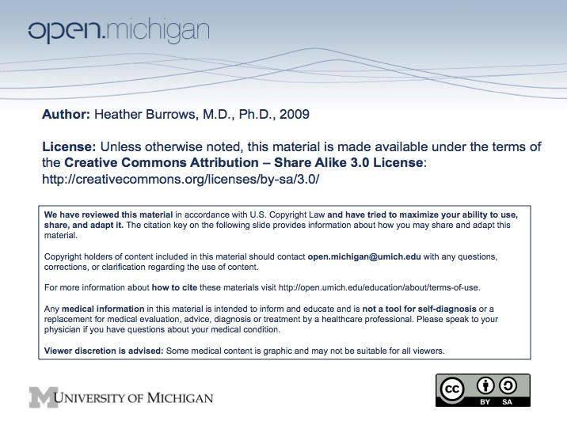
Topic:

Perinatal/Neonatal

Faculty:

Heather Burrows, M.D.

Reading:

None

Lecture Time:

Spring 2009 Human Growth and Development

Learning Objectives:

- Understand aspects of normal fetal growth and causes of abnormal or insufficient growth during fetal gestation.

- Understand nutritional requirements during pregnancy and effects of insufficient nutrition on the fetus and mother.

- Understand methods for measuring fetal and infantile growth and development.

- Understand normal infant growth and developmental patterns and potential threats to each.

- Understand aspects of infant nutrition and effects of insufficient nutrition on the infant

Suggested Additional (NOT REQUIRED) Reading:

Sample Exam Question:

