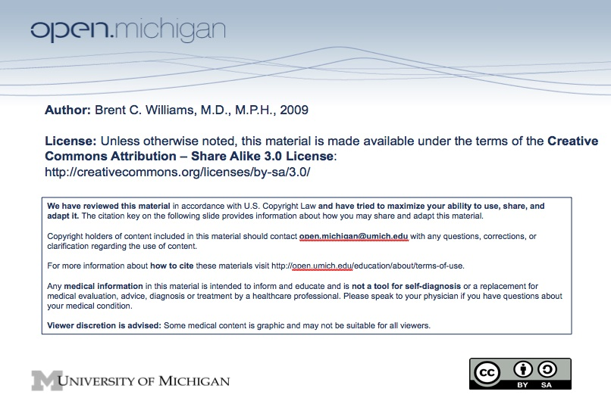
Topic:

Introduction to Human Growth and Development:
Principles of Growth and Development and Epidemiology

Faculty:

Brent C. Williams, MD, MPH

Reading:

None

Lecture Time:

Spring 2009

Learning Objectives:

Overview of course objectives, small group sessions and themes
Review principles of normal growth and development
Understand the demographic imperative of aging
Define life expectancy and life span

Suggested Additional (NOT REQUIRED) Reading:

None.

Sample Exam Question:

True/False:

Life span increased by approximately 30 years during the last century. (Answer: False)

