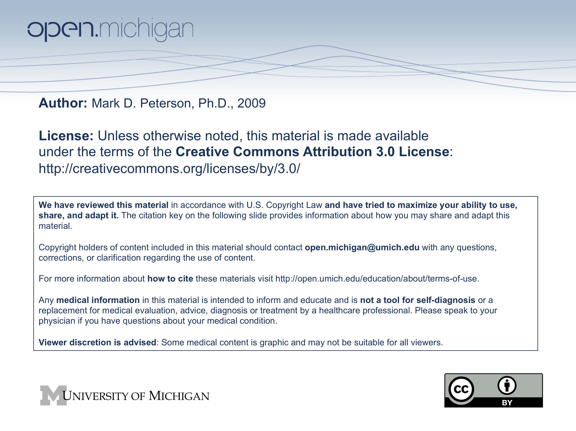
Topic:
Energy Metabolism

Faculty:
Mark Peterson, Ph.D.

Reading:
None.

Lecture Time:
Spring 2009 M1 Human Growth and Development

Learning Objectives:
- The Role of Physical Activity on Energy Balance and Weight Management

- The Influence of Physical Activity and Exercise on Chronic Disease

- To appreciate the complexity of the energy balance problem.

- To describe the component of energy expenditure

- To link these concepts to obesity

Required Reading:
none

Suggested Additional (NOT REQUIRED) Reading:
none

