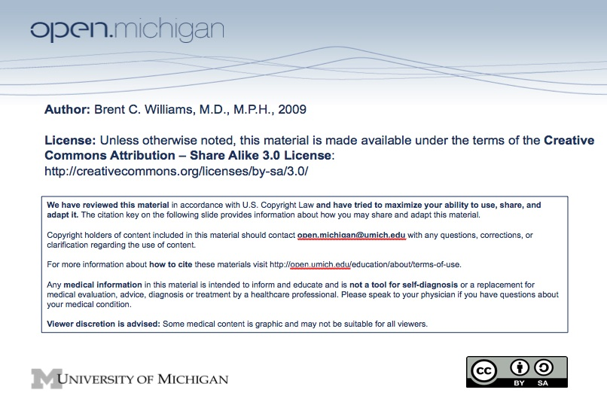
Topic:

Physiology of Successful Aging

Faculty:

Brent C. Williams, MD, MPH

Required Reading:

None.

Lecture Time:

Spring 2009 M1 Human Growth and Development

Learning Objectives:

- Distinguish usual from successful aging.
- Describe the major age-associated changes in human physiology.
- Understand the “anti-aging” effects of exercise.
- Be able to assess nutritional status of older adults, including risks from medications.
- Appreciate the importance of functional assessment of older individuals.

Suggested Additional (NOT REQUIRED) Reading:

- Rowe, J.W. and Kahn, R.L. Successful Aging. New York. Pantheon. 1998.
- Perls, T.T. and Silver, M.H. Living to 100. New York: Basic Books. 1999.
- Rowe, J.W. et al. Human Aging: Usual and Successful. Science 237:143, 1987.
- Deen and Hark. Chapter 6.

Sample Exam Question:

True/False.
A majority of individuals in the US who are age 65 and older describe their health status as good. (Answer: True)

