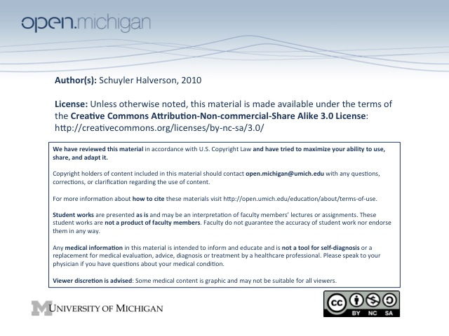
1. Introduction to Human Growth & Development (Williams)

- Life span vs. Life expectancy
  - Life span
    - Theoretical upper limit to human longevity
    - Approximately 100 years
  - Life expectancy
    - The observed age for 50th percentile survival
    - Number derived from cross-sections at census
  - In other words, on a graph with "Age" vs "Number Remaining Alive" on the Y-axis
    - Life span is a fairly constant point where the graph hits the X-axis
    - Life expectancy can change the slope/curvature of the graph

- AVERAGE LIFE EXPECTANCY AT GIVEN AGES (know these)***
  - At birth
    - Men: 74 years
    - Women: 79 years
  - At 65 y.o.
    - Men: expected to live 16 more years
    - Women: expected to live 19 more years Remember, at 65 & 80, women have
  - At 80 y.o. 20 and 10 years left. Men a little less.
    - Men: expected to live 7+ more years
Women: expected to live 9+ more years

Its our goal to compress the morbidity curve as close to the mortality curve as possible.

