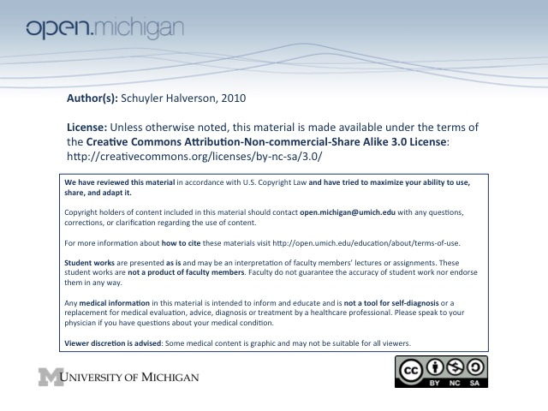
2. Perinatal/Neonatal Health

Patterns of Fetal Growth
Wk 1-8 | Wk 8-20 | Wk 20-34 | Wk 34-40
Embryonic | Rapid growth and organogenesis | Differentiation and viability | Fat deposition

Measures of Fetal Growth (in chronological order)
- Crown-Rump Length (CRL + 6.5 = menstrual age in weeks) Accurate 6 weeks gestation

- Bi-Parietal Diameter (measure head) Accurate 12 weeks gestation

- Femur Length Accurate 14 weeks gestation

- Fundal Height (pubic symph to fundus) Accurate 16 weeks gestation

  - Abdominal Circumference Sensitive indicator of asymmetric growth retardation

Abnormal Fetal Growth
- AGA - appropriate for gestational age
  - SGA - small for gestational age. Birth weight at <5th percentile for gestational age. Cause unknown
  - IUGR - intrauterine growth retardation. SGA with a known cause.
  - Symmetric - small overall. FROM EARLIER PROBLEMS
                -  Extreme Fetal Malnutrition
                -  Decreased growth potential (genetics, congen infect (TORCH),
                - environmental toxins, multiple gestation)
  - Asymmetric – skinny. Head circumference normal but abd circ small. LATER PROBLEMS
          - Maternal factors (MALNUTRION!!! #1!) or Uteroplacental insufficiency 

  - LGA - large for gestational age. Birth weight at >95th percentile for gestational age
From diabetic mother, Obese mother, Cerebral gigantism, Genetic disorder

Infant Growth and Development***
- Birth Averages
  - Weight: 7 lb, 7 oz normal 6 to 10 lb. x2,3,4 at 6 mo, 12 mo, 24 mo.
  - Length: 20 inches (50 cm); normal 18.5 to 21.5 inches. x2, 3 at 2 yrs, 3 yrs
  - Head circumference: 13.8 inches (35 cm); normal range 33 to 37 cm
- Personal/Social (missing in autism)
  - Social smile: 6 weeks
  - Looks for dropped object: 6 m.o.
  - Waves bye-bye: 10 m.o.
  - Interactive games: 12 m.o.

- Language
  - Coos and fixes/follows: 2 m.o.
  - Babbles in consonants and vowels: 6 m.o.
  - Formed words: 12 m.o.
  - 5-10 words: 15 m.o.
  - 50 words: 2 years

- Gross Motor Development
    - Primitive reflexes - gone by 4-6 mo.
Neck control: 2 m.o.
    - Sit without support: 7 m.o.
    - Walk with help: 9-10 m.o.
    - Walk independently: 12-14 m.o.

- Fine Motor Development
  - Reaches and grasps objects: 4 m.o.
  - Fine pincher grasp: 12 m.o.
  - Stack blocks, sorts shapes: 15 m.o.
Start solids – 6 mo
Add Finger Food - 8-9 mo

