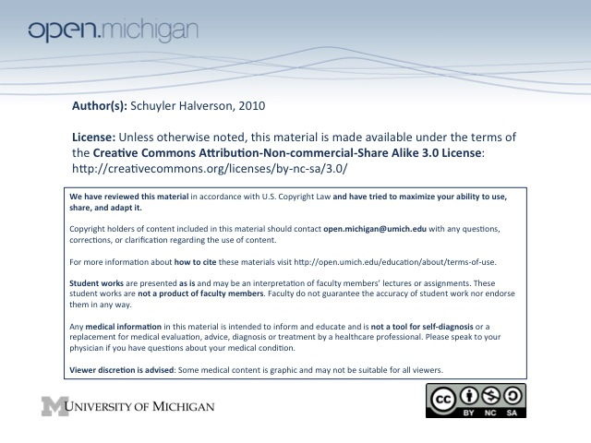
4. Adolescent Development and Adolescent Health

Adolescence results in autonomy and identity.
- Early adol. = dominated by puberty and body image concerns. Conformity to peer norms
  - Girls start pube/breast TS2 @11, 3 & max growth @12, menar @12.5, 4@13, 5@14
  - Boys start TS2@11/12, 3@13, 4&Spermarche@14, 5@15-17
  - Standard Deviation is 1 year for all.
  - Constitutional Delay = late and that’s it. Once it starts, its normal.
- Mid Adol. = High school transition. Puberty nearly done. Shift from family to peer focus.
- Late Adol. = Off to college. More sophisticated cog. Confident autonomy. Future plans.

Trends in adolescent health risk behaviors (alcohol, sex, cigs, pot)
1) Start early 2) Rates rise significantly from 11-19, 3) Rates very high.

Substance abuse in ½ of car accidents, ½ homicides, 1/3 suicides.

Mental illness found in 1/5 of adolescents. Major cause = biological. Also psychosocial.

Lifetime depression risk 20-25%.

Eating disorder is genetic and on a spectrum, pushed by risk factors and stopped by protectives. EDs present medically as multi-organ system disease.

Cutting lifetime prevalence 11-16% and is for a wide range of reasons.

Barriers to Needed Support
Adults just don’t understand. Trusted adult needs to be confidential, attentive listener with genuine concern, non-judgemental/critical.

Resilience: “process where peeps display (+) adaptations despite trauma.”
-Relies on close relationships with caring, connected, competent adults.
-Connection to effective, caring schools. Self esteem, self expectation, and expect success.
- If you think you’re <50%, problem behaviors go up.

Psychosocial ROS: Home Education Eating Activities Drugs Sex Suicide Safety

Small group points:
- High risk behaviors cluster
- Puberty varies in beginning, how long, duration, magnitude, and this is fully normal.
- Despite variability, progession of steps is predictable
  - TS1 – No development
  - TS2 – Smallest amnt to not be TS1 anymore. Few straight countable hairs
  - TS3 – Betw TS2 and TS4
  - Tanner stages describe progression of development, not appearance.

