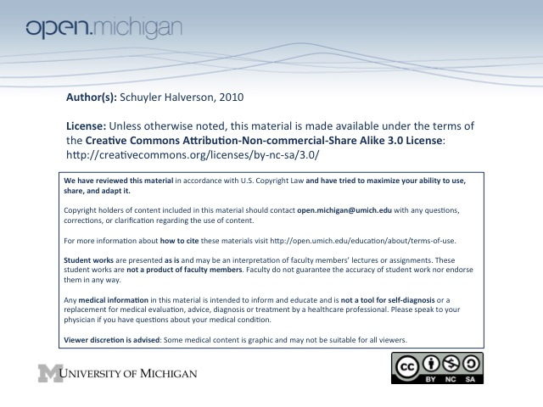
8. Biology of Aging

Aging: A PROCESS that converts healthy young adults into less healthy older adults with progressively increasing risk of injury, illness, and death.
Or… What happens after the rules of evolution no longer matter. Aged adults are the result of genes selected for effects in early life.

***Key Facts:
- Nearly all mammals age similarly, despite a 30-fold variance in life span
- Caloric restriction extends rodent (& others) life span 40%, but don’t know about primates
  - Slows many late-life diseases and preserves cognitive and physical function
- At least 10 single gene mutations can extend mouse lifespan 20-50% (Snell dwarf mice)
  - 6/10 mutations result in low IGF-1
  - Small dogs = low IGF-1 = Longer life span

We age since genes that help when young do bad things later (ex: rapid growth → cancer later). Also there are genes that do bad things when we are older that do not get selected out (Alz, cataracts, etc)

We can’t age slower since these genes would have negative reproductive costs, and its all about sex

Longevity is selected for in safe niche like underground, being top predator.

Many studies show short people have less risk of cancer.

Theories of Aging:
- Rate of Living Theory (100K heartbeats/life), but there are many animals that don’t follow this. The reason the elephant has low metabolism is because its niche with few predators. It can live slow.

- Clonal Exhaustion (telomere whittling), but gut crypt stem cells divide thousands of times, mice have long telomeres despite early death, and dells that don’t divide still lose function in old age (brain)

- Senescence may be something we have evolved to prevent cancer, but once we’re old we need them to become un-senescence

- Cells in worm are resistant to many factors (oxidation, heat, etc) which is his favorite theory.

MDC: Team Care of Older Persons

Who benefits from team care: Multidimensional problems that are reversible or avoidable

Problems with team care: Slow, inefficient, prone to communication errors, expensive.

Principles of Team Care: Equal partnership with transparent decision-making.

Framing
  - Assume you may be missing things that others see
  - Assume you are seeing things that others miss
  - Look for the sense in how others are thinking/acting, even if you don’t agree
  - Seek to understand what leads to behavior you find problematic

Advocacy
  - Help others see what you see, and how you are interpreting what you see
  - Give examples of your data, and how you are interpreting your data
  - Explain the steps in your thinking

Inquiry
  - Find out how others see a situation, and find out what you may be missing
  - Seek different views
  - Ask others to give examples of their data
  - Ask others to explain the steps in their thinking
Ask when you have doubts about how others are acting

Behaviors of good teamwork:
- Forming
- Storming – The conflict before you know how to work with each other
- Norming – Normalized routine of dealing w/each other
- Performing
- Framing
- Advocacy
- Inquiry

Summary:
- State own views clearly, making reasoning explicit
- Invite other to help you see what you may be missing
- Elicit views of others and understand their reasoning
- Be aware of own biases, patterns of behavior and emotional triggers
- Inquire into surprise, error, and disagreement

