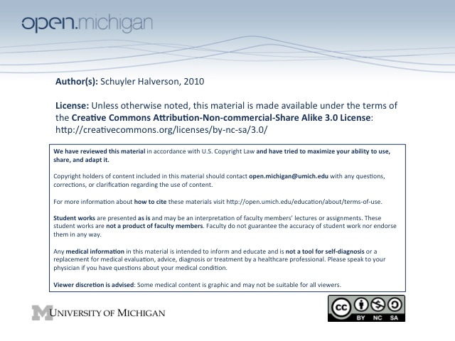
6. Age Related Considerations in Drug Therapy

Recall it takes 4-5 T½’s to get saturated dosage. Half lives can change with age.

Children
75% FDA drugs never evaluated in kids, no central information source, most publications are guesses/ballpark.
-High total body water so increased Vd (thus decreased concentration)
-Immature gastric acid secretion and splanchnic blood flow (altered rate/extend of oral absorp)
-Low body fat increases blood levels of lipid-soluble drugs
-Immature renal/hepatic function alters clearance
-Low binding capacity of albumin increases effect of plasma protein-bound drugs.

Infants often have longer half-life and greater peak of blood levels

***Most pharmacokinetic variables mature to “adult” levels by about 1 year of life, but…
…kids 2-6 metabolize many drugs much faster than younger or older peeps.***

“Qualitatively Unique” (-) Rx FX in young – Gray baby, Reyes, Thalidomide, MANY OTC DRUGS

Elders
***Renal excretion is #1 pharmacokinetic cause of adverse drug effects in elders***
(lots of other reasons though. See P. 115)

Pharmaco changes: more sensitive, responses different, impaired homeostatic mechanisms, altered nutritional states, THERAPEUTIC INDEX SMALLER.

Changes in drug effect depend on specific drug. CAN’T MAKE GENERALIZATIONS BASED ON DRUG CLASS.

Prescribe for elderly:
*Simplify the regimen wrt # drugs, when, how often
*Use old drugs for old people since more info is known about them.

