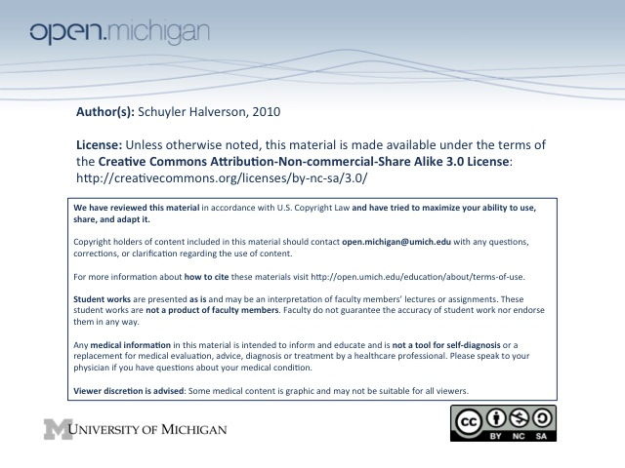

5. Energy Balance and Obesity

- Energy Balance is how much you eat vs activity level.

WHO defines obesity for adults as BMI > 30. BMI can be used OVER AGE 2
<18.5 | 18.5-24.9 | >25 | 25-29.9 | 30-34.9 | 35-39.9 | >40
Underweight | Normal | Overweight | Pre-obese | Obese 1 | Obese 2 | Obese 3

Leptin is an adipokine made by body fat that inhibits appetite. Obese individuals have high leptin levels since it is made in fat and Ob/Ob people don’t have leptin receptors.

Obese people have high Leptin, RMR, fat oxidation, sympathetic NS activity, and low insulin sensitiv.

TEE = Total Energy Expenditure
70% - BMR for absolute necessities (brain, breathe, blood)
10-30% - Thermal Effect of Food (energy to eat)
20% - Physical Activity (all voluntary muscle activity)

TEE calculated by TEF + Physical Activity*Activity factor (1.2-1.9)

BMR calculated by Harris Benedict Equation, measured by calorimetry measuring heat and O2, or from free living with accelerometer etc.

MET = Metabolic Equivalents = 1kcal/min. Different intensity activities are different MET levels.
Walking is #1 choice of exercise

National Weight Registry is for people who have maintained a 30 lb weight loss for one year or longer, but there is tremendous diversity in the registry of amount, duration, and speed.
-98% modified food intake
-94% increased physical activity, most frequently via walking.

Ways to make weight loss easier:
Physical: exercise, medication, surgery
Mental: Resolve non-hunger issues
Workable plan: Easy tracking, change environment, support

All data shows increase activity decreases mortality.

