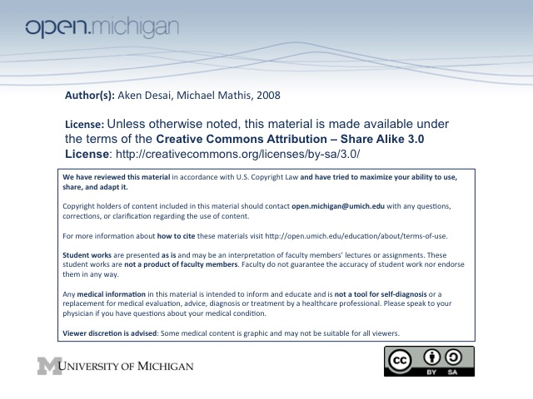
10-2-08 Mechanisms of Acute Renal Failure
ARF/Acute Kidney Injury
- Acute Renal Failure – an increase in BUN or creatinine of abrupt onset, reflecting a loss of clearance
- Prevalence/Impact – about 25% of post-op & ICU cases; huge cause of mortality, very expensive T_{x}
- Kidney Failure – tends to occur when other organs fail
- Urine output – can vary:
  - Oliguric – less than 400cc/day (most concentrated urine output to get all of waste out)
  - Non-oliguric – many other forms of ARF have normal output
- Causes – can be prerenal, renal, or postrenal:
  - Pre-renal – hypovolemia, CHF, hepatorenal, NSAIDs, Angiotensin blockade
  - Renal – vascular disorders, GN, interstitial nephritis, tubular necrosis (ischemia/toxins/pigments)
  - Post-renal – external obstruction (stricture, neoplasms, stones, hematoma), bladder rupture
Kidney Cell – Disease Susceptibility
- Disease Susceptibility – due to high energy demand, inflammatory dysfunction, solutes, toxins:
  - High metabolism – kidneys require high amounts of energy to function, thus fail easier
  - Inflammatory susceptibility – complex microcirculation easily compromised by inflammation
  - Resorptive functions – high exposure to solutes makes for unusual environment
  - Toxins – kidney metabolism involves filtering toxins, can fuck up these cells
    - Acetominophen (Tylenol) – can screw up P450 system in liver/kidneys
Kidney Cells & Oxygen
- Glycolysis – happens mostly in distal parts (ascending limb/DCT)
- Gluconeogenesis – in proximal parts (PCT/descending limb) – less glycolysis, don’t do well w/ ischemia!
- Variable susceptibility – different regions of nephron/kidney susceptible to different insults:
  - Cortex – has high oxygen consumption, uses up a lot of O₂… thus
  - Medulla – very sharp drop in O₂ since it was used up by cortex, becomes ischemic first
  - Nephrons – have different sections with different susceptibilities as well…
Nephron Crypt & Aminoglycosides
- Aminoglycosides – can accumulate in lysozymes of crypts of apical brush border of nephrons, can’t be digested
- Dose Adjustments – should be done by lengthening interval rather than reducing dose
- Myeloid bodies – cells in brush border accumulate pockets of aminoglycoside, become damaged
- Diferent toxins – act on different segments of tubule
Glomerular Filtration Control
- Endothelial Tissue – aff/efferent → make relaxing factors (NO, EDRF) & constricting (TXA, EDCF)
- Smooth muscle – lining outside of afferent/efferent arterioles → respond to factors of endothelium
- Phospholipids – arachidonic acid manipulated to vasocontrictors (bad) & dilators (good) to regulate
  - Dysfunction – involves a shift to vasoconstrictors during ARF → ischemia
  - Endothelins – vasoconstrictor produced more in ARF → constriction
  - Nitric Oxide (NO) – vasodilator produced less in ARF → constriction
- Variety of factors – possible to develop a new indicator of ARF; in ARF many pts are infected, so don’t want to immunosuppress
Ischemia & Inflammation
- Inflammation – can be triggered by ischemia in kidney cells → further vasoconstriction → vicious cycle
- Transplant Rejection – inflammation leading to ischemia & vasoconstriction as well…
- Tubular Change – during inflammation & ischemia, tubules undergo changes:
  - Apical microvilli – will fall off some cells during first stages of ischemia, form granular casts
  - Necrosis – some cells of nephron will also become necrotic & fall off in intermediate stages…
  - Remaining Viable Cells – will spread out and try to fill in holes made by necrotic shed
ARF Clearance Malfunction Causes
- Vasoconstriction – constriction leads to decreased filtration, decreased clearance
- Cast Obstruction – piling up of microvilli casts prevent flow through nephron
- Backleak of Glomerular Filtrate – holes left by necrotic nephron cells allow for filtrate to leak out
Clearance
- Solute Clearance: C_{osm} = [Solute]_{urine}*Volume_{urine} /[Solute]_{plasma} = U_{osm}*V/P_{osm}
  - Clearance – the amount of plasma from which a solute is removed (Volume x urine/plasma ratio!)
  - Units – expressed as mL/min
- Creatinine – produced at constant rate, freely filtered, not reabsorbed, and minimally secreted → GFR calc; however, because it takes time for plasma creatinine to rise, it may take 3-5 days after damage occurs to reach a level that indicates damage
- Rule of Doubling – 50% loss of GFR = doubled creatinine level… thus not noticed too much early on…
ARF Recovery Process
- Mitotic Figures – seen as a sign of recovery, replacing necrotic cells
- Spreading Cells – during ARF, viable cells spread & flatten to seal up necrotic holes… but lengthens the:
- Timeframe to Recovery – can only happen once cells are remodeled & not spread thin, thus can take a week to begin occurring if starting with cells spread thin to cover gaps

