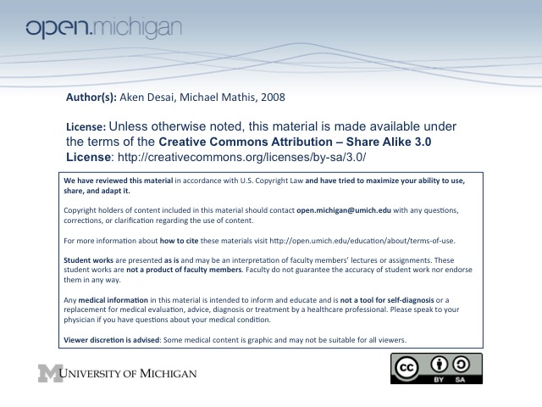
10-3-08 Clinical Approach to Acute Renal Failure
ARF: Prerenal Etiology
- “Prerenal” – Refers to factors before filtration at glomerulus & nephron:
- Hypovolemia – volume loss from GI/renal, hemorrhage, third-spacing, edema, etc.
- Cardiac Failure – infarction, cardiomyopathy, valve disease → decreased circulation
- NSAIDs – blocks endothelin production → can’t dilate afferent arteriole → GFR decreased
- ACEI/ARB – blocks angiotensin → can’t constrict efferent arteriole → GFR decreased
ARF: Prerenal Reversibility
- Reversible – initially reversible, but after a while, sympathetic overdrive causes afferent vasoconstriction
- Irreversible – after SNS vasoconstriction of afferent arteriole, parenchymal damage → may not recover…
ARF: Renal Etiology
- Vascular Disorders – large vessels, such as renal artery stenosis, etc.
- GN – severe inflammation of glomerulus itself, leading to ARF
- Interstitial Nephritis – allergic reaction → interstitium swells, ARF
- Tubular Necrosis - caused by ischemia/toxins/pigments → vasoconstriction/cast obstruction/backleak
ARF: Postrenal Etiology
- Obstruction – anything stopping urine flow out of kidney at “macro” level of urinary tract:
  - Urethral stricture, neoplasms, prostatic hypertrophy, surgical complications, stones, etc.
- Bladder rupture – urine flow can’t get out of body
Renal Failure D_{x}
- Medication Issues – check for H_{x} of NSAIDS, ACEI/ARBs, contrast studies, antibiotics
- Volume Status – possible hypovolemia, causing pre-renal ARF
  - Physical Exam – examine BP, JVP, temperature of extremities, skin color/turgor
  - BUN/Creatinine – ratio >20 = prerenal ARF, ~10 = renal ARF (urea should be easily reabsorbed)
  - Pulmonary Artery Catheter – wedge pressure, measure CO & peripheral resistance
- Urinalysis – key to many different diagnoses of renal failure:
  - RBCs – suggest glomerular dysfunction, rather than tubulointerstitial
  - Tubule epithelial cells, granular casts – suggest ischemia of nephrons → acute tubular necrosis
  - Pyuria/WBC – suggest pyelonephritis
  - Crystal – uric acid → hyperurecemia, gout, ethylene glycol poisoning
- Urine Chemistry – assess ion concentrations:
  - Na – if low, generally prerenal etiology (trying to conserve volume, save Na⁺), ATN is higher
    - Pre-renal – hypovolemia, CHF, NSAIDs
    - Renal – some exceptions which can cause low Na⁺: acute GN, contrast nephropathy
    - Oligura – if patient is not oliguric, low Na⁺ concentration is less meaningful
  - Osmolarity – if high, suggests ADH → conserve volume (lose stuff besides Na⁺) → pre-renal
  - Urine Creatinine – if high, suggests pre-renal, since filtering still okay
  - FENa – if less than 1%, suggests pre-renal (trying to conserve volume!)
    - Prerenal – intravascular volume depletion due to hemorrhage, GI losses, third spacing, low CO, NSAIDs, hepatorenal syndrome
    - Renal – acute GN, contract, early pigment nephropathy
    - Postrenal – obstrucution
    - Complicating factors – diuretic use, glycosuria/mannitol, excretion of contrast, aggressive fluid replacement, alkalemia, not oliguric
- Radiographic Analysis of ARF – most useful imaging method is ultrasound:
  - Non-invasive & non-toxic – other imaging methods do more harm than help
  - Renal Size – very important in diagnosing renal disease
    - ARF – equal, normal sized kidneys, haven’t had a chance to change
    - GN, Nephroscleorsis from HTN – bilaterally small kidneys = chronic systemic process
    - Renovascular disease – will see assymetical kidneys
    - Diabetes/Amyoidosis – will see large kidneys & nephrotic syndrome
  - Renal Parenchyma Quality – can assess if diffuse or focal
  - Rule out Obstruction – if post-renal etiology, US can usually pick up
Renal Failure Treatment
- Offending Drugs – remove them! (ACEI, ARBs, NSAIDs)
- Hypovolemia/Edema – correct this through IV supplements
- Monitor – follow I/O, weight, BUN, creatinine, electrolytes, PO₄
- Dose Adjustments – if drugs renally excreted, make sure to adjust dosing if excretion is down
- Oliguria – may need to prescribe diuretics
Dialysis
- Fluid Overload – if just can’t get rid of fluids input, need to dialyze
- Hyperkalemia – often need dialysis to correct
- Acidosis – same…
- Uremia, BUN > 80-100 – way too much accumulation of toxins…
- High Creatinine Increase Trajectory – since there is a lag of creatinine behind GFR status, start early
Contrast Nephropathy
- Renal Component – contrast agent is a direct tubule toxin, renal function not immediately reversible
- Prerenal Component – contrast agent induces low FE_{Na}, causing vasoconstriction
- Diabetics, Kidney Disease, Low GFR, Shock – at high risk for contrast nephropathy
- Prevention – hold NSAIDs, diuretics, maybe ACEI/ARB; volume expansion may help, minimize amount of contrast, low osmolarity constant contrast, oral N-acetylcysteine
Amingoglycoside Nephrotoxicity
- Every course toxic - accumulates in crypts of villi and lysosomal degradation produces toxic byproduct
- Dose by clearance – not creatinine; lengthen interval of dosing (not amount) if renal fxn drops
- ARF – may occur after stopping drug

