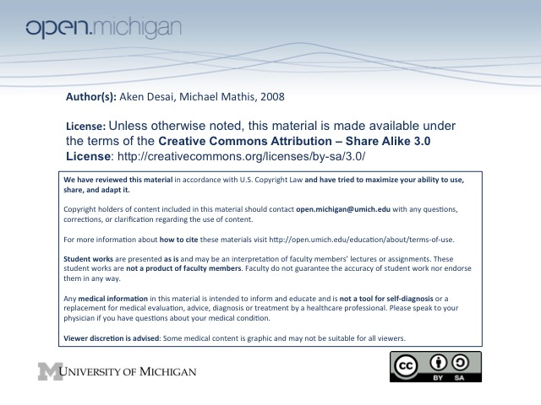
10-6-08 Hemodialysis
Dialysis Goals
- Filtration – replace filtration function of kidney, remove “uremic toxins” → use as markers
- Electrolyte Balance – maintain proper levels of Na⁺, K⁺, HCO₃⁻, Ca⁺⁺, PO₄
- Hormones – hormonal replacement → erythropoietin, vitamin D analogs, PTH control
ESRD Lifestyle Adjustments – Diet, Work/Travel, Comorbidities, Healthcare Support
- Diet – have large dietrary/fluid restrictions
- Travel & Work – limited by constraints of dialysis treatment
- Comorbidities – ESRD usually occurs in the context of other health problems such as DM complications
- Healthcare Support – multi-disciplinary team needed → nurses, physicians, technicians, dieticians, social
Dialysis Physiology – Diffusion/Convection (K/Na), Clearance/Ultrafiltration
- Diffusion/Convection – two different principles used in dialysis:
  - Diffusion – decreasing the concentration of substance across membrane → clearance
  - Convection – bulk flow of a fluid in/out of body → fluid removal
  - Na⁺ removed in saline through convection – pressure gradient between blood/dialysate
  - K⁺ removed by concentration gradients thru diffusion – conc. gradient between blood/dialysate
- Clearance/Ultrafiltration – two different objectives a dialysis machine can accomplish:
  - Fluid Removal – may need to remove 1L of fluid in order to stop pulmonary edema
  - Clearance – removing a solute, not solvent; e.g. clearing “30L” of urea ≠ removing 30L fluid
- Dialysate composition – electrolytes, glucose, heparin
Dialysis Process - Blood In, Diffusion/Convection
- Blood pumped into dialyzer, goes thru lots of tiny semi-permeable tubes in parallel
- Outside of the tubes, a dialysate is flowing through, removing urea/toxins diffusing out into here
- Saline (Na & H₂O) moved by pressure gradient existing between the tubing & dialysate
Dialysis Physiology – Blood Pressure vs. Fluid Status, Vascular Access
- Blood Pressure vs. Fluid Status – need to keep blood pressure up while dialyzing a certain volume
  - Hypovolemia – too much fluid removed/fluid removed faster than equilibration → hypotension
  - Hypervolemia – if not on dialysis for too long, consume too much → hypertension
- Vascular Access – 3 types include double lumen catheter, prosthetic/native vein fistualae:
  - Central venous catheter: Pros: immediate use Cons: thrombosis, infection
  - Prosthetic arteriovenous fistula: Pros: less thrombosis/inf. Cons: less immediate use
  - Native arteriovenous fistula: Pros: best longevity, no thromb Cons: require maturation
- Drug dosing considerations – although 5 liters of circulation, much more in ECF/ICF → equilibration…
  - KT/V, URR (Urea reduction ratio) → terms relating to solute removal kinetics
  - Drug removal – need to know how fast drugs are removed by dialysis vs. kidney → dose adjust
  - Similar Drugs – do not always have similar removal rates (e.g. amoxicillin vs. nafcilin)
___________________________________________________________________________________________________________
Peritoneal Dialysis
Peritoneal Dialysis
- Peritoneal Dialysis – filter fluid through peritoneum
- Outpatient – peritoneal dialysis done at home, whereas hemodialysis usually done at a hospital/clinic
Peritoneal Dialysis Principles
- Peritoneal Membrane – used as filtration surface, SA equivalent to body SA (1.2 sq. m.), but…
  - Effective SA – depends on vascularity as well as actual SA → clearance ~ effective SA
- Solute Movement – driven by diffusion → peritoneal capillary blood to peritoneal dialysate
  - Concentration gradient, SA, Intrinsic Resistance – all affect diffusion in predictable ways
  - Molecular weight – solute MW also affects diffusion, smaller = faster
  - Removal and Supplement – can add high concentrations of chemicals in dialysate to diffuse in
- Fluid Movement – moves by convection, as controlled by fluid removal/addition
  - Ultrafiltration – dialysate is hyperosmolar (due to glucose), net effect is fluid movement out
  - Fluid Movement – rate given by glucose concentration, dwell time, & membrane resistance
    - Low resistance → bad at fluid movement, since [glucose] gradient dissipates!
→ good at solute removal though, since diffusion easier
    - High resistance → good at fluid movment, since [glucose] gradient maintained!
→ bad at solute removal though, since diffusion restricted
    - Glucose concentration – increase to remove more water
  - Hyperglycemia/extra calories – need to adjust insulin/diet to account for glucose diffusion
Peritoneal Dialysis Components/Techniques
- Catheter – port anchored into abdominal wall, flow into peritoneal cavity
- Dialysate – plastic bags of electrolytes, varying glucose concentration, no K⁺/urea/creatinine
- Continuous Ambulatory Peritoneal Dialysis (CAPD) – cycle during day, fill at night and empty in AM
- Automated Peritoneal Dialysis – fill in morning, work all day, come home, empty, overnight automated cycling
- Limitations – peritoneal fluid has high glucose, low pH → biocompatibility issues; also protein/AA loss
- Icodextrin – glucose polymer, still acts as osmotic agent, doesn’t diffuse → slow but sustained UF
- Complications – exit site infection, peritonitis, hernia development, peritoneal sclerosis, “burn out”
  - Peritonitis – 25% of hospitalizations in PD patients, 33% reason to transfer to hemodialysis

