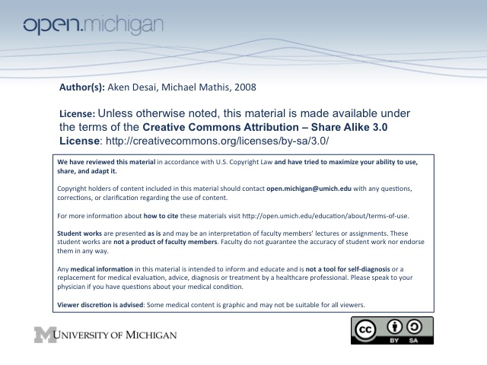
10-7-08 Tubulointerstitial Disease
Interstitial Nephritis
- Interstitial Nephritis – group of diseases characterized by interstitial inflammation w/ edema/fibrosis
  - Tubules – usually also affected here, since there is very little interstitial space
- Etiologies – wide variety, including pyelonephritis, drug hypersensitivies, metabolic disturbances, neoplasia (multiple myeloma), GN, SLE (both GN/IN), transplant rejection
Pyelonephritis
- Pyelonephritis – bacterial infection of kidney affecting interstitium/tubules/medulla
- Acute Pyelonephritis – acute bacterial infection of kidney, accompanied by pus (suppuration)
  - Etiologies – UTI (E. coli, Klebsiella, Enteroacter) ascend from bladder
  - Gross Appearance – kidneys are swollen/edematous, cortical microabscesses
  - Pathology – patchy interstitial inflammation with PMNs, tubular necrosis, WBC casts
  - Glomeruli – characteristically spared in this disease
- Chronic Pyelonephritis – has tubulointerstitial scarring, involving calyces/pelvis of kidney
  - Chronic obstructive pyelonephritis – obstruction to urinary outflow → recurrent infection
  - Reflux nephropathy pyelonephritis – most common → urine reflux up from bladder (children)
  - Gross Appearance – can be unilateral/bilateral; irregular coarse scarring of cortex/calyces
  - Pathology – not D_{x} (D_{x} from gross) interstitial fibrosis → chronic inflammation, loss of tubules
Tubulointerstitial Disease w/ Drugs
- Drug-induced Hypersenstivity Interstitial Nephritis – immunologic response to drug, direct toxicity
  - Tubular BM Antibodies – may or may not be present
  - Systemic Symptoms – often see rash, eosinophilia, edema
  - Common Drugs – include methicillan, penicillin, ampicillin, NSAIDs, sulfa, diuretics, gentamycin
  - Gross appearance – kidneys slightly enlarged (but not too much → acute)
  - Pathology – interstitial infiltrate of mononuclear cells (no PMNs), eosinophils if allergic response, tubule injury
  - Glomeruli – spared
- Long-Term Cumulative Injury (Analgesics) IN – chronic renal injury from long-term painkillers
  - Drugs – phenacetin, aspirin, acetaminophen, codeine
  - Mechanism – direct toxicity & vasoconstriction
  - Gross Appearance – depressed cortical scars overlying necrotic papillae
  - Pathology – ischemic fibrosis, coagulative necrosis of a renal papilla
Tubulointerstitial Disease w/ Neoplasia
- Neoplasia-induced Interstitial Nephritis – malignancy induces interstitial disease
  - Mechanism – metabolic (hypercalcemia, hyperuricemia), ureter obstruction, 2º radiation T_{x}
  - Multiple myeloma – disease from Bence-Jones proteins (Ig light chains) that are monoclonal
  - Multiple Myeloma Appearance – kidneys normal size/slightly shrunken
  - Mutliple Myeloma Pathology – Bence-Jones protein tubular casts (hard, concentric), giant cells, rupture of tubules may occur and cause inflammatory response
Amyloidosis
- Amyloidosis – a protein not normally produced by body circulating in blood stream; two types:
  - AL – associated with immunoglobulin light chains
  - AA – associated with chronic inflammatory diseases (multiple myeloma, Alzheimer’s)
- Beta-pleated sheet – structure of the amyloid molecule which body can’t clear → unifying amyloid feature; seen in Alzheimer’s plaques too
- Nephrotic Syndrome – commonly developed with amyloidosis
- Gross Appearance – diffuse enlargement of kidney
- Pathology – diffuse eosinophilic deposition in glomeruli/vessels; Congo red stain
Microangiopathic Hemolytic Anemia
- Microangiopathic Hemolytic Anemia – associated with ARF, hemolysis, thrombocytopenia
  - Mechanism – involves endothelial cell injury/activation, and platelet aggregation
  - Gross Appearance – patchy or widespread cortical necrosis
  - Pathology – thombosis of interlobular arteries/afferent arterioles/glomeruli, onion-skinned walls, fibrinoid necrosis, glomeruli may show thrombi
  - Types – two major types: HUS, TTP:
- Hemolytic Uremic Syndrome (HUS) – can lead to disseminated intravascular coagulation (DIC)
  - Demographic – disease in children, leading to ARF
  - E. coli – most cases associated with a verocytotoxin from E. coli
- Thombotic Thombocytopenic Purpura (TTP) – can lead to disseminated intravascular coagulation (DIC)
  - Demographic – commonly affects female adults under 40
  - CNS involvement – common with TTP
  - DIC – less common with TTP
Atheroembolic Renal Disease – Infarct, Timing, Organs, Presentation
- Renal Infarcts – can happen from rupture plaques & thrombosis
- Insidious (chronic) onset – atherosclerotic disease of long standing
- Multiple organs – thromboses head in many directions
- Presentation – oliguric renal failure, hematuria/proteinuria, flank pain… progress to RF

