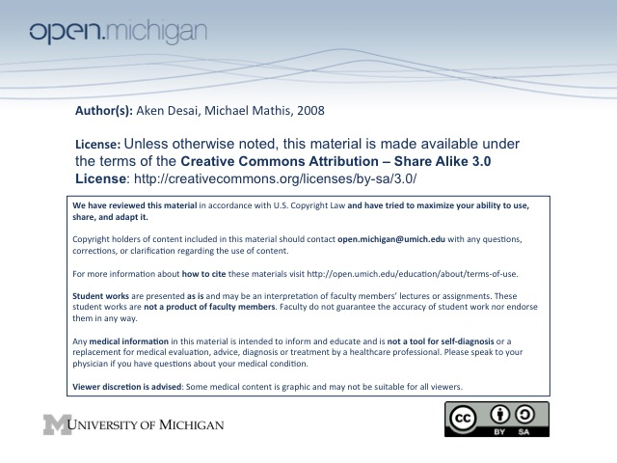
Psychiatric Classification
Diagnosis – the classification of pathology according to groups of symptoms w/ characteristic etiology, course and outcome
- Etiology/pathophysiology may not be understood and hypothesized to be the same for all patients w/ the diagnosis
- Purpose of diagnosis – organize and simplify history, predict course, determine treatment and predict outcomes, facilitate professional communication, create groups for study, meet administrative and legal needs
- Historical diagnosis – madness, melancholy, feeble-mindedness, hypochondriasis, nervous disposition, alcoholic dissolution
- Biomedical classification – closely follows other medical disciplines, based on S/Sx and outcomes, etiology can be incorporated
- Psychoanalytic classification – diagnosis is based on psychological processes, etiology is inferred from history and psychotherapeutic process
- Biopsychosocial model – integrates elements of both, not used for diagnosis
Psychiatric Classification
- DSM – Diagnostic & Statistical Manual of Medical Disorders
- DSM III
  - Defined mental disorder as a clinically significant behavorial or psychological syndrome or pattern that occurs in an individual and that is associated with present distress or disability or with significant increased risk of death, pain, disability, or an important loss of freedom
  - Based on statistical evidence for symptoms of major disorders
  - Improved inter-rater reliability, not diagnostic validity
- DSM IV – current psychiatric classification system, used to identify common D_{x}, and give common T_{x}
- DSM V – coming in 2012; reorganized according to current research, reconsider how to describe personality traits/disorders
DSM System
- Diagnostic Criteria – each DSM entry has a boxed in section giving D_{x} criteria for disorder
- Multiaxial – DSM system has five axes, patients will have information in each:
  - Axis I – covers clinical disorders (largest group, most mental disorders belong here)
  - Axis II - covers personality disorders as well as mental retardation
    - Symptoms extend back to developmental years (adolescence/early adulthood)
  - Axis III – covers medical conditions, coincident with mental disorders (don’t have to relate!)
  - Axis IV – covers psychosocial & environmental stressors (often cause of Axis I & II)
    - Primary support group – relationships with parents/friends/partners act to stress
    - Occupational/Educational problems – job/schooling stresses
  - Axis V – covers a global assessment of functioning (GAF)
    - GAF Score – how well a patient is functioning with mental disorder (100 = best)
    - Includes – psychological/social/occupational stressors leading to impairment
    - Excludes – impairments in function due to physical limitations
- Axis I & II Notations – allow for multiple D_{x}, principle D_{x}, severity, provisional D_{x}
V-Code – Definition, Common V-Codes
- DSM V-Code – something that is not a psychiatric disorder, but may still need treatment
- Common V-Codes – relationship problems, academic problems, child abuse/neglect, bereavement
Using DSM
- Medical Disorder – always first; if a DSM disorder comes from both medical & mental, medical trumps
- Mental Disorder – of primary cause, rather than mental disorder 2º to medical disorder
- Minor Disorder – don’t diagnose minor disorder separate from major, if major disorder presents same S_{x}
  - Ex: Insomnia comes from depression, so if patient is depressed, don’t list insomnia separately
- Clinical Judgment – boundaries between disorders indistinct; some subjective clinical judgment needed

