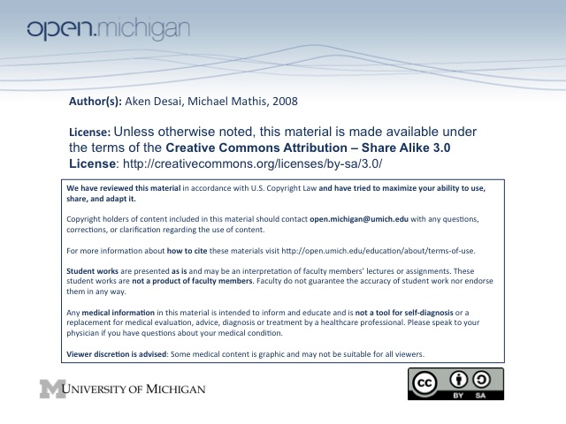
Mental Status Exam
Mental Status Exam Parts
- Appearance/Behavior – dress/grooming, posture, facial expression, eye contact, mannerisms, cooperation
- Speech – rate, quantity, volume, fluency, clarity (articulation)
- Emotions – mood (emotion), affect (expression), lability, appropriateness
- Thought – process (pattern → few, blocked, racing, loose), content (substance → delusion, OCD, fear)
- Perceptions – illusions (misinterpreted), hallucinations (no stimulus)
- Dissociative States – depersonalization, derealization
- Cognitive – consciousness, orientation, concentration, memory, language, fund, abstract, judgment
Mood vs. Affect
- Mood – pervasive emotional state of patient, often in own words → “sad”, “happy”, “angry”, “anxious”
- Affect – how patient manifests mood
  - Intensity – amount of emotion displayed
    - Blunted – less emotion than would be expected
    - Flat – little/no emotion shown at all
  - Lability – how rapidly a patient’s mood changes
  - Appropriateness – does the affect match the mood?
Thought Process vs. Content
- Process/Form – how ideas fit together, including rate and flow:
  - Poverty of thought – having very few thoughts (not same as having thoughts & not saying)
  - Blocking – inability to form thoughts
  - Flight of ideas – having racing, rapid thoughts
  - Loose Associations – thoughts are disconnected
  - Circumstantiality – lots of extra details, but gets to the point
  - Tangentiality – extra details, connected thoughts, but doesn’t get to the point
- Content – what is being thought:
  - Delusions – fixed false beliefs
  - Ideas/Delusions of Reference – belief that some unimportant event related specifically to patient
  - Thought Insertion/Withdrawal – belief that thoughts put into/taken out of head
  - Broadcasting – belief that others can hear thoughts
  - Obsession – a disorder of thinking → distracting, persistent thoughts
  - Compulsion – a disorder of doing → irresistible urges to perform meaningless tasks
  - Phobia – irrational fear of specific things
  - Suicidal/Homicidal Ideation – thoughts of killing oneself/others
Perceptions
- Illusions – misinterpreted sensory inputs
- Hallucinations – perceiving input in absence of external sensory stimulation (visual, auditory, olfactory, gustatory, tactile)
- Hypnagogic – hallucinations as patient falls asleep or awakens
Dissociative States
- Depersonalization – feeling that one is not oneself
- Derealization – feeling that the world, people, and things around are not real
Cognitive Functions
- Level of consciousness – include awake & alert, subdued, asleep, or comatose
- Orientation – name, person, place, time (place >> time >> person)
- Concentration/attention – serial 7’s test
- Memory – immediate recall (3 words), recent (minutes), remote (days/years)
- Language – can patient talk & interact with others appropriately?
  - Comprehension
  - Repetition – “no ifs, ands, or buts”
  - Naming – point to objects in room
  - Reading/Writing
- Fund of Knowledge – does patient know what’s going on in world?
- Abstractions – can patient understand what is meant by “don’t throw stones in glass houses”?
- Insight – can patient reason and deduce? Can patient recognize if they have psychiatric problem?
- Judgment – does patient know how to do right thing at right time (e.g. leave building when smell smoke)

