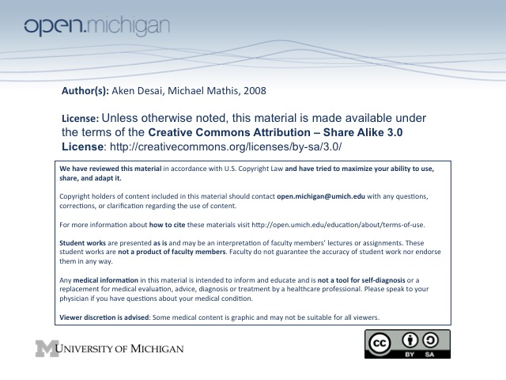
Anxiety Medications
Antianxiety Drugs
- Antidepressant Meds – most common severe anxiety T_{x}, include SSRIs, TCAs, MAOIs
- Benzodiazepines – can also treat anxiety, insomnia
- Buspirone – similar to benzodiazepine; a sedative hypnotic
Benzodiazepines
- Action – act to relieve anxiety, cause sedation, and muscle relaxation, anticonvulsive, antero. amnesia
- Structure – many kinds, all have same action (pharmacodynamics), only different pharmacokinetics
- Mechanism – sensitizes the GABA_{A} receptor → Cl⁻ enters cell to hyperpolarize → inhibitory effect
  - Glutamate – principle excitatory NT in the CNS
  - GABA – principle inhibitory NT in the CNS
- GABA_{A} Receptor – has various domains at which different chemicals can act:
  - Benzodiazepines – act to sensitize GABA_{A} at one domain
  - Barbituates – act to sensitize GABA_{A} at another domain → longer opening time than BZDs
  - Anesthetics, Steroids – more domains…
- Without GABA - …benzodiazepines would be useless! Need GABA, benzodiazepines only sensitize
Benzodiazepine Pharmacodynamics
- GABA Dose Response Curve – shifted left by benzodiazepine → activated more easily by GABA
- Pharmacodynamics – largest effect BZDs can have is hypnosis; larger doses don’t lead to resp. depression/death (like barbituates can do)
- Absorption – BZDs differ (pharmacokinetics vary):
  - QUIZ: Greater lipid solubility → greater absorption
  - Rapid absorption/excretion – might be good as sedative/hypnotic
  - Slower absorption/excretion – more long-term, can treat anxiety
- QUIZ: Elimination – determined by metabolism rate, differ widely (many have active metabolites)
Diazepam (Valium)
- Absorption – very lipophilic → very rapid absorption (max effect 30 minutes – 2 hours)
- Activation – very rapid onset and decline, because distributes out of brain very rapidly as well…
- Metabolism/Elimination – would be very fast, but actually so lipophilic that stored in fat at sub-T_{x} level
  - Chronic Diazepam – amount stored in fat becomes larger, and reaches a therapeutic level
  - “Diazepam Hangover” – because of amount stored in fat, if taken chronically
- QUIZ: Dimethyldiazepam – long-lasting metabolite of diazepam thru CYP 3A4 → long T_{1/2}
Lorazepam (Ativan)
- Lorazepam – benzodiazepine not metabolized thru P450 → shorter T_{1/2}, no dimethyldiazepam metabolite
- Absorption – slightly less lipophilic → takes a few hours to reach peak effect
- Metabolism/Elimination – straight to conjugation → urinary excretion; no P450 metabolism in liver
Other Benzodiazepines
- Slower Absorption, Fast Elimination – (Temazepam) good for treating insomnia… but amnesia
- Fastest Elimination – (Midazolam = Versed) pre-op anesth… amnesia = awesome (forget surgery)
- GABA_{A} Subtypes – many different, located in different areas of brain
  - QUIZ: α1 Subtype – located in area of brain where activation causes sedation
  - Zolpidem (Ambien) – not BZD, but same site → targets α1 subtype, causes sleep, amnesia
  - Anything with a “Z” – not BZD targets α1 subtype, produces zzz… (zaleplona, eszopiclone)
Benzodiazepine Drug-Drug Interactions – By Themselves, Potentiation, CYP3A4
- By Themselves – are safe CNS depressants, can’t achieve respiratory depression or coma
- With CNS Depressants – can potentiate effects (Antipsychotics, opioids, alcohol, antihistamine, MAOI, TCA, anticonvulsants) → possibly dangerous effects
- CYP3A4 – benzodiazepines effected by CYP3A4 activators/inhibitors
Benzodiazepine Risks – Side Effects, Contraindications, Tolerance/Abuse/Dependence
- Side Effects – light-headed, “hangover”, drowsiness, rebound withdrawal, ataxia/nystagnus, amnesia
- Contraindications – decreased airway tone (bad COPD), alcoholism/liver problems → bad metabolism
- Dependence/Abuse – some risk, but less than barbituates; common in abusers of other drugs
- Tolerance – can develop a tolerance or a physical dependence after long-term use
Flumazenil
- Flumazenil – is a benzodiazepine receptor antagonist → will reverse effects of BZDs
- Use – can be used to bring someone out of pre-op state of sedation
Buspirone – Anxiety, Sedation
- Anxiolytic – used to treat anxiety, but not sedative hypnotic
Chloral Hydrate – Mechanism, Effect
- Mechanism – rapidly converted to ethanol in liver
- Effect – super-duper alcohol
- Usage – sedation for small uncomfortable procedures/surgeries

