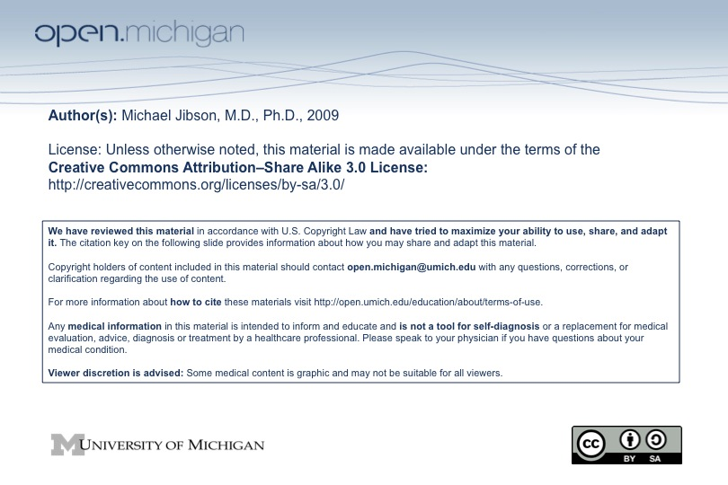
Psychiatry Sequence (PSY614)

Topic: | Psychiatric Classification and Terminology
Faculty: | Michael Jibson, M.D., Ph.D.  Department of Psychiatry
Recommended Reading: | Andreasen & Black, Introductory Textbook of Psychiatry, 3rd ed., pp. 21-43
Lecture: | Monday, 10/27/08, 8:00 - 9:00 a.m.

Learning Objectives:

After reviewing the material on psychiatric classification and terminology, the student should be able to:
1. Explain the differences among biomedical, psychodynamic, and biopsychosocial classifications of mental illness.
2. List the purposes for making a psychiatric diagnosis.
3. Explain the difference between a general medial and primary psychiatric disorder.
4. Describe general design of DSM, the basis on which it classifies diagnoses, and its implications for reliability and validity.
5. Give the definition of a mental disorder.
6. Describe the DSM multiaxial system, including what information is reported on each Axis.
7. Define "V code."
8. Explain the hierarchy of diagnoses incorporated into DSM (eg, medical before psychiatric).

Sample Test Questions:

1. By convention, personality disorder diagnoses are reported on:  A. Axis I  B. Axis II  C. Axis III  D. Axis IV  E. Axis V  Answer: B | 2. The DSM system has improved:  A. Diagnostic validity  B. Acceptance of mental illness  C. Psychotherapy outcomes  D. Pharmacotherapy outcomes  E. Diagnostic reliability  Answer: E

