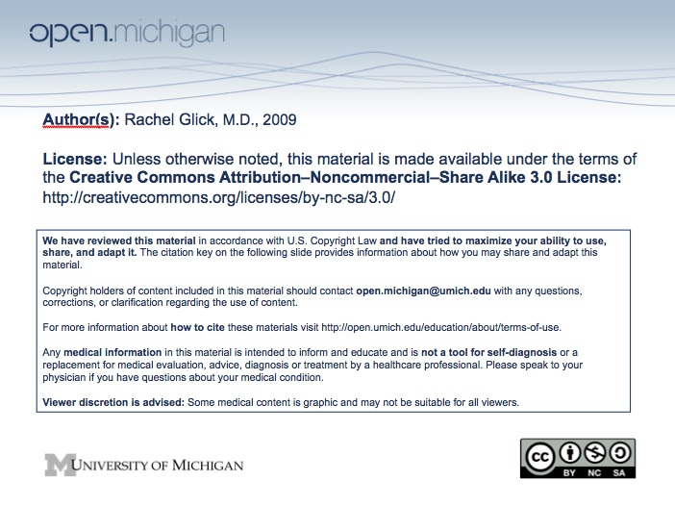

Psychiatry Sequence (PSY614)

Topic: | The Mental Status Examination
Faculty: | Rachel Glick, M.D.
Recommended Reading: | Andreasen & Black, Introductory Textbook of Psychiatry, 3rd Edition, pp 53-84; 791-792
Lecture: | Monday, 10/27/08, 9:00 – 10:00 a.m.
Required Patient Presentation: | Small Groups - Weds, October 29, or Thurs, October 30, 1-3 p.m.
Learning Objectives:

After reviewing the material and participating in the small group experience, the student will be expected to:

1. Know the parts of the mental status exam.
2. Define mood. Define affect and be able to describe the variability, intensity, and appropriateness of a patient's affect given a clinical description of the patient. Define labile affect. Define blunted and flat affect.
3. Distinguish thought process from thought content.
4. Know the definition of the following thought process abnormalities: poverty of thought, blocking, flight of ideas, loose associations, circumstantiality, tangentiality. Be able to recognize these abnormalities given a clinical vignette.
5. Know the definition of the following thought content abnormalities: Delusion, ideas (or delusions) of reference, thought insertion or withdrawal, thought broadcasting, obsessions, compulsions, phobias, suicidal or homicidal ideation. Be able to recognize these abnormalities given a clinical vignette.
6. Know the difference between illusions and hallucinations. Define the dissociative states: derealization and depersonalization.
7. Know ways to assess a patient's cognitive (intellectual) functions including: orientation, concentration or attention, memory, use of language, fund of knowledge, abstraction, judgment and insight.

Sample Test Question:

When a psychiatrist asks a patient what "people who live in glass houses shouldn't throw stones" means, he/she is testing:

A. Insight
B. Judgment
C. Abstraction
D. Orientation
E. Memory

Answer: C

