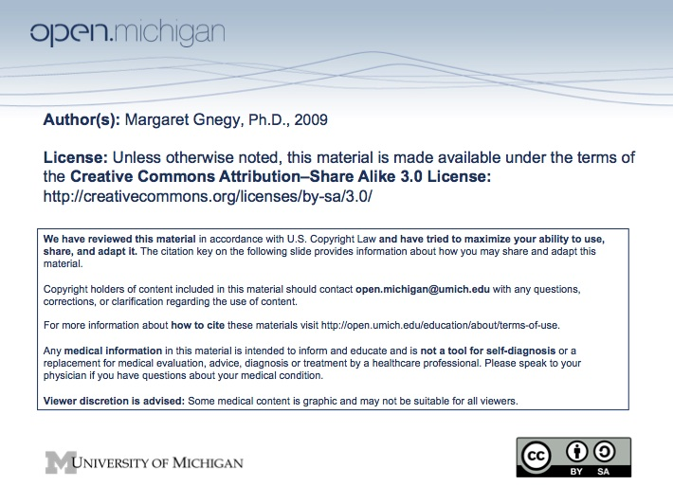

Psychiatry Sequence (PSY614)

Topic: | Antianxiety & Hypnotic Medications
Faculty: | Margaret E. Gnegy, Ph.D.  Professor, Department of Pharmacology
Recommended Reading: | Goodman & Gilman’s The Pharmacological Basis of Therapeutics, 11th Ed., Ch. 16
Lecture: | Monday, 10/27/08; 11:00 am -12:00 noon

Learning Objectives:

After reviewing the material on antianxiety drugs, the student should know and understand:
1. The mechanism of action of benzodiazepines at the GABA_{A} receptor and understand that many drugs act at the GABA_{A} receptor.
2. The pharmacokinetics of the drugs with particular attention paid to mechanisms involving lipophilicity, redistribution and metabolism.
3. The major therapeutic uses of the drugs.
4. The major side effects of the drugs, including concepts of dependence and withdrawal.
5. Other drugs used to treat anxiety (buspirone) and insomnia (nonbenzodiazepine hypnotics) and their key actions.

Primary drugs to know are: diazepam, lorazepam, zolpidem

Sample question:

Which of the following is NOT an effect of diazepam?

A. Ataxia
B. Amnesia
C. Severe respiratory depression
D. Anti-convulsive
E. Muscle relaxation

Answer: C

