

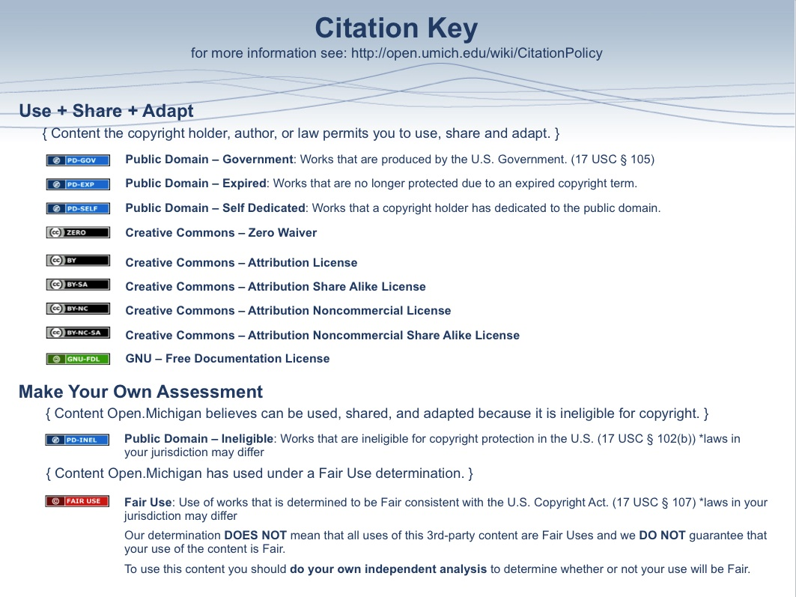
Psychiatric Classification and Terminology

I. Background
A. Diagnosis – the classification of pathology according to groups of symptoms with characteristic etiology (if known), course, and outcome
1. Etiology and pathophysiology may or may not be understood
2. Etiology and pathophysiology are hypothesized to be the same for all patients with the diagnosis
3. Purpose of Diagnosis
a. Organize and simplify clinical history
b. Predict clinical course of illness
c. Determine treatment options and predict outcomes
d. Facilitate professional communication
e. Create homogenous groups and patients for scientific study
f. Meet administrative and legal needs

B. Historical Overview of Psychiatric Diagnoses
1. Madness
2. Melancholy
3. Feeble-mindedness
4. Hypochondriasis
5. Nervous disposition
6. Alcoholic dissolution

C. Biomedical Classification
1. Closely follows other medical disciplines
2. Diagnosis is initially based on signs, symptoms, and outcomes
3. Etiology is sought through research on pathophysiology
4. Etiology may later be incorporated into diagnosis

D. Psychoanalytic Classification
1. Diagnosis is based on psychological processes (eg, drives, defenses, conflicts)
2. Etiology is inferred from the history and psychotherapeutic process

E. Biopsychosocial Model
1. Incorporates elements of the biomedical and psychoanalytic models
2. Is not currently used for diagnosis, but for “formulation,” which seeks to explain the patient’s symptoms within the context of the patient’s life

II. Diagnostic and Statistical Manual of Mental Disorders (DSM)
A. History and Development
1. DSM-I (1952) and DSM-II (1968)
a. Designed to create a systematic nomenclature and classification system for psychiatric diagnoses
b. Diagnosis was largely based on expert opinion
c. Incorporated psychoanalytic concepts of etiology in classifications
d. Showed poor inter-rater reliability
2. DSM-III (1980)
a. Defined “Mental Disorder”
i. “A clinically significant behavioral or psychological syndrome or pattern that occurs in an individual and that is associated with present distress or disability or with a significant increased risk of suffering death, pain, disability, or an important loss of freedom.”
ii. The terms “mental illness” and “disease” are not used in DSM
b. Retained historical classifications of major disorders
c. Designed by researchers based on best available statistical evidence for symptoms of major disorders
d. Eliminated theoretical constructs in diagnosis
e. Improved inter-rater reliability (likelihood that 2 clinicians will reach the same diagnosis), not diagnostic validity (likelihood that the diagnosis represents a unique disease process)
f. Clarified and facilitated differential diagnosis
g. Facilitated research on diagnosis, etiology, and treatment
h. Corresponds to International Classification of Disease (ICD) used outside the US
3. DSM-IV (1994)
a. Refined diagnostic criteria with additional research data
b. Reorganized major diagnostic categories according to current research

4. DSM-IV (2012)
a. Will reorganize chapters according to current research data
b. Will reconsider how to describe personality traits and disorders (dimensional vs categorical)

B. Organization and Design
1. Axes I – major clinical syndromes
a. Clinical disorders
b. Other conditions that may be the focus of attention (“V-codes”)
2. Axis II – life-long or background conditions
a. Personality disorders
b. Mental retardation
3. Axis III – general (ie, nonpsychiatric) medical conditions
4. Axis IV – psychosocial and environmental stressors
a. Nature of stressor
b. Severity of stressor
5. Axis V – Global Assessment of Functioning (GAF)
a. Anchored numerical scale (0-100) based on ability to function psychologically, socially, and occupationally

Global Assessment of Functioning (GAF) Scale

Consider psychological, social, and occupational functioning on a hypothetical continuum or mental health – illness. Do not include impairment in functioning due to physical (or environmental) limitations.

100  91- | Superior functioning in a wide range of activities, life's problems never seem to get out of hand, is sought out by others because of his or her many qualities. No symptoms.
90  81- | Absent or minimal symptoms, good functioning in all areas, interested and involved in a wide range of activities, socially effective, generally satisfied with life, no more than everyday problems or concerns.
80  71- | If symptoms are present they are transient and expectable reactions to psychosocial stresses; no more than slight impairment in social, occupational, or school functioning.
70  61- | Some mild symptoms OR some difficulty in social, occupational, or school functioning, but generally functioning pretty well, has some meaningful interpersonal relationships.
60  51- | Moderate symptoms OR any moderate difficulty in social, occupational, or school functioning.
50  41- | Serious symptoms OR any serious impairment in social, occupational, or school functioning.
40  31- | Some impairment in reality testing or communication OR major impairment in several areas, such as work or school, family relations, judgment, thinking, or mood.  Global Assessment of Functioning (GAF) Scale  (Cont)
30  21- | Behavior is considerably influenced by delusions or hallucinations OR serious impairment in communications or judgment OR inability to function in all areas.
20  11- | Some danger of hurting self or others OR occasionally fails to maintain minimal personal hygiene OR gross impairment in communication.
10  1- | Persistent danger of severely hurting self or others OR persistent inability to maintain minimum personal hygiene OR serious suicidal act with clear expectation of death.
0 | Not enough information available to provide GAF.
C. General DSM Categories
1. Disorders usually first diagnosed in infancy, childhood, or adolescence
2. Delirium, dementia, amnestic and other cognitive disorders
3. Mental disorders due to a general medical condition
4. Substance-related disorders
5. Schizophrenia and other psychotic disorders
6. Mood disorders
7. Anxiety disorders
8. Somatoform disorders
9. Factitious disorders
10. Dissociative disorders
11. Sexual and gender identity disorders
12. Eating disorders
13. Sleep disorders
14. Impulse-control disorders no elsewhere classified
15. Adjustment disorders
16. Personality disorders
17. Other conditions that may be a focus of clinical attention (V-Codes
a. Noncompliance with treatment
b. Physical abuse of a child
c. Relational problem
d. Academic problem
e. Malingering

D. Use of DSM
1. Begin with an assessment of the patient’s major complaint or problem (eg, depressed mood)
a. This will usually be described by the major criteria for the disorder (ie, A, B, C…)
2. Create a differential diagnosis based on that problem (eg, major depressive disorder; bipolar I disorder, depressed; substance induced mood disorder)
3. Compare the checklist of diagnostic criteria for each disorder to the patient’s history and symptoms
a. This will usually be described by secondary criteria (ie, 1, 2, 3…)
b. Secondary criteria are listed in order of predictive value for the disorder, not prevalence or clinical significance
4. Do not give separate diagnoses for symptoms occurring only in the context of a diagnosed condition (eg, poor appetite occurring only in the context of major depressive disorder should not be diagnosed as anorexia nervosa)
5. Diagnoses that must be excluded are listed
a. There is often a hierarchy of diagnoses that should be followed
i. medical disorders before primary psychiatric disorders
ii. specific disorders before general disorders
iii. mood disorders before psychotic disorders
6. Multiple diagnoses are allowed
a. Most patients have 2-4 diagnoses
7. Provisional diagnoses are allowed
8. Severity, chronicity, and recurrence of the disorder are described
9. Catch-all diagnoses are allowed in most categories (“NOS” = not otherwise specified)
a. Conditions that fit the large descriptors, but not the specifics
b. Conditions that do not meet criteria for any diagnosis

E. Case examples
1. Anxiety
2. Habitual stealing

Diagnostic Criteria for Generalized Anxiety Disorder
A. Excessive anxiety and worry (apprehensive expectation), occurring more days than not for at least 6 months, about a number of events or activities (such as work or school performance).

B. The person finds it difficult to control the worry.

C. The anxiety and worry are associated with three (or more) of the following six symptoms (with at least some symptoms present for more days than not for the past six months).

(1) restlessness or feeling keyed up or on edge
(2) being easily fatigued
(3) difficulty concentrating or mind going blank
(4) irritability
(5) muscle tension
(6) sleep disturbance (difficulty failing or staying asleep, or restless unsatisfying sleep)

D. The focus of the anxiety and worry is not confined to features of an Axis I disorder, e.g., the anxiety or worry is not about having a Panic Attack (as in Panic Disorder), being embarrassed in public (as in Social Phobia), being contaminated (as in Obsessive Compulsive Disorder), being away from home (as in Separation Anxiety Disorder), gain weight (as in Anorexia Nervosa), having multiple physical complaints (as in Somatization Disorder), or having serious illness (as in Hypochondriasis), and the anxiety or worry do not occur exclusively during Posttraumatic Stress Disorder.

E. The anxiety, worry, or physical symptoms cause clinically significant distress or impairment in social, occupational, or other important areas of functioning.

F. The disturbance is not due to the direct physiological effects of a substance (e.g., a drug of abuse, a medication) or a general medical condition (e.g., hyperthyroidism) and does no occur exclusively during a Mood Disorder, a Psychotic Disorder, or a Pervasive Developmental Disorder.

Diagnostic Criteria for a Panic Attack
A discrete period of intense fear or discomfort, in which four (or more) of the following symptoms developed abruptly and reached a peak within 10 minutes:

(1) palpitations, pounding heart, or accelerated heart rate
(2) sweating
(3) trembling or shaking
(4) sensations of shortness of breath or smothering
(5) feeling of choking
(6) chest pain or discomfort
(7) nausea or abdominal distress
(8) feeling dizzy, unsteady, lighthearted, or faint
(9) derealization (feelings of unreality) or depersonalization (being detached from oneself)
(10) fear of losing control or going crazy
(11) fear of dying
(12) paresthesias (numbness or tingling sensations)
(13) chills or hot flushes

Diagnostic Criteria for Kleptomania
A. Recurrent failure to resist impulses to steal objects that are not needed for personal use or for their monetary value.
B. Increasing sense of tension immediately before committing the theft.
C. Pleasure, gratification, or relief at the time of committing the theft.
D. The stealing is not committed to express anger or vengeance and is not in response to a delusion or a hallucination.
E. The stealing is not better accounted for by Conduct Disorder, a Manic Episode, or Antisocial Personality Disorder.

Diagnostic Criteria for Pathological Gambling
A. Persistent and recurrent maladaptive gambling behavior as indicated by five (or more) of the following:
(1) is preoccupied with gambling (e.g., preoccupied with reliving past gambling experiences, handicapping or planning the next venture, or thinking of ways to get money with which to gamble)
(2) needs to gamble with increasing amounts of money in order to achieve the desired excitement
(3) has repeated unsuccessful efforts to control, cut back, or stop gambling
(4) is restless or irritable when attempting to cut down or stop gambling
(5) gambles as a way of escaping from problems or of relieving a dysphoric mood (e.g., feelings of helplessness, guilt, anxiety, depression)
(6) after losing money gambling, often returns another day to get even (“chasing” one’s losses)
(7) lies to family members, therapist, or others to conceal the extent of involvement with gambling
(8) has committed illegal acts such as forgery, fraud, theft, or embezzlement to finance gambling
(9) has jeopardized or lost a significant relationship, job, or educational or career opportunity because of gambling
(10) relies on others to provide money to relieve a desperate financial situation caused by gambling

B. The gambling behavior is not better accounted for by a Manic Episode.

Diagnostic Criteria for Antisocial Personality Disorder
A. There is a pervasive pattern of disregard for and violation of the rights of others occurring since age 15 years, as indicated by three (or more) of the following.
(1) failure to conform to social norms with respect to lawful behaviors as indicated by repeatedly performing acts that are grounds for arrest
(2) deceitfulness, as indicated by repeated lying, use of aliases, or conning others for personal profit or pleasure
(3) impulsivity or failure to plan ahead
(4) irritability and aggressiveness, as indicated by repeated physical fights or assaults
(5) reckless disregard for safety of self or others
(6) consistent irresponsibility, as indicated by repeated failure to sustain consistent work behavior or honor financial obligations
(7) lack of remorse, as indicated by being indifferent to or rationalizing having hurt, mistreated, or stolen from another
B. The individual is at least age 18 years.
C. There is evidence of Conduct Disorder (see p.90) with onset before age 15 years.
D. The occurrence of antisocial behavior is not exclusively during the course of schizophrenia or a Manic Episode.

