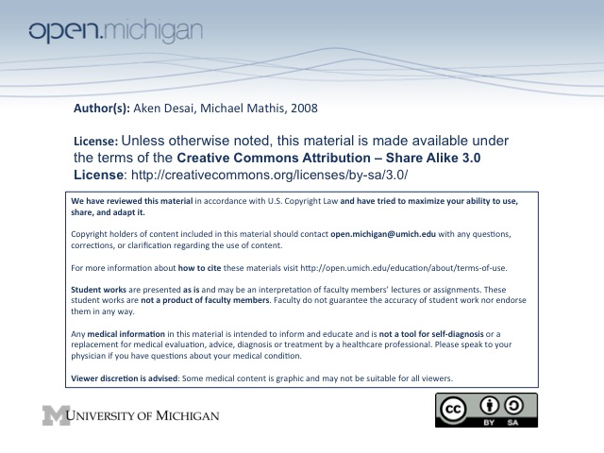
Mood Disorders
Introduction
- Mood – pervasive emotional state of patient
- Depression - #1 burden of disease for ages 15-45
- Bipolar - #6 burden of disease ages 15-45
Mood Disorder Neurobiology
- Depression – associated with low levels of NE & serotonin in body
- Mania – associated with high levels of NE & serotonin in body
- Antidepressants – aim to increase the synaptic transmission of NE/serotonin, or both
- Hypothalamic-Pituitary-Adrenal (HPA) axis – depression causes hyperactivation
  - Excess cortisol secretion – as a result of whole HPA axis screwed up
  - Dexamethasone Suppression Test (DST) – in depression, cortisol unsuppressed in DST
- Hypothalamic-pituitary-thyroid axis – depression associated w/ hypoactivation → hypothyroidism
Depression
- Sleep cycle – altered for the worse → decreased sleep time, more frequent REM, less slow wave sleep
- Neuroimaging – decreased volume/metabolism in frontal lobes, amygdala, hippocampus
- “Learned Helplessness” – fatalist mentality of chronically depressed, believe life events out of control
The Major Depressive Episode
- Major Depressive Episode – defined as 2 weeks of consistently depressed mood with some symptoms:
  - Decreased appetite/weight loss – in most cases; but can be increased in atypical
  - Insomnia – usually early waking; but can be increased in atypical
  - Psychomotor – retardation & slow movement; but can be increased in atypical
  - Fatigue – loss of energy
  - “Learned Helplessness” – fatalist mentality of chronically depressed; often inappropriate guilt
  - Death/Suicide Ideation – recurrent thoughts of death/suicide
- Impaired Function – to qualify as major depressive, must impair function or cause significant distress
- Substance Abuse/Medical Illness – don’t qualify as major depressive episodes
- Bereavement – normal in many circumstances, also doesn’t qualify
Depressive Episode Subtypes
- Atypical – can have increased appetite, hypersomnia, preserved affect; sensitive to rejection
- Melancholia – prominent anhedonia (no pleasure or interest in anything), along w/ depressive symptoms
- Postpartum – depressive episodes within 4 weeks of delivery of child
- Catatonic – depressive episode with characteristic motor signs (similar to Schizophrenia)
- Psychotic Features – accompany 10% of depressive episodes → 1% population psychotic!
- Seasonal – depressive episodes occur most commonly in fall/winter
The Manic Episode
- QUIZ: Manic Episode – defined as 1 week of continuous elevated/expansive/irritable mood with some symptoms:
  - Inflated self-esteem – takes on grandiose ideas, increased involvement in goal-directed activity
  - Decreased sleep need – manic episode requires little to no sleep each day
  - Loud, rapid, intrusive speech – can talk for hours without breaking/prompting
  - Flight of ideas – constantly racing thoughts, very distractible
  - High-risk behavior – fast driving, indiscriminate sex, spending sprees, bad investments, etc.
- Impaired Function - to qualify as manic episode, must impair function or have active psychosis
- Subtypes – include mixed, psychotic features, rapid cycling:
  - Mixed – episode meets criteria for both depressive episode and manic episode “crash and burn”
  - Psychotic Features – present in 80% manic episodes, has grandiose delusions and poor insight
  - Rapid Cycling – episodes occur 4 or more times per year
The Hypomanic Episode
- Hypomanic Episode – defined as 4-7 days of symptoms same as manic episode
- QUIZ: Unimpaired Function – unlike a manic episode, patient stays unimpaired and can be very productive
- No Psychosis/Hospital Admission – patient stays away from threshold of manic episode
Major Depressive Disorder
- Major Depressive Disorder – having one or more depressive episodes, without manic/hypomanic episode
- QUIZ: Prevalence – twice as common in women as men:
  - Lifetime risk – 10-25% for women; men half
  - Point Prevalence – 5-10% of women; men half
- Onset – very wide age range, can be sudden or gradual, strong genetic component
- Recurrence – 50% of patients experience recurrence
- Recovery – 50% recover after 6 months
- Treatment – include medications, psychotherapy, and electroconvulsive therapy (ECT)
  - Antidepressant R_{x} – SSRIs, tricyclic antidepressants = 1st line; MAOIs = 2nd line; 6-month T_{x}
  - Psychotherapy – cognitive behavioral therapy (stopping spirals), good for mild T_{x}, good with R_{x}
  - Electroconvulsive Therapy – used w/ severe depression, 80% effective, great T_{x} but $$$
    - Indications – non-response to other therapies, psychotic features, high sucide risk, starvation/dehydration, pt. request, prior response
    - CI: intracranial mass, dementia, severe personality disorder, anesthesia risk
Major Depressive Disorder + Pyschotic Features
- Prevalence – about 10% of depressed patients → 1% population!
- Mood – psychotic symptoms usually congruent with mood
- Treatment – can give combination drugs or ECT:
  - Combination drugs – unlike other depressive disorders, need antidepressant and antipsychotic
  - ECT – electroconvulsive therapy also highly effective treatment (80%)
Dysthymic Disorder
- Dysthymic Disorder – at least 2 years of mildly depressed mood, with a couple depressive symptoms
- Prevalence – lifetime risk 6%, point prevalence 3%
- “Double Depression” – can be co-morbid w/ major dep. → slightly depressed always + depressive bursts
- Treatment – antidepressants, psychotherapy (cognitive behavioral T_{x} CBT, interpersonal T_{x} IPT)
Bipolar I Disorder
- Bipolar I Disorder – have one or more manic episodes, regardless of depressive
- Prevalence – 1% lifetime prevalence, 1:1 M:F, strong genetic component
- Onset – range teens-60s, peaks 20s, rapid onset: elevated mood → euphoria → irritability → pyschosis
- Triggers – often triggered by stress, lack of sleep; can be followed/proceeded by depressive episode
- QUIZ: Recurrence – 90% of patients have recurrent episodes, prophylaxis essential
- Recovery – 70-80% recover to full function between episodes, rest are persistently unstable
- Complications – high suicide risk; can also ruin life (relationships, reputation, etc)
- Treatment – involves antipsychotics & mood stabilizers:
  - Antipsychotics – 1st line treatment
  - Mood Stabilizers – lithium, Valproic acid, anticonvulsants – 1st line T_{x} and prophylaxis!
  - No Antidepressants – bad idea, can help trigger manic episodes
Bipolar II Disorder
- Bipolar II Disorder – have one or more hypomanic episodes (no manic), at least one depressive
- Prevalence, Onset, Course, Complications, Treatment – same as Bipolar I
Cyclothymic Disorder
- Cyclothymic Disorder – chronic fluctuating mood not qualifying for manic/major depressive episodes
- Onset – very gradual, unlike Bipolar I & II disorders
- Prevalence, Treatment – same as Bipolar I & II → 1%, give antipsychotics & mood stabilizers
Substance Induced Mood Disorder
- Substance-Induced Mood Disorder – persistent mood disturbance related to intoxication/withdrawal
- Common Drugs – alcohol = depressant, amphetamine, cocaine, steroids = mood elevators
- Treatment – can resolve spontaneously after de-tox, or may need antidepressants
Mood Disorder Due to General Medical Condition
- Definition - persistent mood disturbance related to direct physiological effects of illness
- Illnesses – huge range, can be neurologic, endocrine, infectious…
Adjustment Disorder with Depressed Mood
- Definition – depressed mood within 3 months of stressor, symptoms resolve by 6 months after removal
- Depression Criteria – not met during adjustment disorder, although obvious stressor exists

