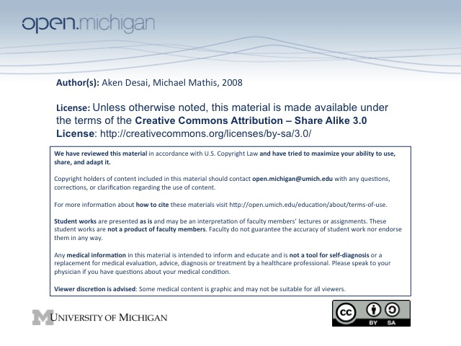
Delirium
Evaluation of Delirium
- Mental Status Exam – will show changes in consciousness, orientation, attention, mood & affect
- Neurologic Exam – assess medications & time of onset of delirium, also neuron physical
- Labs – blood chemistries (hypoglycemic?), blood count (infection?), drug levels, ABG, urinalysis, CXR
- Follow-up Labs – electroencephalogram (seizures?), CT scan, lumbar puncture
Epidemiology of Delirium
- Hospitalized Patients – occurs in 10-30% of all hospitalized medical/surgical patients!
- High-Risk Pop – include elderly, post-heart surgery, burn, prior psychiatric, drug withdrawal, AIDS
Delirium
- Delirium – “acute brain failure”, transient, reversible cerebral dysfunction, acute onset, very fluctuating
- Clinical Features – prodromal, fluctuation, inattentive, sleep/wake, memory, orientation, perception, phys:
  - Prodromal symptoms – restless, anxious, irritable
  - Fluctuating Course – changes can occur on the order of minutes
  - Neurologic – motor abnormalities, altered EEG findings – fast low voltage activity
  - Attention Deficit – can’t pay attention or focus
  - Altered Arousal – hyperactive/hypoactive, constantly changing
  - Sleep-wake Disturbance – circadian rhythm altered
  - Impaired Memory – immediate & recent memory often lost
  - Cognitive & Speech – can be disorganized & impaired
  - Orientation – unaware of person, place, time
  - Perceptions – can have delusions (fixed false belief), visual hallucination, auditory/tactile illusion
  - Emotional – anxiety, panic, fear, anger, sadness, depression, apathy, euphoria (steroid)
Delirium Diff. D_{x}, vs. Dementia
- Differential Diagnosis – includes delirum, psychosis, and dementia
  - Psychosis (schizophrenia, mania) – will not fluctuate, have normal EEG, no 1st pres. elderly
  - Dementia – more gradual & stable than delirium
- Delirum vs. Dementia – differ in many ways:
  - Onset/Duration – delirium more acute; dementia chronic
  - Course – delirium more fluctuating; dementia stable
  - Alertness – delirium has wider range; dementia has normal alertness
  - Attention – delirium easily distracted, dementia has normal attention
  - Orientation – both impaired
  - Memory – delirium has short-term memory loss; dementia has global memory loss
  - Thought – delirium affects thought process (disorganized); dementia affects content (poverty)
  - Perception – delirium has many illusions/hallucinations, dementia rarely has perceptual problems
Causes of Delirum
- Unknown Cause – pathophysiology of delirum is largely unclear
- Wide Range – a wide range of factors can contribute to the onset of delirium
- Cholinergic Deficit – best hypothesis → patients with delirium anxiety often have anticholinergic activity
  - Anticholinergics – antihistamines, tricyclic antidepressants
  - Cardiac – anti-arrhythmia drugs can cause
- Hypoxia/Hypoglycemia – other possible causes
- Course – recovery/progression → dementia → death or chronic delirious state
- Morbidity and mortality – high rates of complications even vs dementia
Delirium Treatment
- Treat Underlying Cause – usually a dangerous underlying cause of delirium (sepsis, drug withdrawal)
- Safety – danger of patient hurting oneself/others → get sitters, restraints
- Monitoring – keep close watch on vital signs, labs
- Meds – minimize all medications given (many psychoactive, e.g. pain meds), manage w/ benzodiazepines
- Social Support – comfort patient & family, assure that disease is reversible
- Environmental – have well-lit facilities with windows, helps orient patient

