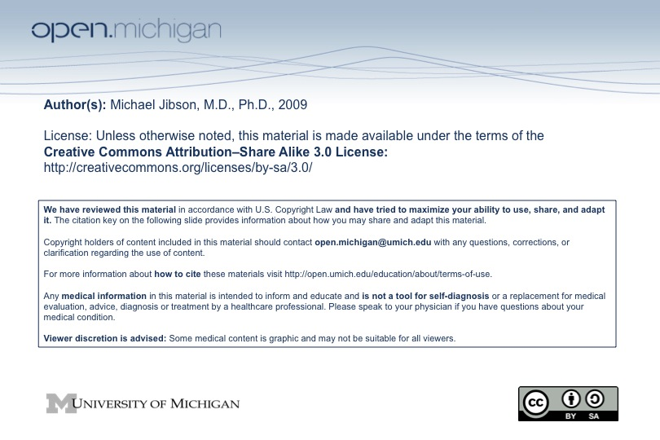
Psychiatry Sequence (PSY614)

Topic: | Mood Disorders
Faculty: | Michael Jibson, M.D., Ph.D.  Department of Psychiatry
Recommended Reading: | Andreasen & Black, Introductory Textbook of Psychiatry, 3rd ed., pp. 269-314  or  Sadock & Sadock, Kaplan & Sadock’s Pocket Handbook of Clinical Psychiatry, 3rd ed., pp. 128-49
Lecture: | Tuesday, 10/28/08, 8:00 - 9:30 a.m.

Learning Objectives:

After reviewing this material, the student will be expected to:
1. Define mood.
2. Describe the neurobiology of mood disorders.
3. List the diagnostic criteria for major depressive, manic, and hypomanic episodes.
4. Be able to diagnose major depressive disorder, dysthymic disorder, bipolar I disorder, bipolar II disorder, cyclothymic disorder, substance induced mood disorder, and mood disorder due to a general medical condition.
5. Define the subtypes of depressive and manic episodes.
6. Describe the major psychosocial factors involved in the development of mood disorders.
7. Describe the onset, prevalence, course, and complications of the major mood disorders.
8. Describe current treatments for mood disorders.
9. Recognize common substances and medical illnesses associated with mood disorders.

Sample Test Question:

A 54-year-old business executive has been unusually productive in the past month. During that time, she has worked 20 hours a day without apparent fatigue. She has developed a number of plans for expansion of the business, which have met with approval from the board of directors. She appears energetic and sometimes giddy as she describes her work. Her grooming and speech are somewhat sexually provocative, although she denies any unusual sexual activity. Her family describes this as a clear change from her usual demeanor. Her history is remarkable for two prior episodes of major depression. Her current presentation most likely represents a:

A. depressive episode.
B. hypomanic episode.
C. manic episode.
D. brief psychotic episode.
E. schizophrenic episode.

Answer: B

