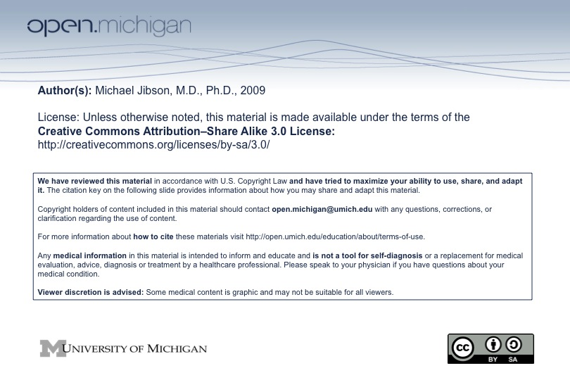

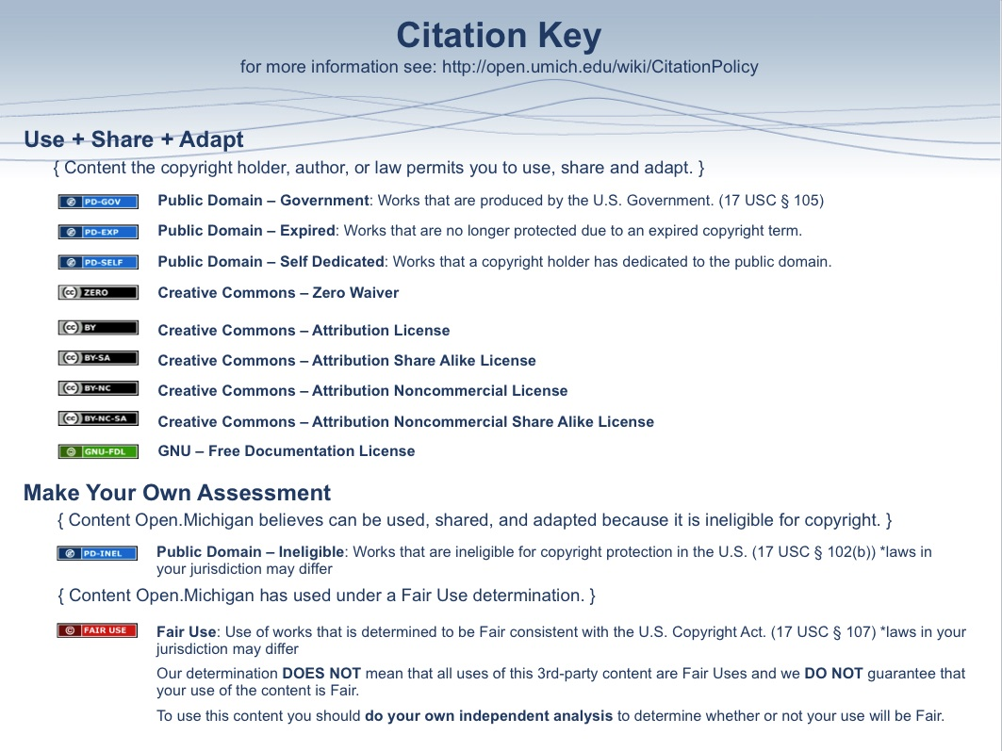
Mood Disorders

I. Introduction
A. Definition: “Mood” (or “affect”) is a pervasive emotional state that influences one’s view of self, others, and the environment.
B. History: “Melancholy” (Gr: “black bile”) has been recognized throughout history, and has been attributed to psychological, biological, and psychosocial factors at least since Hippocrates.
C. Significance: Depression is #1 and bipolar disorder #6 on the WHO Global Burden of Disease for ages 15-45

II. Neurobiology of Mood Disorders
A. Biogenic amines
1. Low norepinephrine and serotonin levels are associated with depression
2. Elevated norepinephrine and serotonin levels are associated with mania
3. Most antidepressants increase synaptic transmission of norepinephrine, serotonin, or both

B. Neuroendocrine dysfunction in depression
1. Hypothalamic-pituitary-adrenal (HPA) axis
a. Hyperactivation leads to excess cortisol secretion
b. Dexamethasone suppression test (DST) shows nonsuppression of cortisol in 50% of cases
c. Immune functions may be suppressed with depressed mood
2. Hypothalamic-pituitary-thyroid axis
a. 10% of severely depressed patients have hypothyroidism

C. Neurophysiological dysfunction in depression
1. Sleep architecture is disrupted
a. Decreased total sleep time
b. Decreased REM latency
c. Increased total REM sleep

D. Neuroimaging in depression
1. Decreased volume of frontal lobes, amygdala, and hippocampus
2. Decreased metabolic activity in the frontal lobes, hippocampus, and amygdala

III. Psychosocial Factors
A. Stress
1. Early life losses (e.g., death of a parent) are associated with greater risk of depression in adulthood
2. Acute life stress is highly associated with onset of depression

B. Cognitive factors
1. Negative self-image, interpretation of events, and expectation for the future are associated with depression
2. “Learned helplessness” refers to passivity and despair associated with lack of control over life events

C. Psychoanalytic theory
1. Depression arises from ambivalence toward a lost love object

IV. Episodic Mood Symptoms (DSM-IV Criteria)
A. Major Depressive Episode
1. Two weeks of depressed mood or anhedonia (diminished interest or pleasure)
2. Accompanied by 3-4 “vegetative” symptoms:
a. Decreased appetite or weight loss (>5% of body weight in one month) or increased appetite
b. Insomnia (usually early waking) or increased sleep
c. Psychomotor retardation or agitation
d. Fatigue or loss of energy
e. Feelings of worthlessness or inappropriate guilt
f. Impaired concentration or indecisiveness
g. Recurrent thoughts of death or suicide
3. Symptoms cause significant distress or impairment in function
4. Not attributable to substance abuse or medical illness
5. Not in the context of normal bereavement
6. Subtypes of Depression
a. Atypical – reversed vegetative symptoms
i. Hypersomnia
ii. Increased appetite or weight gain
iii. Rejection sensitivity
b. Melancholia
i. Prominent anhedonia
ii. Intense vegetative symptoms
c. Postpartum – within 4 weeks of delivery of a child
d. Catatonic – characteristic motor signs (see Schizophrenia notes)
e. Psychotic features – psychosis is present only during depressive episodes
f. Seasonal pattern – depression occurs at specific times of the year
i. Depression most common in fall and winter

Criteria for Major Depressive Episode (DSM-IV)
A. Five (or more) of the following symptoms have been present during the same 2-week period and represent a change from previous functioning; at least one of the symptoms is either (1) depressed mood or (2) loss of interest or pleasure.  (1) depressed mood most of the day, nearly every day, as indicated by either subjective report (e.g., feels sad or empty) or observation made by others (e.g., appears tearful). Note: In children and adolescents, can be irritable mood.  (2) markedly diminished interest or pleasure in all, or almost all, activities most of the day, nearly every day (as indicated by either subjective account or observation made by others)  (3) significant weight loss when not dieting or weight gain (e.g., a change of more than 5% of body weight in a month), or decrease or increase in appetite nearly every day. Note: In children, consider failure to make expected weight gains.  (4) insomnia or hypersomnia nearly every day  (5) psychomotor agitation or retardation nearly every day (observable by others, not merely subjective feelings of restlessness or being slowed down)  (6) fatigue or loss of energy nearly every day  (7) feelings of worthlessness or excessive or inappropriate guilt (which may be delusional) nearly every day (not merely self-reproach or guilt about being sick) | (8) diminished ability to think or concentrate, or indecisiveness, nearly every day (either by subjective account or as observed by others  (9) recurrent thoughts of death (not just fear of dying), recurrent suicidal ideation without a specific plan, or a suicide attempt or a specific plan for committing suicide  B. The symptoms do not meet criteria for a Mixed Episode.  C. The symptoms cause clinically significant distress or impairment in social, occupational, or other important areas of functioning.  D. The symptoms are not due to the direct physiological effects of a substance (e.g., a drug of abuse, a medication) or a general medical condition (e.g., hypothyroidism).  E. The symptoms are not better accounted for by Bereavement, i.e., after the loss of a loved one, the symptoms persist for longer than 2 months or are characterized by marked functional impairment, morbid preoccupation with worthlessness, suicidal ideation, psychotic symptoms, or psychomotor retardation.
B. Manic Episode
1. A distinct period of at least one week during which there is an abnormally and persistently elevated, expansive, or irritable mood
2. The symptoms must cause substantial impairment in ability to function, or be accompanied by active psychotic symptoms
3. Accompanied by 3-4 diagnostic symptoms:
a. Inflated self-esteem or grandiosity
b. Decreased need for sleep
c. Loud, rapid, and intrusive speech
d. Flight of ideas or racing thoughts, distractibility
e. Increased involvement in goal-directed activities
f. High-risk behavior – fast driving, indiscriminate sex, spending sprees, ill-considered financial investments, etc.

Criteria for Manic Episode (DSM-IV)
A. A distinct period of abnormally and persistently elevated, expansive, or irritable mood, lasting at least 1 week (or any duration if hospitalization is necessary).  B. During the period of mood disturbance, three (or more) of the following symptoms have persisted (four if the mood is only irritable) and have been present to a significant degree:  (1) inflated self-esteem or grandiosity  (2) decreased need for sleep (e.g., feels rested after only 3 hours of sleep)  (3) more talkative than usual or pressure to keep talking  (4) flight of ideas or subjective experience that thoughts are racing  (5) distractibility (i.e., attention too easily drawn to unimportant or irrelevant external stimuli)  (6) increase in goal-directed activity (either socially, at work or school, or sexually) or psychomotor agitation | (7) excessive involvement in pleasurable activities that have a high potential for harmful consequences (e.g., engaging in unrestrained buying sprees, sexual indiscretions, or foolish business investments)  C. The symptoms do not meet criteria for a Mixed Episode.  D. The mood disturbance is sufficiently severe to cause marked impairment in occupational functioning or in usual social activities or relationships with others, or to necessitate hospitalization to prevent harm to self or others, or there are psychotic features.  E. The symptoms are not due to the direct physiological effects of a substance (e.g., a drug of abuse, a medication, or other treatment) or a general medical condition (e.g., hyperthyroidism).
4. Subtypes
a. Mixed – meets criteria for both depressive and manic episode
i. Symptoms may rapidly alternate or be simultaneously present
b. Psychotic features
i. Psychosis occurs in ~80% of manic episodes
ii. Often mood congruent (e.g., grandiose delusions), but may be indistinguishable from psychotic symptoms of schizophrenia or other disorders
iii. Insight tends to be good between episodes, but very poor during the episodes
c. Rapid cycling – 4 or more episodes per year

B. Hypomanic Episode
1. Same diagnostic features as a manic episode, but:
a. Shorter duration (at least 4 days)
b. No significant impairment in function
c. No psychosis
d. No hospital admission

V. Mood Disorders (DSM-IV Criteria)
A. Major Depressive Disorder
1. One or more major depressive episodes without a manic or hypomanic episode
2. Onset and course
a. Peak age of onset is late 20s
b. Age range for onset is childhood to late life
c. Onset may be sudden or gradual
i. Gradual onset often includes weeks-months of subclinical symptoms
ii. Acute onset usually follows within 6 months of a significant stressor
d. 50% of patients will experience a subsequent episode
i.. Risk of recurrence increases with age and number of previous episodes
ii. Average number of episodes is 4
e. 50% recover within 6 months
3. Complications and co-morbidity
a. 15% lifetime suicide risk
b. Depressive pseudodementia
i. Cognitive deficits related to poor concentration and energy
ii. Resolves with improvement in mood
c. Substance abuse
d. Anxiety disorders are common
4. Epidemiology
a. Lifetime risk is 10-25% for women, 5-12% for men
b. Point prevalence is 5-10% for women, 2-3% for men
c. Gender distribution is 2:1 W:M
d. Monozygotic twins show 50-75% concurrence
e. 25% risk to first-degree relatives
5. Treatment
a. Antidepressant medications
i. Selective Serotonin Reuptake Inhibitors (SSRIs) – usual 1st-line agents
ii. Atypical antidepressants – also used as 1st-line agents
iii. Tricyclic antidepressants – less common, older agents
iv. Monoamine oxidase inhibitors (MAOIs) – least common, older agents
v. All medications work in 65-70% of cases (placebo response is 30%)
vi. At least 6 months of treatment is optimal
vii. Prophylactic treatment is effective for patients at high risk for relapse
b. Psychotherapy
i. Cognitive behavioral therapy (CBT)
ii. Interpersonal therapy (IPT)
iii. 65-70% effectiveness in mild-moderate depression
iv. Combination of psychotherapy and medication is more effective than either treatment alone
c. Electroconvulsive therapy (ECT)
i. Indicated for severe depression, lack of response to other treatments, psychotic features, high suicide risk, starvation or dehydration, prior good response, or patient preference
ii. Relative contraindications are intracranial mass, dementia, severe personality disorder, high anesthesia risk
iii. Primary side effect is memory loss and confusion (both self-limiting)
iv. Effective in 80% of patients
v. Maintenance ECT is used when risk of relapse is high
vi. Maintenance antidepressant medication is used in all other cases

B. Major Depressive Disorder with Psychotic Features
1. 10% of depressed patients develop psychotic features
2. Psychotic symptoms are often (but not always) congruent with mood
3. Treatment
a. Combination of antidepressant and antipsychotic medications
i. Neither medication works well alone
ii. 50% effective when used together
b. ECT
i. May be appropriate 1st-line treatment
ii. 80-90% effective

C. Dysthymic Disorder
1. At least 2 years of depressed mood
2. 2 or more vegetative symptoms
3. Does not meet criteria for major depressive episode for at least the first 2 years
4. Lifetime risk is 6%; point prevalence is 3%
5. Often co-morbid with episodes of major depression (“double depression”)
6. Treatment
a. Antidepressant medications
b. Psychotherapy (CBT, IPT)

D. Bipolar I Disorder (formerly “manic-depression”)
1. At least one manic episode with or without a depressive episode
2. Onset and course
a. Peak age of onset is in 20s
b. Age range for onset is from teens to 60s
c. Symptoms tend to progress rapidly (i.e., a few days) from pleasantly elevated mood at onset to euphoria to irritability to psychosis. Some cases progress to catatonia.
d. Episodes are often triggered by physical or psychosocial stressors
e. Episodes are often (~60%) preceded or followed immediately by a depressive episode
f. >90% of patients have recurrent episodes
g. 70-80% of patients return to full function between episodes; 20-30% have persistent mood instability or functional impairment
h. Episodes occur every 2-3 years for patients in their 20s, gradually increasing in frequency to 1-2 episodes per year for patients in their 50s
3. Complications
a. 10-15% lifetime suicide risk
b. Substance abuse is common
4. Epidemiology
a. Lifetime prevalence is 1% of the general adult population
b. Gender distribution is 1:1
c. Monozygotic twins show ~80% concurrence
d. 25% risk to first-degree relatives
5. Acute treatment
a. Antipsychotic medication – 1st-line treatment
b. Mood stabilizers
i. Lithium – 1st-line treatment
ii. Valproic acid – 1st-line treatment
iii. Other anticonvulsants – carbamazepine, lamotragine, topiramate
c. Avoid antidepressant medications during manic phase
6. Maintenance treatment
a. Mood stabilizers (same as above)
b. Antidepressant medications may be indicated

E. Bipolar II Disorder
1. At least one hypomanic episode (no manic episode) with at least one depressive episode
2. Similar onset, course, and complications to bipolar I disorder
3. Lifetime prevalence is 0.5%
4. Treatment is the same as major depressive disorder and bipolar I disorder

F. Cyclothymic Disorder
1. Chronic fluctuating mood not meeting criteria for manic or major depressive episodes
2. Insidious onset in adolescence or young adulthood followed by chronic course
3. 50% risk of eventual development of bipolar I or bipolar II disorder
4. Lifetime prevalence is 0.4-1%
5. Treatment is the same as major depressive disorder and bipolar I disorder

G. Substance Induced Mood Disorder
1. Prominent and persistent mood disturbance (depressed or elevated) related to intoxication or withdrawal from a substance (drug of abuse, medication, toxin)
i. Alcohol is most common substance causing depressed mood
ii. Amphetamine, cocaine, and steroids (e.g., prednisone) are commonly associated with mood elevation
2. May improve spontaneously with detoxification
3. Some cases require additional treatment with antidepressant medications
4. Antidepressants are rarely effective if intoxication or withdrawal continues or recurs

H. Mood Disorder Due to a General Medical Condition
1. Prominent and persistent mood disturbance (depressed or elevated) related to the direct physiological effects of an illness

Neurologic  Cerebrovascular disease  Dementia  Huntington’s disease  Hydrocephalus  Migraine  Multiple sclerosis  Narcolepsy  Neoplasm  Parkinson’s disease  Progressive supranuclear palsy  Seizure disorder  Sleep apnea  Traumatic brain injury  Wilson’s disease | Endocrine  Addison’s disease  Cushing’s disease  PMS  Parathyroid disorders  Postpartum  Thyroid disorders  Other  Cancer (esp. pancreatic)  Cardiopulmonary disease  Porphyria  Uremia  Vitamin deficiencies (B12, folate, niacin, thiamine) | Infectious and Inflammatory  AIDS  Encephalitis  Mononucleosis  Pneumonia  Rheumatoid arthritis  Sjogren’s arteritis  Systemic lupus erythematosus  Temporal arteritis  Tuberculosis
I. Adjustment Disorder with Depressed Mood
1. Development of depressed mood within 3 months of the onset of a stressor
2. Symptoms resolve within 6 months of the removal of the stressor
3. Symptoms do not meet criteria for another mood disorder

