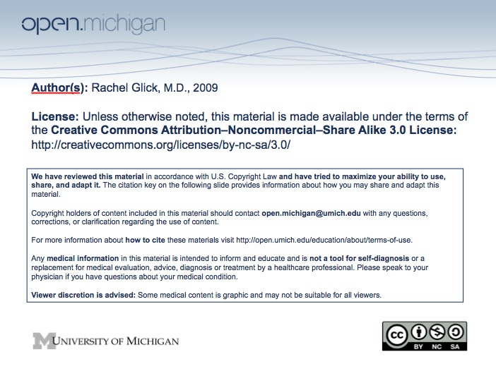

Psychiatry Sequence (PSY614)

Topic: | Delirium
Faculty: | Rachel Glick, M.D.
Recommended Reading: | Andreasen & Black, Introductory Textbook of Psychiatry, 3rd Edition, pp. 184-189
Lecture: | Tuesday, October 28, 2008, 11:00 am – 12:00 noon
Learning Objectives:

After reviewing this material, the student should be able to:
1. Define delirium and list its clinical features.
2. Recognize the wide range of underlying medical causes of delirium.
3. Discuss the evaluation of delirium including a list of relevant laboratory tests.
4. Comment on the epidemiology of delirium.
5. Know the differential diagnosis of delirium and be able to compare and contrast delirium and dementia.
6. Know that the treatment of delirium involves identifying and treating the underlying cause as well as providing safety and support to the patient.
7. Identify delirium if given a clinical case report, highlighting those features of the case that suggest the diagnosis of delirium, listing potential underlying causes, and suggesting an initial work-up.

Sample Test Question:

Which population of patients is predisposed to delirium?

A. Elective surgical patients
B. Schizophrenic patients
C. Bipolar patients
D. Elderly patients
E. Children

Answer: D

