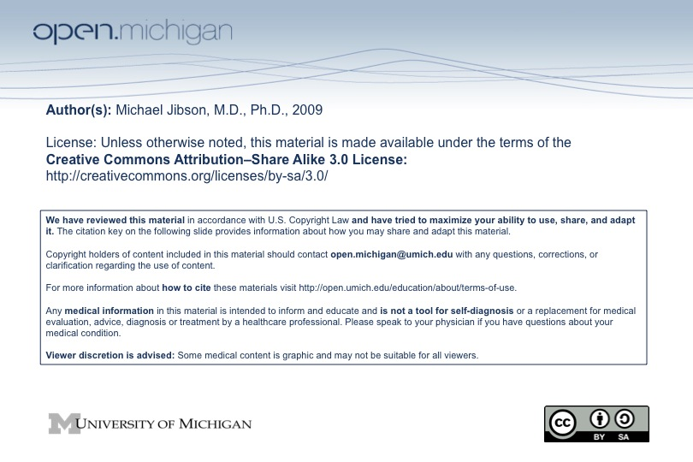

Psychiatry Sequence (PSY614)

Topic: | Personality and Personality Disorders
Faculty: | Michael Jibson, M.D., Ph.D.  Department of Psychiatry
Recommended Reading: | Andreasen & Black, Introductory Textbook of Psychiatry, 3rd ed., pp. 457-89  or  Sadock & Sadock, Kaplan & Sadock’s Pocket Handbook of Clinical Psychiatry, 3rd ed., pp. 239-60
Lecture: | Wednesday, 10/29/08, 8:00 - 10:00 a.m.

Learning Objectives:

After reviewing the material on personality disorders, the student will be expected to:
- Define personality traits vs. personality disorders.
- Describe common instruments used in the assessment of personality.
- Describe the major theories regarding the etiology of personality disorders.
- List the three DSM-IV personality clusters and their ten component disorders.
- Describe the clinical characteristics of each personality disorder.
- Give the prevalence rates, major clinical issues, and major co-morbidities of antisocial and borderline personality disorders.
- Describe the major treatments used for personality disorders.
- Describe the consequences of personality disorders in doctor-patient relations, and how these can be handled.

Sample Test Question:

A 45-year-old unmarried man presents himself to an outpatient psychiatric clinic with a lifetime history of difficulty establishing relationships, especially with women. He describes himself as shy and fearful of talking to other people, who he believes invariably reject his attempts to socialize. He is preoccupied with fears that others criticize or ridicule him. The most likely diagnosis is:

A. antisocial personality disorder.
B. generalized anxiety disorder.
C. paranoid personality disorder.
D. avoidant personality disorder.
E. schizoid personality disorder.

Answer: D

