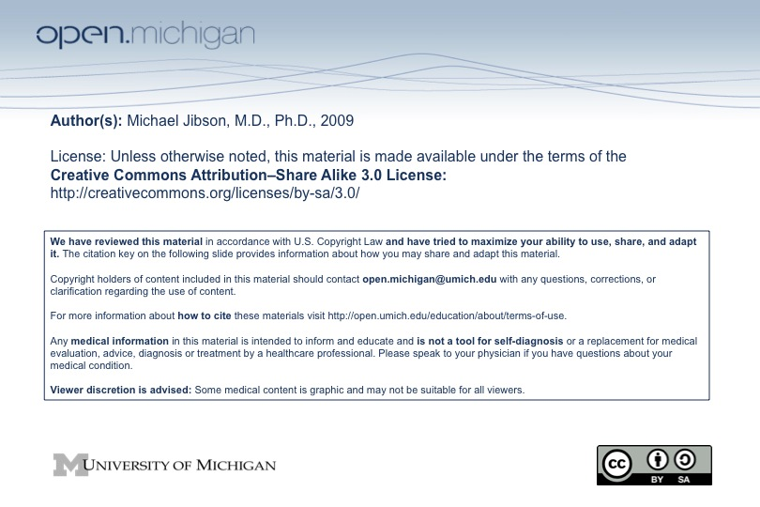

Psychiatry Sequence (PSY614)

Topic: | Schizophrenia and Other Psychotic Disorders
Faculty: | Michael Jibson, M.D., Ph.D.  Department of Psychiatry
Recommended Reading: | Andreasen & Black, Introductory Textbook of Psychiatry, 3rd ed., pp. 211-67  or  Sadock & Sadock, Kaplan & Sadock’s Pocket Handbook of Clinical Psychiatry, 3rd ed., pp. 100-27  Jibson MD, Up-to-Date, “Schizophrenia and Related Disorders,” 2008
Lecture: | Tuesday, 10/30/08, 8:00 – 9:30 a.m.

Learning Objectives:

After reviewing the material on schizophrenia, the student will be expected to:
- Define psychosis.
- List the psychiatric differential diagnosis for psychosis.
- List the diagnostic criteria for schizophrenia and its subtypes.
- Define and describe the three symptom clusters of schizophrenia (positive symptoms, negative symptoms, cognitive impairment).
- Describe the onset, prevalence, and course of schizophrenia.
- List the major risk factors for the development of schizophrenia.
- Describe the pathophysiology of schizophrenia.
- Describe current treatments for schizophrenia.
- Describe schizoaffective disorder, brief psychotic disorder, delusional disorder, and common substances and medical illnesses associated with psychosis.

Sample Test Question:

At what age is a patient with schizophrenia most likely to experience the onset of psychotic symptoms?
A. 6-19
B. 20-34
C. 35-49
D. 50-64
E. 65-79

Answer: B

